NHMS
2600 Douglas Road, Suite 800, Coral Gables, FL 33134
(305) 854-1711
Property Condition Report
Case Number:
093-601378
Full Address:
7406 Duke Dr
Hudson, FL 34667
Inspection Date:
02-04-2010
Inspection Type:
Property Condition Inspection
Prepared By:
Snow Enterprises, LLC
NOTICE TO ALL PROSPECTIVE PURCHASERS: Pursuant to section 5.3.4 of HUD RFP: R-OPC-22505, you are hereby notified that
the contents of this inspection report are for information only and do not imply any guarantee or warranty of property condition. 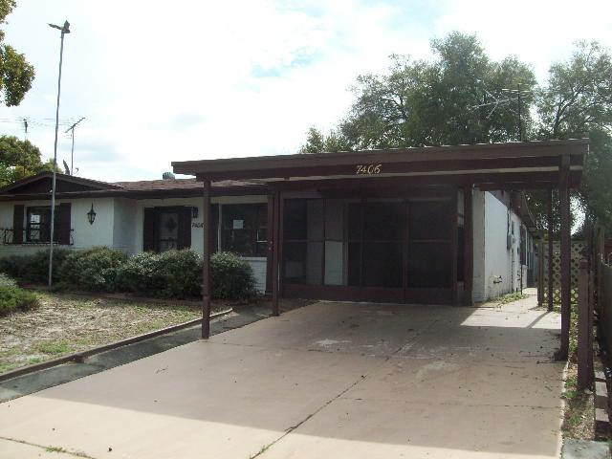

Table of Contents
1
Inspection Requirements ............................................................................................................................... 1
1.1
Exclusions of Inspections........................................................................................................................ 1
1.2
Exclusions and Limitations ..................................................................................................................... 1
2
Report Summary............................................................................................................................................ 2
3
Directions to Property.................................................................................................................................... 4
4
Property Information..................................................................................................................................... 4
5
Additional Comments .................................................................................................................................... 4
6
Structure ......................................................................................................................................................... 5
6.1
General Structure Information................................................................................................................. 5
6.2
Structure Checkpoints ............................................................................................................................. 5
6.3
Structure Comments................................................................................................................................ 5
7
Exterior ........................................................................................................................................................... 6
7.1
General Exterior Information .................................................................................................................. 6
7.2
Exterior Checkpoints............................................................................................................................... 6
7.3
Exterior Comments.................................................................................................................................. 6
8
Roof.................................................................................................................................................................. 8
8.1
General Roof Information ....................................................................................................................... 8
8.2
Roof Checkpoints.................................................................................................................................... 8
8.3
Roof Comments....................................................................................................................................... 8
9
Plumbing ......................................................................................................................................................... 9
9.1
General Plumbing Information................................................................................................................ 9
9.2
Plumbing Checkpoints ............................................................................................................................ 9
9.3
Plumbing Comments ............................................................................................................................... 9
10
Electrical ....................................................................................................................................................... 11
10.1
General Electrical Information.............................................................................................................. 11
10.2
Electrical Checkpoints........................................................................................................................... 11
10.3
Electrical Comments ............................................................................................................................. 11
11
HVAC ............................................................................................................................................................ 12
11.1
General HVAC Information.................................................................................................................. 12
11.2
HVAC Checkpoints............................................................................................................................... 12
11.3
HVAC Comments ................................................................................................................................. 13
12
Interior .......................................................................................................................................................... 14
12.1
General Interior Information ................................................................................................................. 14
12.2
Interior Checkpoints.............................................................................................................................. 14
12.3
Interior Comments................................................................................................................................. 14
13
Appliances..................................................................................................................................................... 15
13.1
General Appliances Information ........................................................................................................... 15

Table of Contents (continued)
13.2
Appliances Checkpoints........................................................................................................................ 15
13.3
Appliances Comments........................................................................................................................... 15
14
HOA Information......................................................................................................................................... 16
15
Code Violations............................................................................................................................................. 16
16
Pending Litigation........................................................................................................................................ 16
17
Demo Orders................................................................................................................................................. 16
18
Radon Gas and Mold Notice and Release Agreement .............................................................................. 17
19
Environmental Issues................................................................................................................................... 18
20
Environmental Compliance Record, Attachment 18 in Handbook 4310.5............................................. 19
21
Report Images............................................................................................................................................... 20

Case Number: 093-601378
1
Snow Enterprises, LLC
1
.
INSPECTION REQUIREMENTS
STRUCTURAL COMPONENTS including foundation, floors, walls, columns, ceilings, and roofs.
EXTERIOR OF STRUCTURE including wall claddings, entryway doors, decks, steps, eaves,
driveways, windows, patios, pools/spas, lawns, landscape, retaining walls, sheds/outbuildings, and
fences.
ROOFING including roof coverings, roof drainage systems, flashing, skylights, and chimneys.
PLUMBING including interior water supply and distribution system, interior waste drains and vent
system, hot water system, fuel storage and distribution system, and sump pump.
ELECTRICAL including service entrance conductors, service equipment, main distribution panels,
voltage ratings, a representative number of installed ceiling fans, lighting fixtures, switches and
receptacles, ground fault circuit interrupters, and smoke detectors.
HVAC (Heating Ventilation, Air Conditioning) including permanently installed heating system and its
controls, chimneys, heat distribution system, including fans, pumps, and ducts , and automatic safety
controls.
Normal operating control of the central air conditioning system and the distribution system.
Insulation vapor barriers, ventilation of attic and foundation, kitchen, bathroom and laundry venting
systems, and the operation of any readily accessible attic ventilation fan when temperature permits
INTERIOR including walls, ceilings, floors, steps, cabinets, doors, windows, etc
BUILT-IN KITCHEN APPLIANCES including the observation and operation of dishwasher, range,
trash compactor, garbage disposal, ventilation equipment, permanently installed oven and microwave
oven.
1
.
1
.
Exclusions of Inspection
1
.
2
.
Exclusions and Limitations
This inspection is limited to visual observations of apparent conditions existing at the time of the
inspection only.
This inspection is not intended to provide the purchaser with information regarding
the advisability of this purchase, the market value of the property, the compliance or non-compliance
with codes, ordinances and statutes, the suitability of this property for specialized use, the life
expectancy of any component or system in the property, the presence or absence of pests or insects,
or cosmetic or underground items or items that are not permanently installed. This inspection report
does not address and is not intended to address the possible presence of any danger from any
potentially harmful substance and environmental hazards, including but not limited to radon gas, lead
paint, asbestos, urea formaldehyde (UFFI), toxic or chemical analysis, airborne hazards, polluted
water, or underground oil tanks.

Case Number: 093-601378
2
Snow Enterprises, LLC
2
Report Summary
This summary is provided to highlight those findings that we believe are for information,
significant in nature or which appear to be in immediate need of repair or a safety concern.
This inspection is visual only in areas that were accessible at the time of inspection. No
dismantling of building components or systems, no destructive testing, no engineering functions,
and no code compliance inspections were performed at the time of the inspection. The findings
were as follows:
Structure
•
The structure was in satisfactory condition at the time of the inspection.
•
The checkpoints within the "Structure" area of the property condition report pertain to the foundation
areas of the home. This includes slabs, crawlspaces, and basements. Information on Non-structural
issues regarding floors, walls, and ceilings will be found on the "Interior" page of the report.
Exterior
•
At the time of the inspection, the exterior of the structure was in acceptable condition with noted
deficiencies.
Roof
•
At the time of the inspection, there were apparent deficiencies noted regarding the roof of the
structure.
Plumbing
•
The plumbing system was not in working condition at the time of the inspection. The water was
active at the time of the inspection, there were two leaking shut off valves at the exterior of the
structure.
•
There is an irrigation pump at the structure.
•
Wells and septic systems, if present, are inspected only for the presence of obvious visible defects.
The water quality and flow capacity of wells is not determined and the full operational functionality
of septic systems cannot be determined due to the unavailability of water and the extended non-use of
the system.
•
This report reflects general conditions noted during the time of the inspection. Systems such as
HVAC, Plumbing, and Electrical because of their nature and complexity are subject to deterioration
or breakdown over time that cannot be predicted.
•
Because of this, prospective buyers are strongly urged to obtain a full home inspection prior to
purchase.
Electrical
•
The electrical system was in working condition at the time of the inspection. The system was
powered up using a generator.
•
Electrical systems, if not active, are tested using 220 volt generators.

Case Number: 093-601378
3
Snow Enterprises, LLC
•
This report reflects general conditions noted during the time of the inspection. Systems such as
HVAC, Plumbing, and Electrical because of their nature and complexity are subject to deterioration
or breakdown over time that cannot be predicted.
•
Because of this, prospective buyers are strongly urged to obtain a full home inspection prior to
purchase.
HVAC
•
The heating system was in working condition when the structure was connected to a 220V generator.
The AC unit was visually tested due to the low temperature. There is a window AC unit present at the
structure.
•
This report reflects general conditions noted during the time of the inspection. Systems such as
HVAC, Plumbing, and Electrical because of their nature and complexity are subject to deterioration
or breakdown over time that cannot be predicted.
•
Because of this, prospective buyers are strongly urged to obtain a full home inspection prior to
purchase.
Interior
•
At the time of the inspection, the interior of the structure was in satisfactory condition with noted
deficiencies.
Appliances
•
The appliances that were present were in acceptable condition at the time of the inspection.

Case Number: 093-601378
4
Snow Enterprises, LLC
3
Directions to Property
Automatically Generated via Google Maps -- MAY NOT BE ACCURATE
1. Head east on Lazy Ln toward Diagonal Rd -- 322 ft
2. Lazy Ln turns slightly left and becomes Diagonal Rd -- 0.1 mi
3. Turn left at New York Ave -- 0.3 mi
4. Take the 1st left onto FL-55 S US-19 S -- 2.4 mi
5. Turn left at Country Club Dr -- 0.5 mi
6. Turn right at College Hill Dr -- 361 ft
7. Take the 1st right onto Duke Dr Destination will be on the left -- 240 ft
4
Property Information
Address: 7406 Duke Dr, Hudson, FL 34667
Structure Age: See Appr.
Access to Property: HUD Key
Number of Bathrooms: 2.5
Square Footage: 501-1000 Sq. Ft.
Electric Status: Inactive
Water Status: Active
Gas Status: NA
Occupancy Status: No
5
Additional Comments
Power Company:WRECK
Meter Number:39624673
Water Company:Pas co utilities
41106568

Case Number: 093-601378
5
Snow Enterprises, LLC
6
Structure
This portion of the inspection covers general structural component checkpoints of the subject property
such as foundation, floors, walls, columns, ceilings, basement, etc.
6.1
General Structure Information
Access Method: NA
Foundation Type: Slab
Basement Type: NA
6.2
Structure Checkpoints
Checkpoint
Rating
Comment
Basement Floor:
NA
Beam Supports:
NA
Ceilings:
NA
Cracks:
NV
Crawlspace Door:
NA
Floor:
NA
Footing Drain:
NV
Ground Grade:
S
Insulation:
NV
Joists:
NA
Sill Plate:
NA
Structural:
S
Sub-Flooring:
NA
Walls:
NA
Wood-Ground Distance:
NA
Key: Y=Yes N=No S=Satisfactory U=Unsatisfactory MR=Marginal MG=Missing NA=Not Applicable NV=Not Visible
6.3
Structure Comments
The structure was in satisfactory condition at the time of the inspection.
The checkpoints within the "Structure" area of the property condition report pertain to the foundation
areas of the home. This includes slabs, crawlspaces, and basements. Information on Non-structural issues
regarding floors, walls, and ceilings will be found on the "Interior" page of the report.

Case Number: 093-601378
6
Snow Enterprises, LLC
7
Exterior
This portion of the inspection covers general exterior checkpoints of the subject property structure such as
wall claddings, entryway doors, decks, steps, eaves, driveways, windows, patios, pools/spas, lawns,
landscape, retaining walls, sheds/outbuildings, fences, etc.
7.1
General Exterior Information
Exterior Siding: Stucco
Lot Size: Less than one-quarter
Weather Conditions: Clear
Wall Structure: Frame
Temperature: 50-60
7.2
Exterior Checkpoints
Checkpoint
Rating
Comment
Balconies:
NA
Carports:
S
Debris:
S
Decks/Deck Steps:
NA
Driveway:
S
Eaves:
MR
There are damaged eave boards.
Entry Locks:
S
Exterior Door/Locks:
MR
The rear exterior door is damaged but does not prevent it from being
secured.
Fencing/Gates:
MR
There is damaged areas of fencing.
Garage Door:
S
Garage Door Opener:
S
Landscape:
S
Lawn Care:
S
Leaf Removal:
S
Patio:
S
Pool/Spa:
NA
Porches:
NA
Railings:
NA
Retaining Walls:
NA
Sheds and Outbuildings:
MR
The shed door and roof are damaged.
Sidewalks:
S
Siding Condition:
MR
There are damaged shutters.
Snow Removal:
NA
Exterior Steps:
S
Storm/Screen Windows:
MR
There are missing window screens in the structure.
Storm/Screen Doors:
MR
There is missing door hardware.
Windows:
S
Key: Y=Yes N=No S=Satisfactory U=Unsatisfactory MR=Marginal MG=Missing NA=Not Applicable NV=Not Visible
7.3
Exterior Comments

Case Number: 093-601378
7
Snow Enterprises, LLC
At the time of the inspection, the exterior of the structure was in acceptable condition with noted
deficiencies.

Case Number: 093-601378
8
Snow Enterprises, LLC
8
Roof
This portion of the inspection covers general exterior roofing component checkpoints of the subject
property such as roof coverings (shingles, flashing, skylights, chimneys, etc.), structural elements of the
roof (trusses, rafters, ceiling foists, etc.), roof drainage systems, etc.
8.1
General Roof Information
Roof Type: Gabled
Gutter Type: Aluminum
Method to Observe Attic: None
Method to Observe Roof: Ladder
Number of Layers: 1
Attic Vent Type: Soffit, Gable
Roofing Material: Asphalt
8.2
Roof Checkpoints
Checkpoint
Rating
Comment
Shingle Cond.:
S
Flashing/Joints:
S
Soffits/Fascias:
S
Skylights:
NA
Vent Pipes:
S
Chimney:
NA
Gutters:
S
Downspouts:
MR
There are damaged downspouts.
Attic Ventilation:
S
Attic Water:
NV
Attic Insulation:
NV
*Structural Cond.:
S
*Sheathing Cond.:
NV
Truss:
NV
Roof Exhaust Fan(s):
NA
Key: Y=Yes N=No S=Satisfactory U=Unsatisfactory MR=Marginal MG=Missing NA=Not Applicable NV=Not Visible
8.3
Roof Comments
At the time of the inspection, there were apparent deficiencies noted regarding the roof of the structure.

Case Number: 093-601378
9
Snow Enterprises, LLC
9
Plumbing
This portion of the inspection covers general plumbing checkpoints of the subject property such as interior
water supply and distribution system, interior waste drains and vent system, hot water system, fuel storage
and distribution system, and sump pump.
9.1
General Plumbing Information
Waste Disposal: Septic
Waste Piping: PVC
WH Size: 30 gallons
WH Manufacturer: Rheem
WH Model: RBa03855c13027
Water Supply: Municipal
Water Piping: Copper
9.2
Plumbing Checkpoints
Checkpoint
Rating
Comment
Bar Sinks:
NA
Bath Fixtures:
S
Connections:
MR
Interior Spa/Hot Tub:
NA
Interior Vent:
NA
Kitchen Sink:
MR
There are cut pumbing lines under the kitchen sink.
Laundry Tub:
NA
Main Shut Off:
S
Pressure Relief Valve:
S
Pressure Tank:
NA
Septic Location:
S
Septic System:
NV
Sewer Drainage:
S
Shower Pan:
NV
Sprinkler System:
NA
Storage Tanks:
NA
Vent System:
S
Water Filter:
NA
Water Heaters:
S
Water Meter:
S
Water Softener:
NA
Water Supply:
S
Well:
NA
Well Location:
NA
Well/Sump Pump:
NA
Key: Y=Yes N=No S=Satisfactory U=Unsatisfactory MR=Marginal MG=Missing NA=Not Applicable NV=Not Visible
9.3
Plumbing Comments
The plumbing system was not in working condition at the time of the inspection. The water was active at
the time of the inspection, there were two leaking shut off valves at the exterior of the structure.

Case Number: 093-601378
10
Snow Enterprises, LLC
There is an irrigation pump at the structure.
Wells and septic systems, if present, are inspected only for the presence of obvious visible defects. The
water quality and flow capacity of wells is not determined and the full operational functionality of septic
systems cannot be determined due to the unavailability of water and the extended non-use of the system.
This report reflects general conditions noted during the time of the inspection. Systems such as HVAC,
Plumbing, and Electrical because of their nature and complexity are subject to deterioration or breakdown
over time that cannot be predicted.
Because of this, prospective buyers are strongly urged to obtain a full home inspection prior to
purchase.

Case Number: 093-601378
11
Snow Enterprises, LLC
10
Electrical
This portion of the inspection covers general electical checkpoints of the subject property such as service
entrance conductors, service equipment, main distribution panels, voltage ratings, a representative number
of installed ceiling fans, lighting fixtures, switches and receptacles, ground fault circuit interruptors,
smoke detectors, etc.
10.1
General Electrical Information
Additional Space Available: Yes
Box Location: Garage
Capacity: 150A 120-240V
Conductor Type: Aluminum
General Wiring: Good
Num. of Disconnects: 1
Panel Manufacturer: Square D
Panel Type: Breaker
Wiring: Copper
10.2
Electrical Checkpoints
Checkpoint
Rating
Comment
Applicance Wiring:
S
Bath GFCI:
S
Breaker Cond.:
S
Exterior GFCI:
NA
Exterior Wiring:
S
Ground/Bonding:
S
HVAC Wiring:
S
Interior Wiring:
S
Kitchen GFCI:
S
Lighting Fixtures:
S
Panel Box:
S
Rec. Location:
S
Service Attach:
S
Service Meter:
S
Sub Panel Box:
S
Key: Y=Yes N=No S=Satisfactory U=Unsatisfactory MR=Marginal MG=Missing NA=Not Applicable NV=Not Visible
10.3
Electrical Comments
The electrical system was in working condition at the time of the inspection. The system was powered up
using a generator.
Electrical systems, if not active, are tested using 220 volt generators.
This report reflects general conditions noted during the time of the inspection. Systems such as HVAC,
Plumbing, and Electrical because of their nature and complexity are subject to deterioration or breakdown
over time that cannot be predicted.
Because of this, prospective buyers are strongly urged to obtain a full home inspection prior to
purchase.

Case Number: 093-601378
12
Snow Enterprises, LLC
11
HVAC
This portion of the inspection covers general HVAC checkpoints of the subject property such as
permanently installed heating system and its controls, chimneys, heat distribution system, including fans,
pumps, and ducts, and automatic safety controls.
Normal operating control of the central air conditioning system and the distribution system, etc.
Insulation vapor barriers, ventilation of attic and foundation, kitchen, bathroom and laundry venting
systems, and the operation of any readily accessible attic ventilation fan when temperature permits, etc.
11.1
General HVAC Information
Inside Unit Brand: Not Visible
Outside Unit Brand: Goodman
Inside Model No.: Not Visible
Outside Model No.: 0406161759
Inside Unit Type: Electrical
Outside Unit Type: Electrical
11.2
HVAC Checkpoints
Checkpoint
Rating
Comment
A/C Component Cond.:
S
Boiler:
NA
Coil:
S
Coil Fins:
S
Condens. Pipe:
S
Controls:
S
Draft Device:
NA
Duct Work:
S
Electric Heat:
S
An electric forced air unit supplies the heat.
Evaporator:
NV
Fans:
S
Filter:
MR
The HVAC filter needs to be replaced.
Fireplace:
NA
Flue Pipe/Draft:
NA
Furnace System:
NA
Gas Lines:
NA
Heat Exchanger:
NA
Heat Pump:
NA
Inside Fan Motor:
S
Oil Tank:
NA
Oil Tank Vent:
NA
Refrigerant Line:
S
Supply Returns:
S
Temp. Drop Test:
NA
Thermostat:
S
Vapor Barrier:
NV
Ventilation:
S
Key: Y=Yes N=No S=Satisfactory U=Unsatisfactory MR=Marginal MG=Missing NA=Not Applicable NV=Not Visible

Case Number: 093-601378
13
Snow Enterprises, LLC
11.3
HVAC Comments
The heating system was in working condition when the structure was connected to a 220V generator. The
AC unit was visually tested due to the low temperature. There is a window AC unit present at the
structure.
This report reflects general conditions noted during the time of the inspection. Systems such as HVAC,
Plumbing, and Electrical because of their nature and complexity are subject to deterioration or breakdown
over time that cannot be predicted.
Because of this, prospective buyers are strongly urged to obtain a full home inspection prior to
purchase.

Case Number: 093-601378
14
Snow Enterprises, LLC
12
Interior
The interior portion of the inspection covers checkpoints involving the interior walls, ceilings, floors,
steps, cabinets, doors, and windows.
12.1
General Interior Information
There are no general information points in this section.
12.2
Interior Checkpoints
Checkpoint
Rating
Comment
Cabinets:
MR
There are damaged cabinets.
Ceilings:
S
Closets:
S
Countertops:
S
Interior Debris:
S
Detectors:
S
Door Hardware:
S
Doors:
S
Dryer Vent:
S
Floor:
MR
This structure has stained carpets.
Mold:
NV
Railings:
NA
Stairwells:
NA
Steps:
NA
Walls:
MR
There are damaged walls.
Windows:
MR
There are boarded windows from missing AC window units.
Key: Y=Yes N=No S=Satisfactory U=Unsatisfactory MR=Marginal MG=Missing NA=Not Applicable NV=Not Visible
12.3
Interior Comments
At the time of the inspection, the interior of the structure was in satisfactory condition with noted
deficiencies.

Case Number: 093-601378
15
Snow Enterprises, LLC
13
Appliances
The kitchen appliance portion of the inspection covers checkpoints involving the observation and
operation of the refrigerator, dishwasher, range, trash compactor, garbage disposal, ventilation equipment,
microwave and any other permanently installed appliances.
13.1
General Appliances Information
There are no general information points in this section.
13.2
Appliances Checkpoints
Checkpoint
Rating
Comment
Dishwasher:
MG
The dishwasher is missing.
Disposal:
NA
The garbage disposal is not applicable.
Dryer:
MG
The dryer is missing.
Microwave:
NA
Oven:
NA
Range Hood:
S
Range/Stove:
S
Refrigerator:
MG
The refrigerator is missing.
Washer:
MG
The washing machine is missing.
Other:
NA
Key: Y=Yes N=No S=Satisfactory U=Unsatisfactory MR=Marginal MG=Missing NA=Not Applicable NV=Not Visible
13.3
Appliances Comments
The appliances that were present were in acceptable condition at the time of the inspection.

Case Number: 093-601378
16
Snow Enterprises, LLC
14
HOA Information
Country club estates home owner association
15
Code Violations
There are no known code violations.
16
Pending Litigation
There is no known pending litigation.
17
Demo Orders
There are no known property demo orders.

Case Number: 093-601378
17
Snow Enterprises, LLC
18 – Radon Gas and Mold Notice
U.S. Department of Housing
and Release Agreement
and Urban Development
Office of Housing
Federal Housing Commissioner
Property Case #:

Property address:

PURCHASERS ARE HEREBY NOTIFIED AND UNDERSTAND THAT RADON GAS AND
SOME MOLDS HAVE THE POTENTIAL TO CAUSE SERIOUS HEALTH PROBLEMS.
Purchaser acknowledges and accepts that the HUD-owned property described above (the “Property”) is being offered for sale
“AS IS” with no representations as to the condition of the Property. The Secretary of the U.S. Department of Housing and
Urban Development, his/her officers, employees, agents, successors and assigns (the “Seller”) and

,
an independent management and marketing contractor (“M & M Contractor”) to the Seller, have no knowledge of radon or
mold in, on, or around the Property other than what may have already been described on the web site of the Seller or M & M
Contractor or otherwise made available to Purchaser by the Seller or M & M Contractor.
R
adon is an invisible and odorless gaseous radioactive element. Mold is a general term for visible growth of fungus, whether
it is visible directly or is visible when barriers, such as building components (for example, walls) or furnishings (for example,
carpets), are removed.
Purchaser represents and warrants that Purchaser has not relied on the accuracy or completeness of any representations that
have been made by the Seller and/or M & M Contractor as to the presence of radon or mold and that the Purchaser has not
relied on the Seller’s or M & M Contractor’s failure to provide information regarding the presence or effects of any radon or
mold found on the Property.
R
eal Estate Brokers and Agents are not generally qualified to advise purchasers on radon or mold treatment or its health and
safety risks. PURCHASERS ARE ENCOURAGED TO OBTAIN THE SERVICES OF A QUALIFIED AND
EXPERIENCED PROFESSIONAL TO CONDUCT INSPECTIONS AND TESTS REGARDING RADON AND
MOLD PRIOR TO CLOSING. Purchasers are hereby notified and agree that they are solely responsible for any required
remediation and/or resulting damages, including, but not limited to, any effects on health, due to radon or mold in, on or
around the property.
I
n consideration of the sale of the Property to the undersigned Purchaser, Purchaser does hereby release, indemnify, hold
harmless and forever discharge the Seller, as owner of the Property and separately, M & M Contractor, as the independent
contractor responsible for maintaining and marketing the Property, and its officers, employees, agents, successors and
assigns, from any and all claims, liabilities, or causes of action of any kind that the Purchaser may now have or at any time in
the future may have against the Seller and/or M & M Contractor resulting from the presence of radon or mold in, on or
around the Property.
Purchaser has been given the opportunity to review this Release Agreement with Purchaser’s attorney or other representatives
of Purchaser’s choosing, and hereby acknowledges reading and understanding this Release. Purchaser also understands that
the promises, representations and warranties made by Purchaser in this Release are a material inducement for Seller entering
into the contract to sell the Property to Purchaser.
Dated this ____ day of ____________, 20__.

Purchaser’s Signature
Purchaser’s Signature

Purchaser’s Printed Name
Purchaser’s Printed Name
Form HUD-9548-E (6/2004)
093-601378
7406 Duke Dr
Hudson, FL 34667
NHMS

Case Number: 093-601378
18
Snow Enterprises, LLC
19
Environmental Issues
There are no known property environmental issues.

Case Number: 093-601378
19
Snow Enterprises, LLC
20 – ENVIRONMENTAL COMPLIANCE RECORD
SINGLE FAMILY PROPERTY DISPOSITION
FHA Case Number:
Property Address:
COMPLIANCE FINDINGS
SOURCE / DOCUMENTATION
1. HISTORIC PRESERVATION
Property
…
is
…
is not listed on the National Register of
Historic Places.
Property
…
is
…
is not located in an Historical District.
Note:
An appropriate deed restriction will be required if
property meets either of the foregoing conditions.
2. FLOODPLAIN
Property
…
is
…
is not located within the 100-year
floodplain (Zones A and V).
Note:
Flood insurance may be required.
3
.
AIRPORT RUNWAY CLEAR ZONES (24 CFR 51D)
Property
…
is
…
is not located within boundary of runway
zone.
If “yes”,

Has the airport operator declined to acquire the
property?
…
yes
…
no

A signed disclaimer is required (24 CFR Part 51D).
4. SUMMARY
Additional actions
…
are
…
are not required on the basis of the findings above. If additional actions are required, describe them
in an attachment.
NOTE: OTHER ENVIRONMENTAL STATUES, EXECUTIVE ORDERS AND AUTHORITIES
The remaining statutes and authorities cited at 24 CFR 50.4 do not require compliance because they are not relevant to property disposition
actions which do not involve new construction.
Preparer:
________________________________________________
Title:
Date:
Supervisor:
________________________________________________
Title:
Date:
093-601378
7406 Duke Dr, Hudson, FL 34667

Case Number: 093-601378
20
Snow Enterprises, LLC 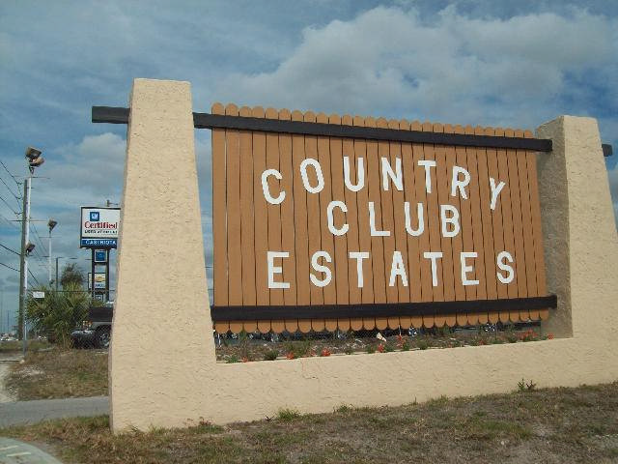
1. Subdivison Sign
2. Front Elevation 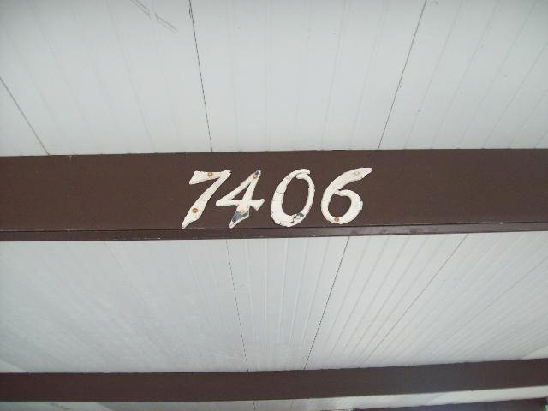
3. Address 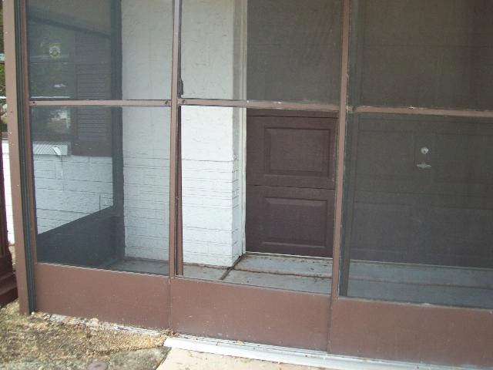
4. Missing Screen 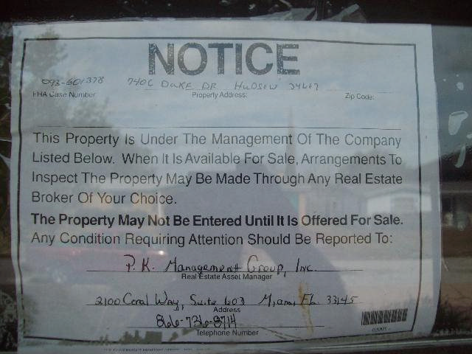
5. Pk Sign 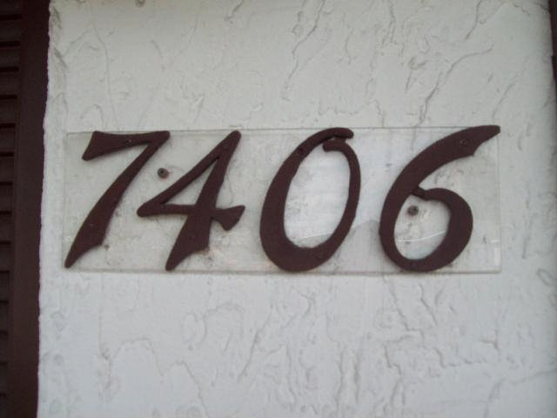
6. Address 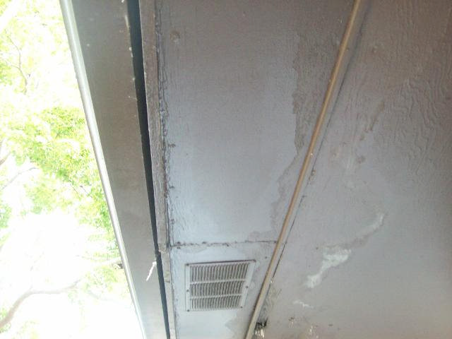
7. Soffits 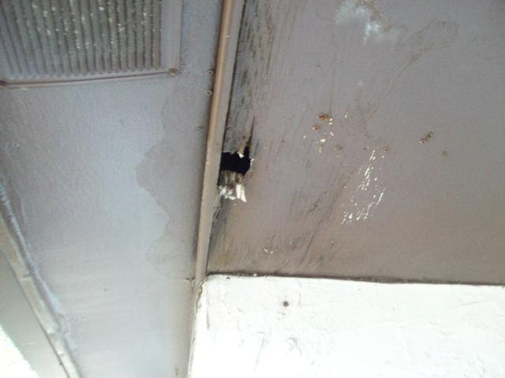
8. Damaged Eave 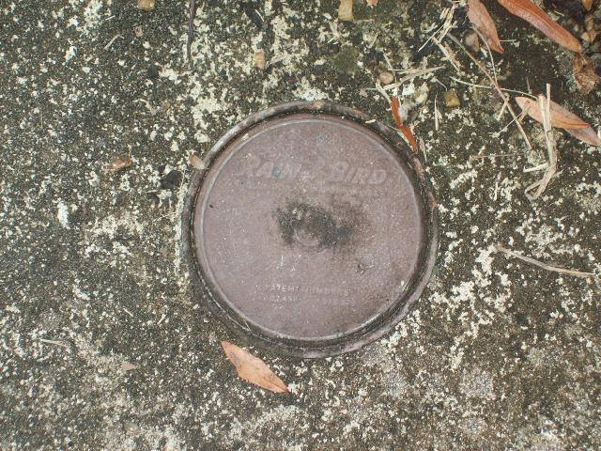
9. Irrigation 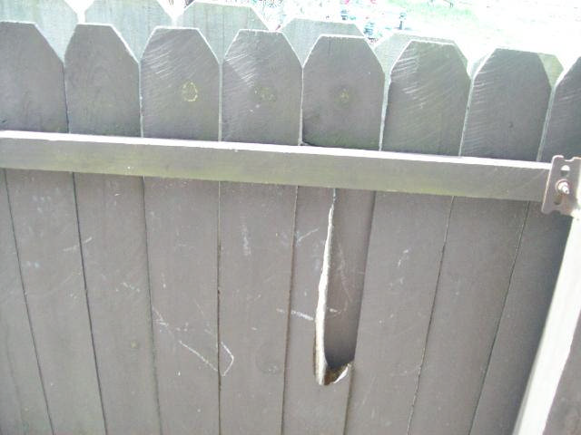
10. Damaged Fence 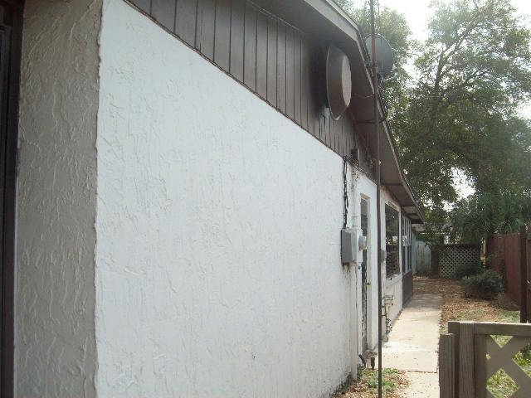
11. Side Elevation 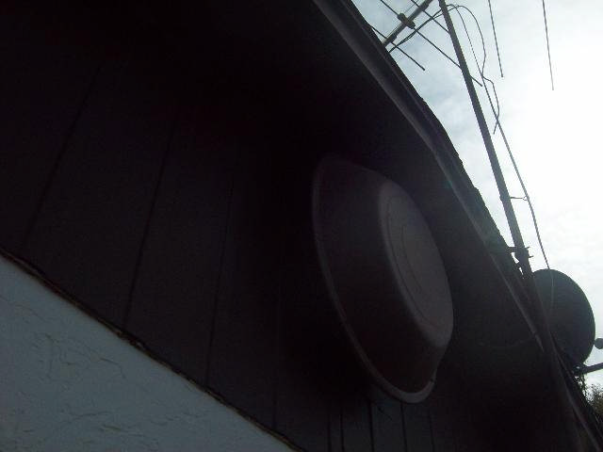
12. Vent

Case Number: 093-601378
21
Snow Enterprises, LLC 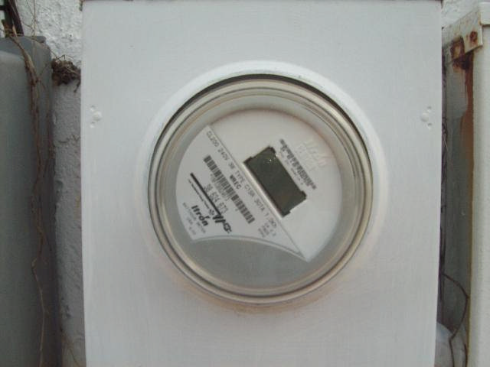
13. Electrical Meter 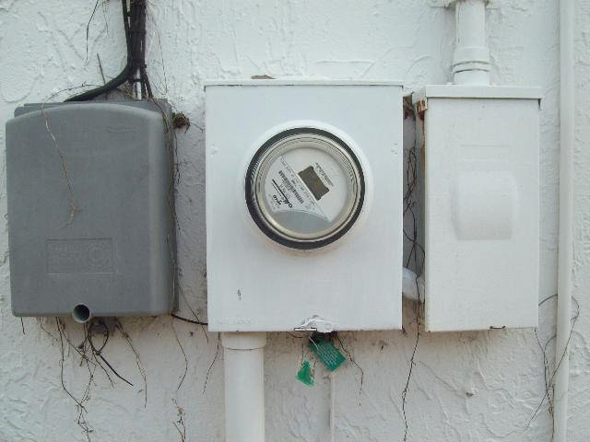
14. Electrical Meter 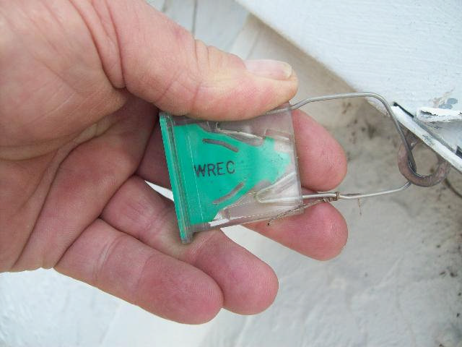
15. Electric Company Tag 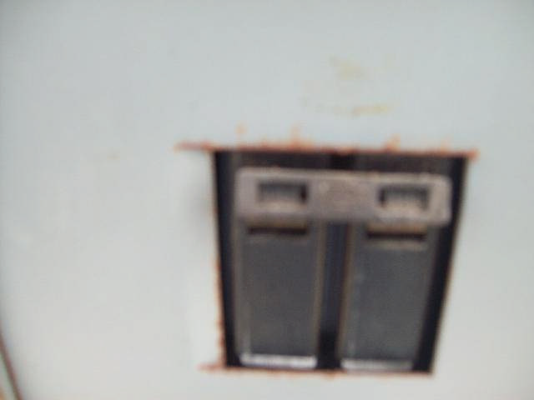
16. Main Breaker 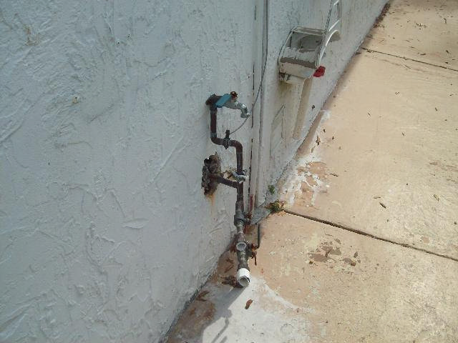
17. Shutoff 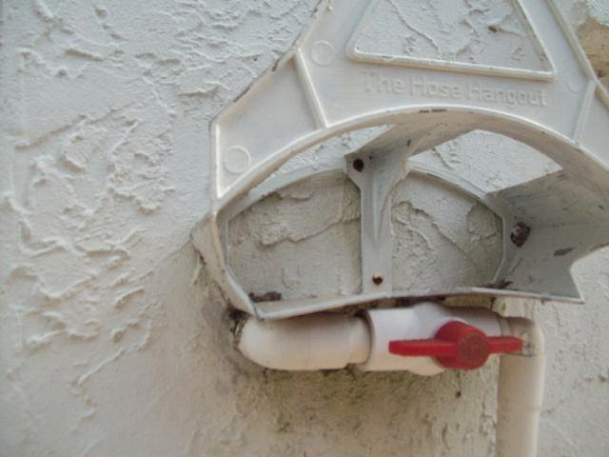
18. Shutoff 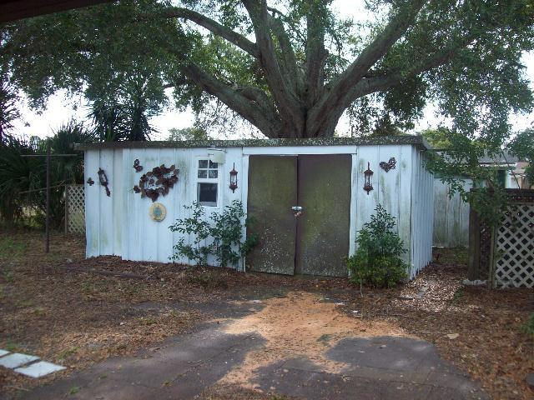
19. Shed 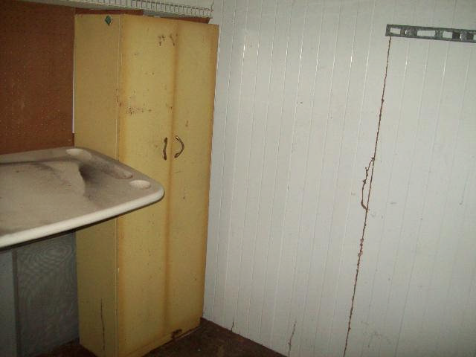
20. Shed Inteiror 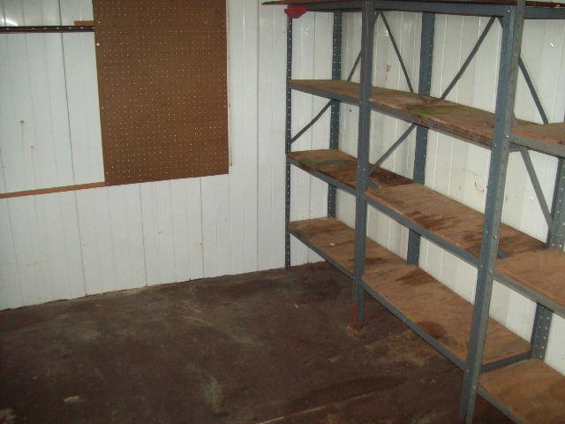
21. Garage 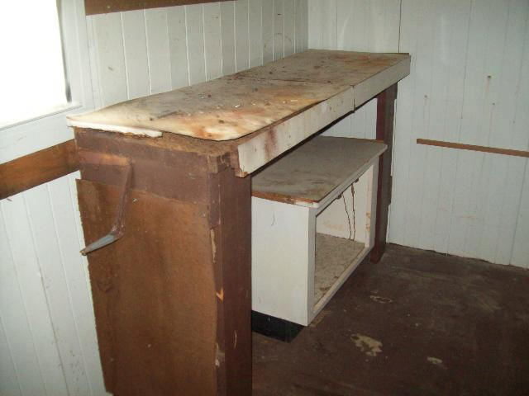
22. Garage 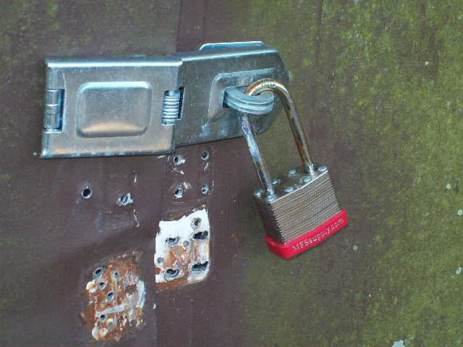
23. Shed Secured 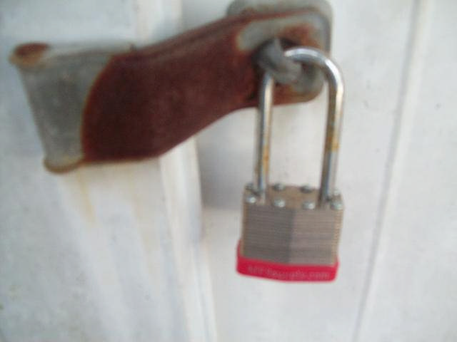
24. Shed Secured

Case Number: 093-601378
22
Snow Enterprises, LLC 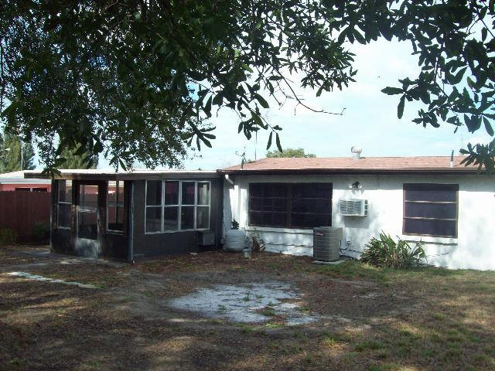
25. Rear Elevation 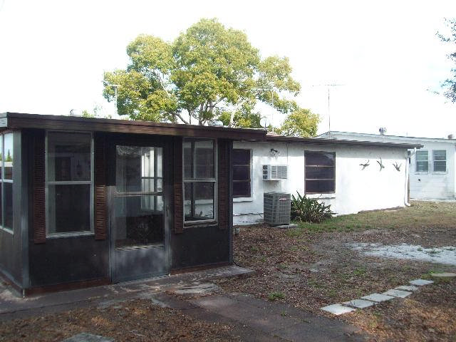
26. Rear Of Property 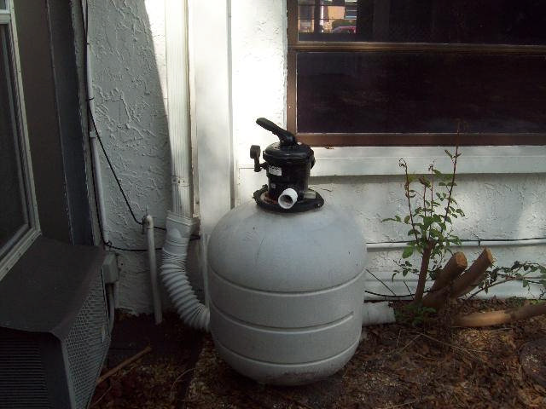
27. Pump 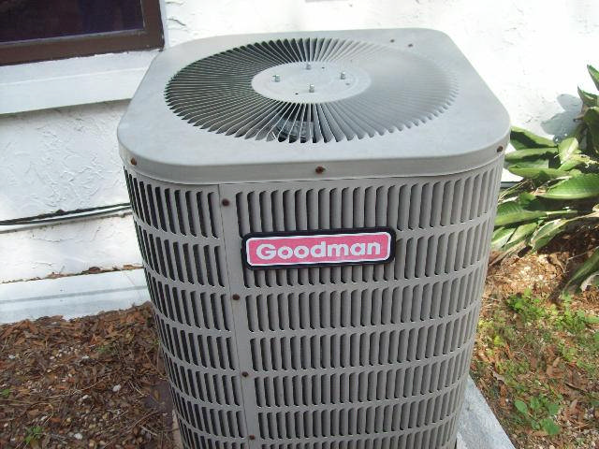
28. Hvac 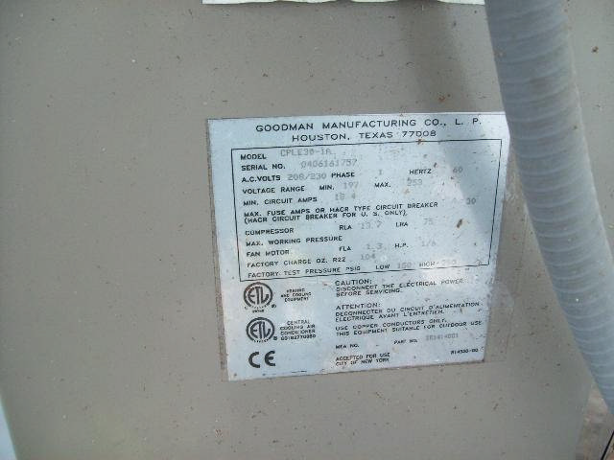
29. Hvac Information 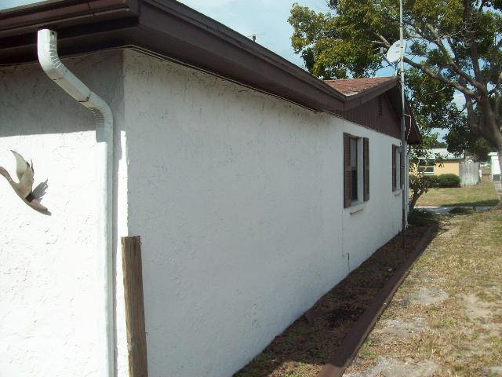
30. Side Elevation 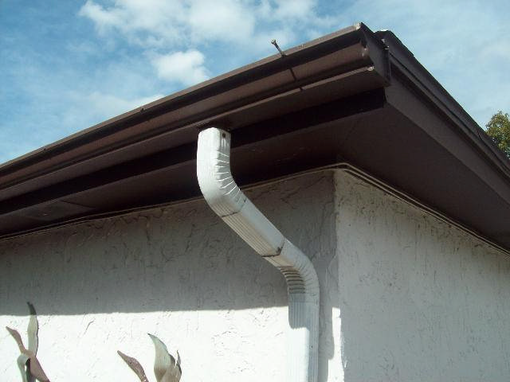
31. Gutter And Downspout 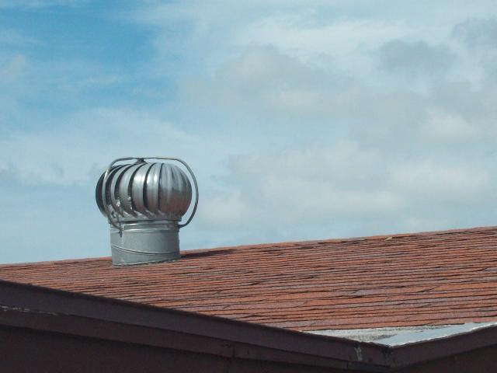
32. Roof 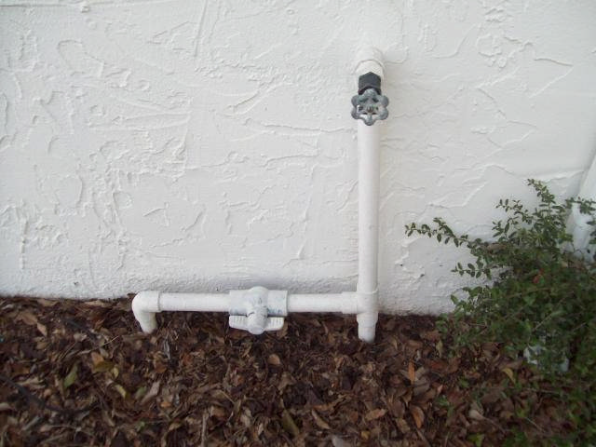
33. Shutoff 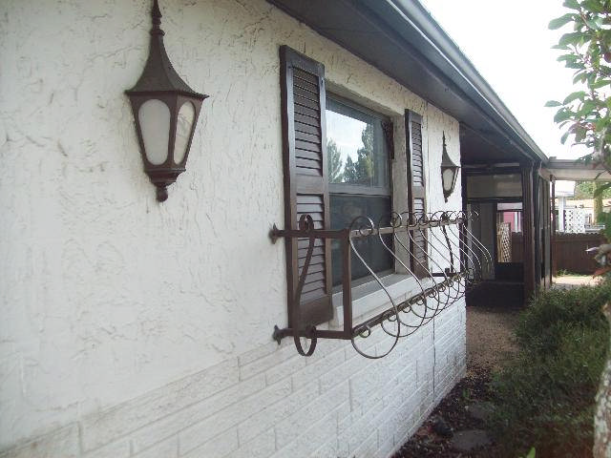
34. Side Elevation 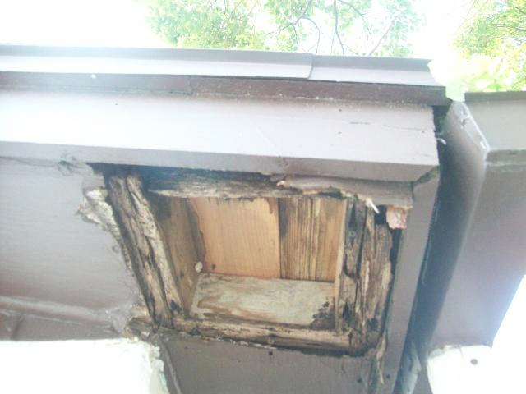
35. Damaged Eave 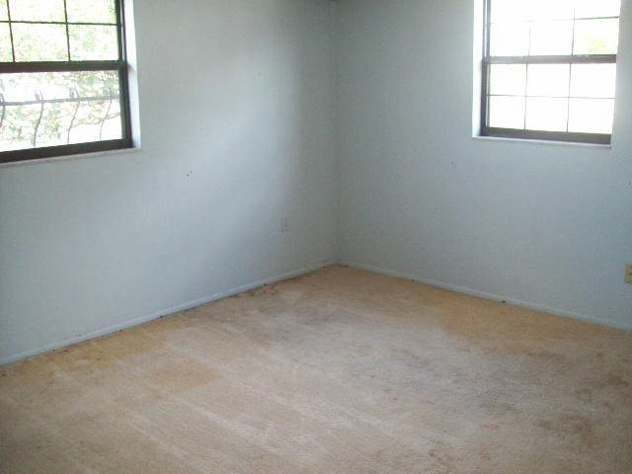
36. Interior Room

Case Number: 093-601378
23
Snow Enterprises, LLC 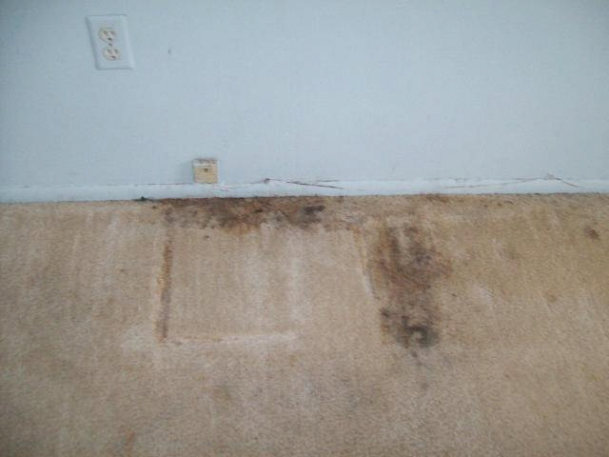
37. Damaged Floor 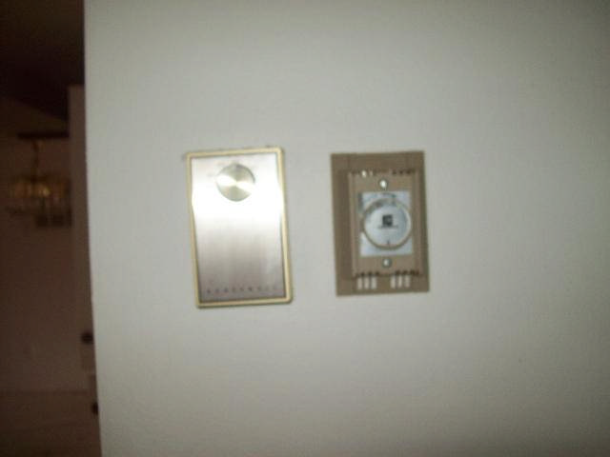
38. Thermostat 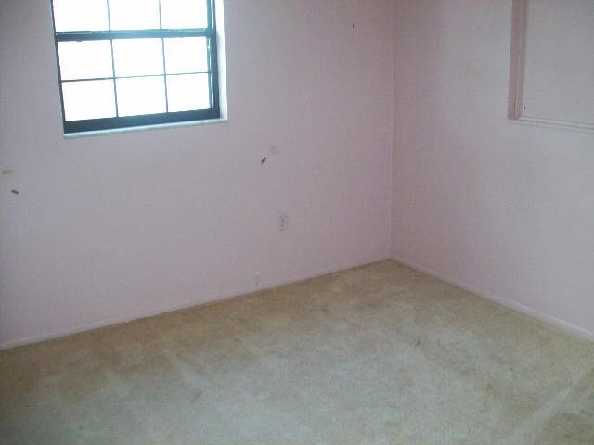
39. Interior Room 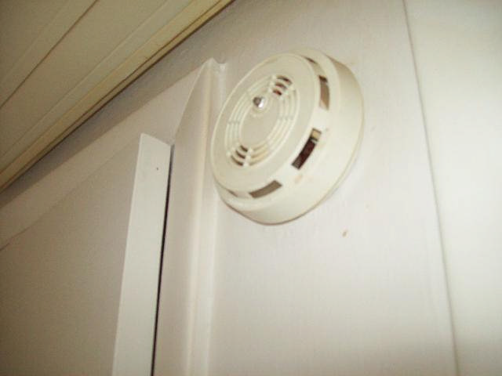
40. Detector 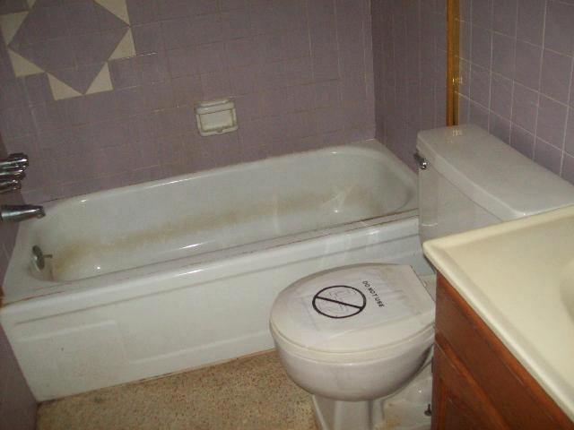
41. Bathroom 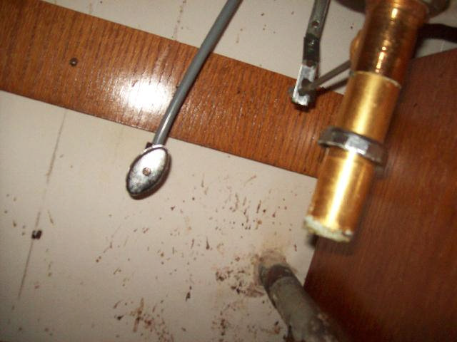
42. Plumbing 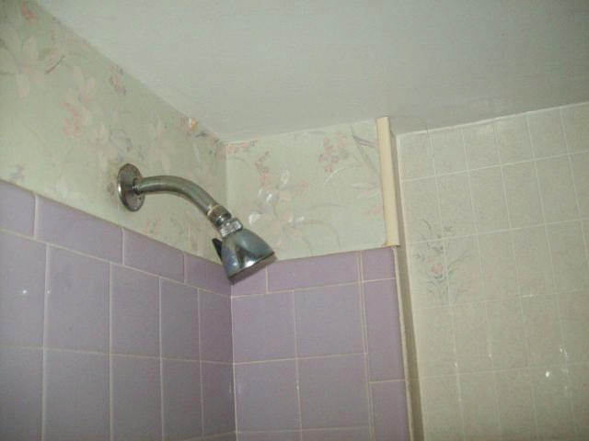
43. Shower Head 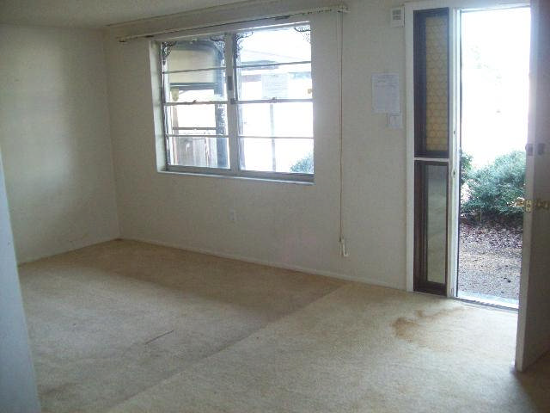
44. Interior Room 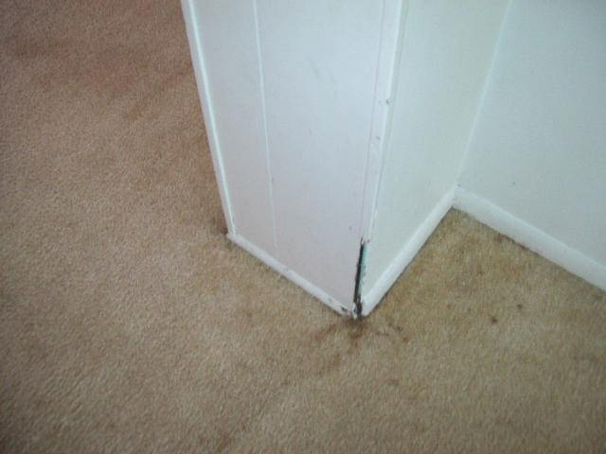
45. Damaged Wall 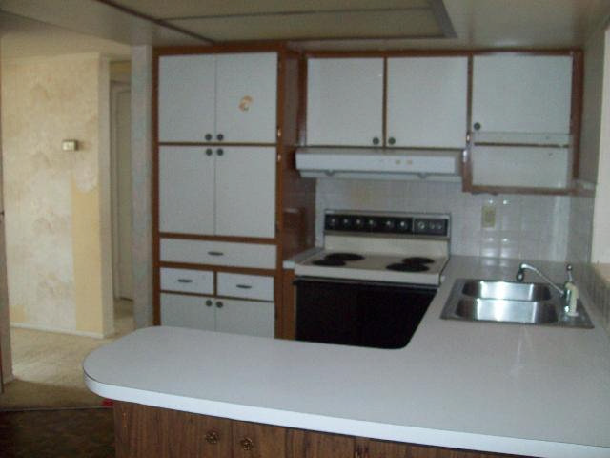
46. Kitchen 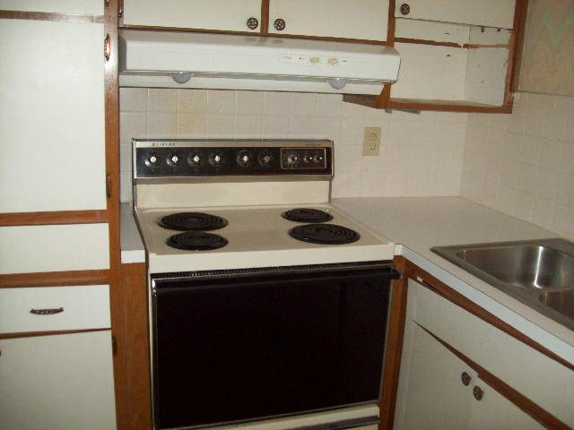
47. Kitchen 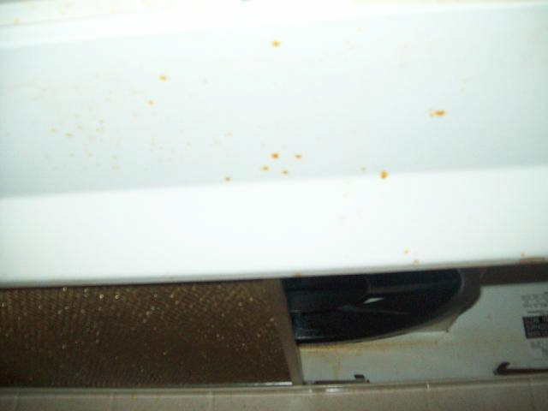
48. Rangehood

Case Number: 093-601378
24
Snow Enterprises, LLC 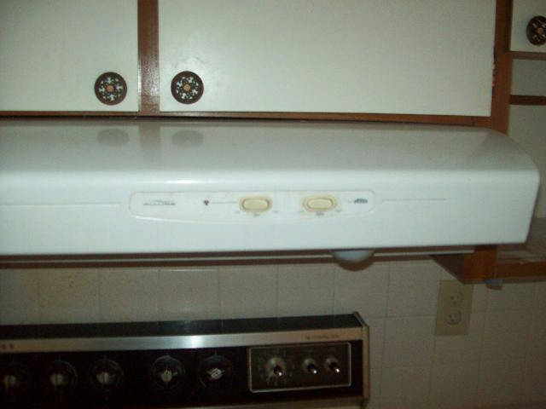
49. Rangehood 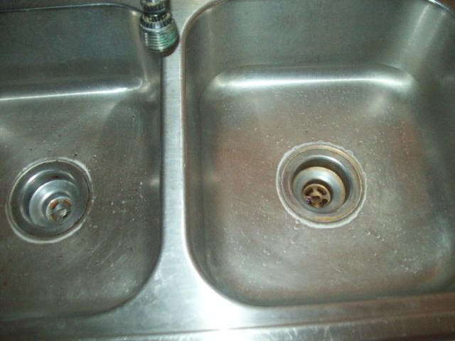
50. Sink 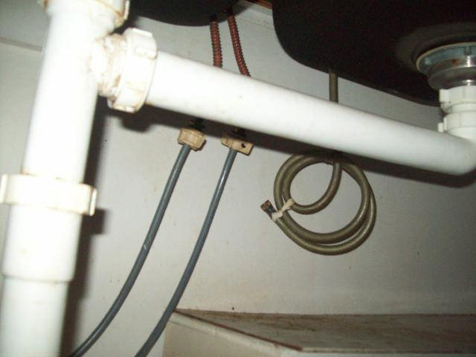
51. Plumbing 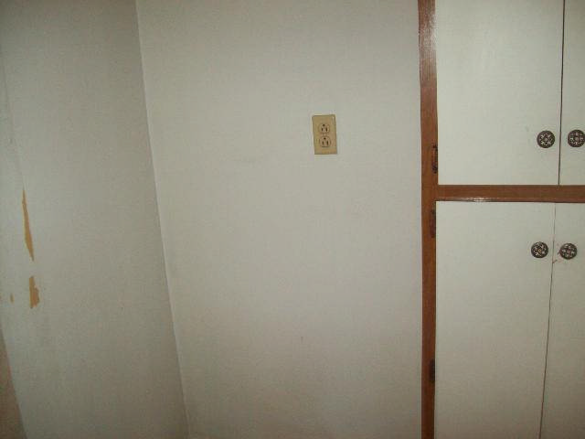
52. Missing Refrigerator 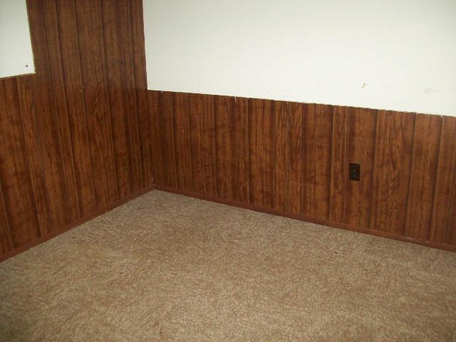
53. Inteiror Room 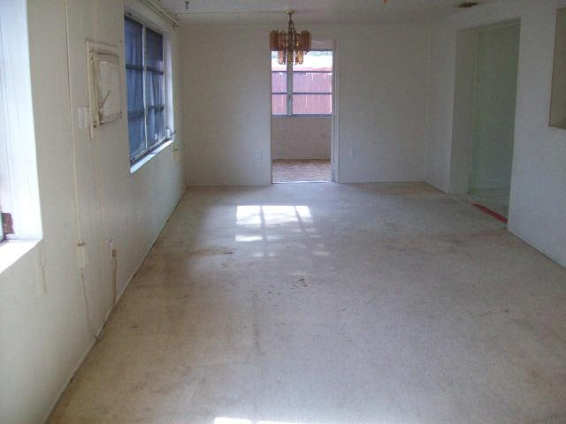
54. Inteiror Room 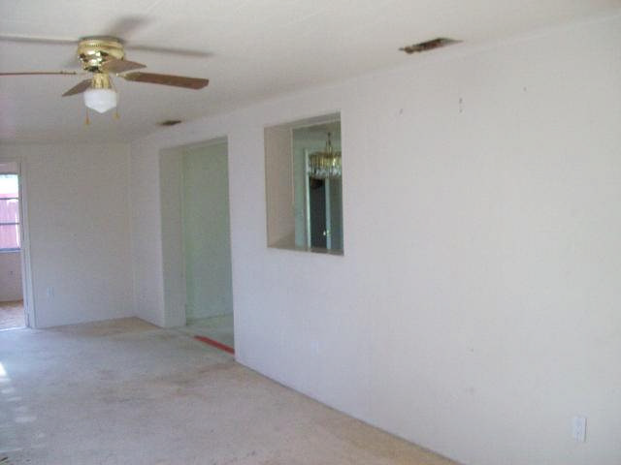
55. Inteiror Room 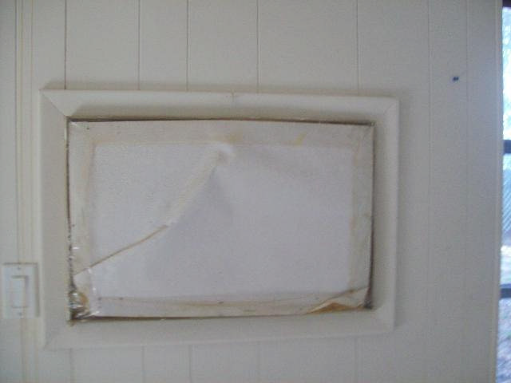
56. Window Unit Covered 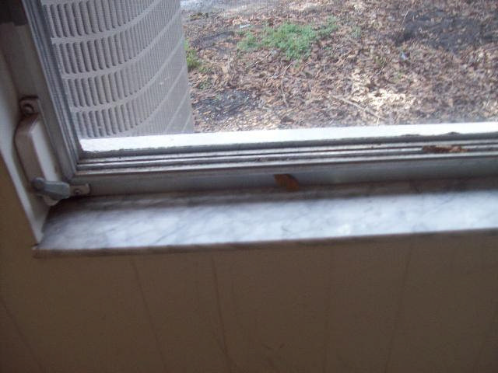
57. Marble Window Sill 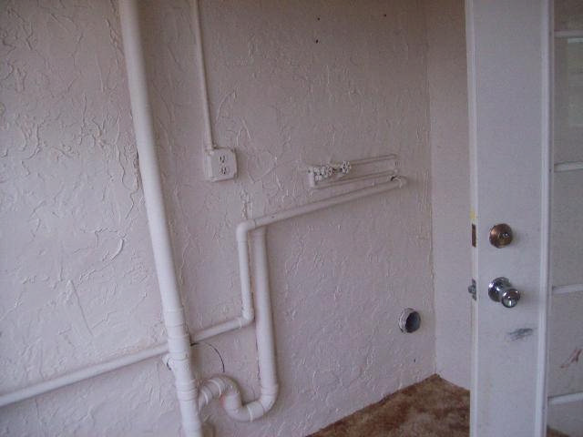
58. Missing Washer And Dryer 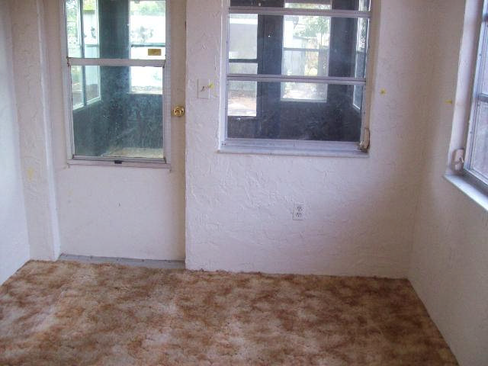
59. Inteiror Room 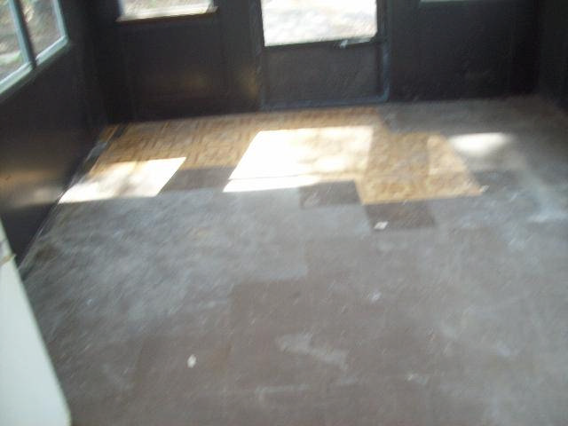
60. Interior Room

Case Number: 093-601378
25
Snow Enterprises, LLC 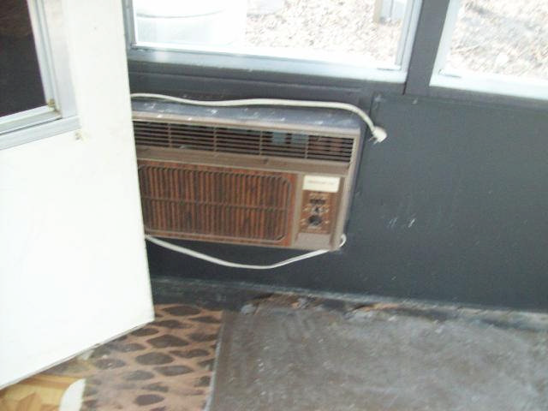
61. Window Ac 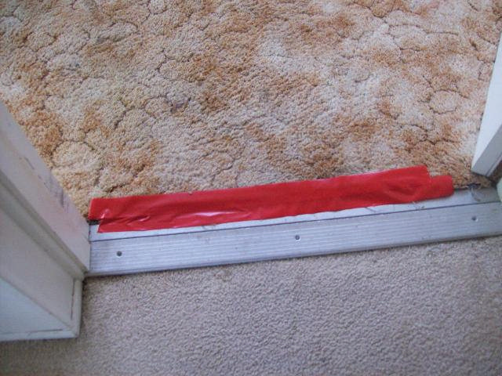
62. Damaged Floor 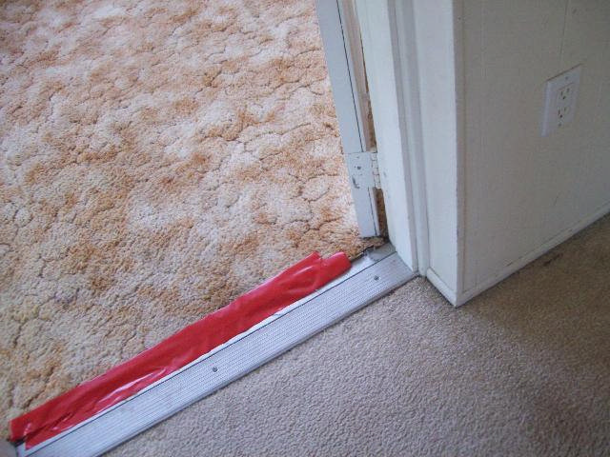
63. Damaged Floor 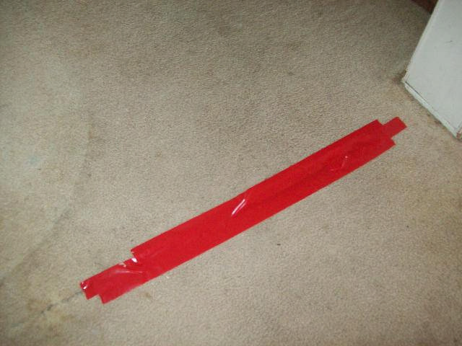
64. Damaged Floor 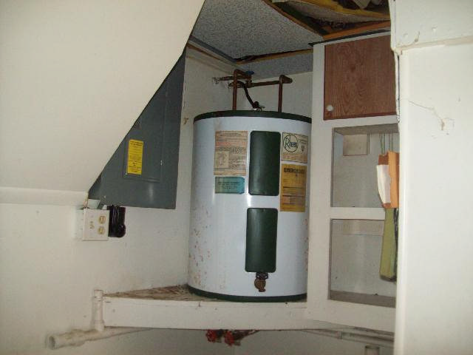
65. Water Heater 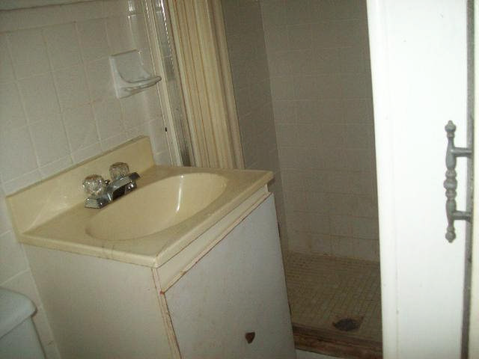
66. Bathroom 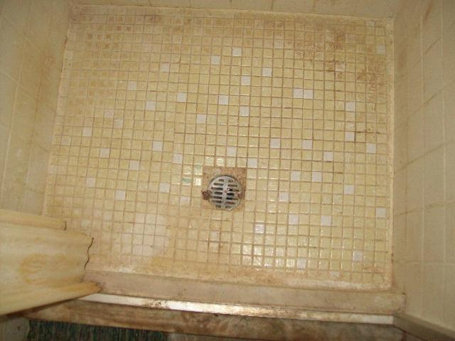
67. Shower Pan 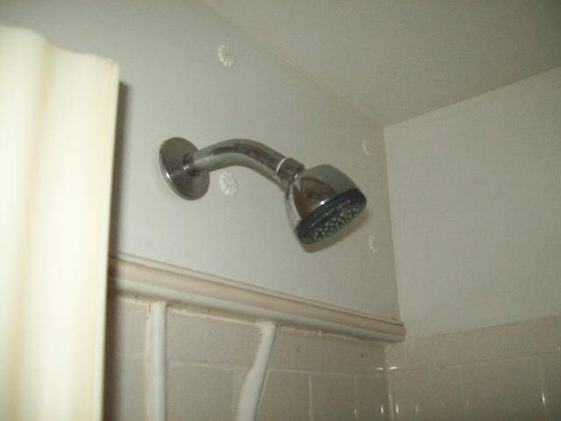
68. Shower Head 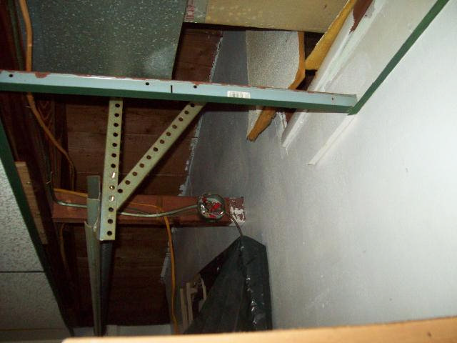
69. Attic 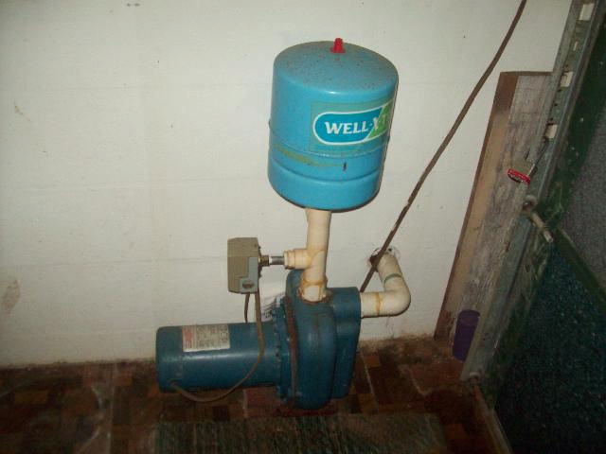
70. Irrigation Pump 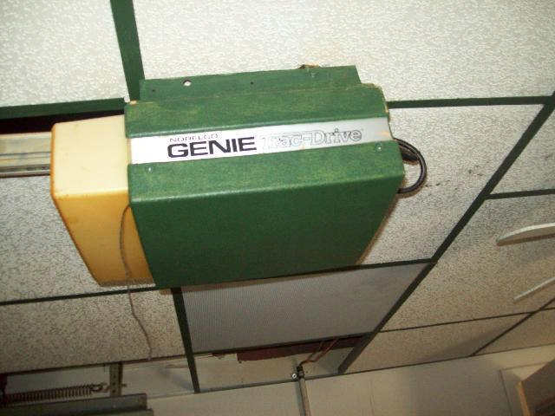
71. Garage Door Opener 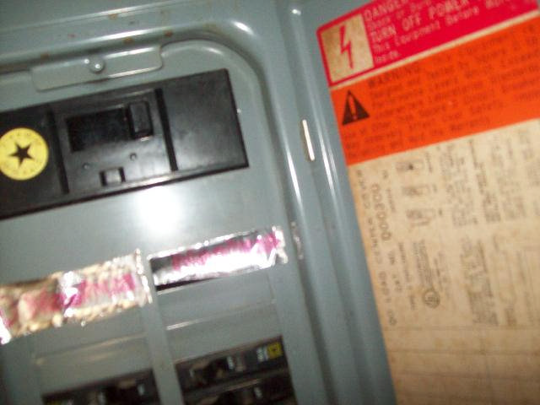
72. Electric Panel

Case Number: 093-601378
26
Snow Enterprises, LLC 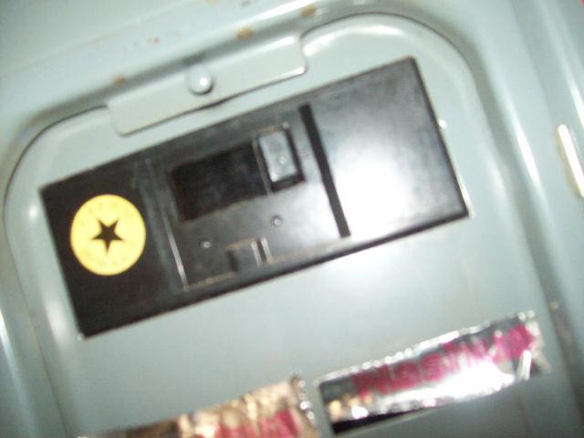
73. Electric Main 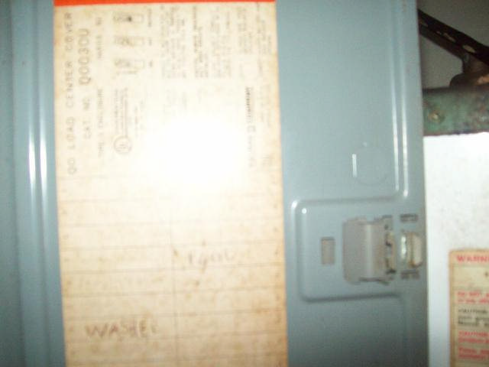
74. Electrical Information 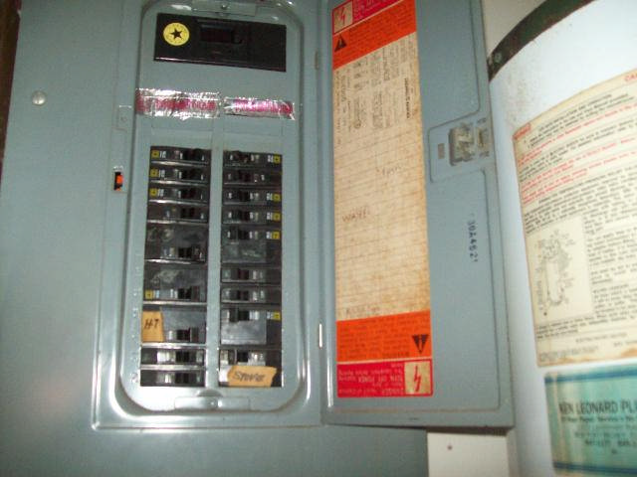
75. Electrical Panel 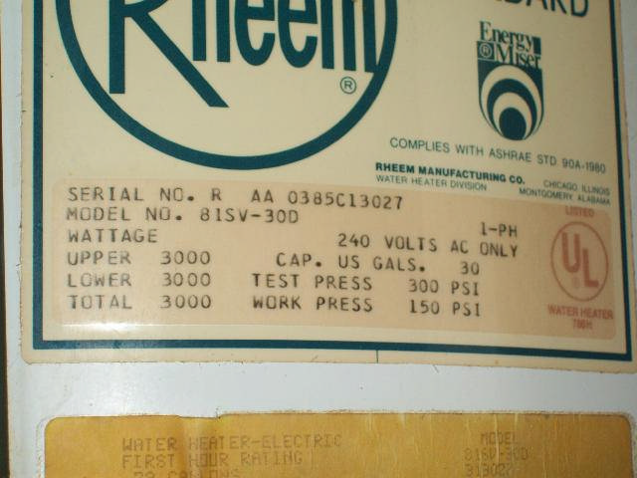
76. Water Heater Information 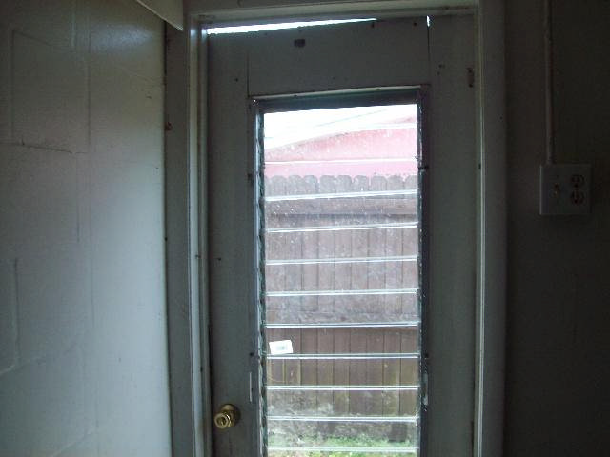
77. Rear Door 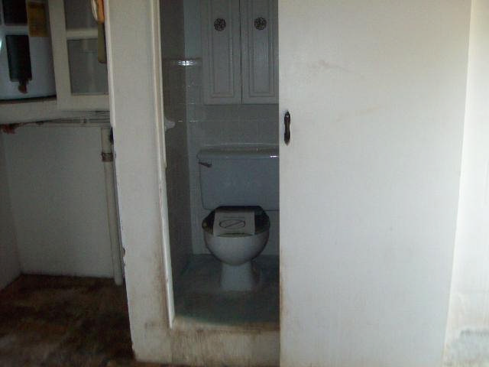
78. Bthroom 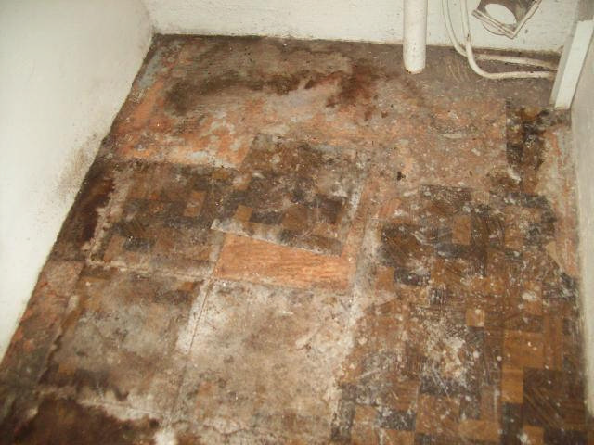
79. Damaged Floor 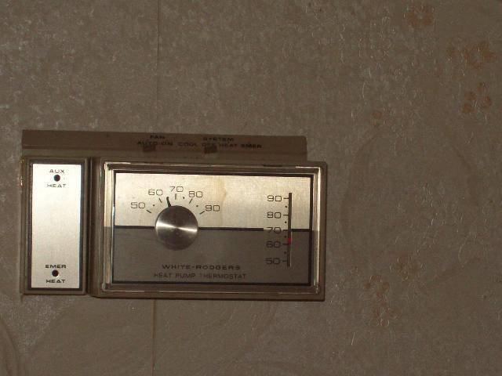
80. Thermostat 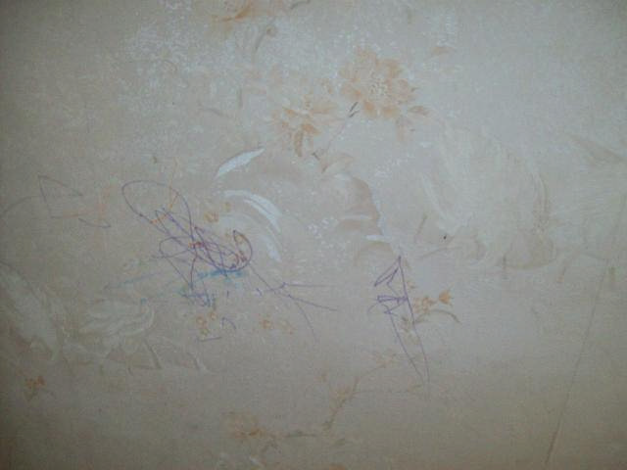
81. Damged Wall 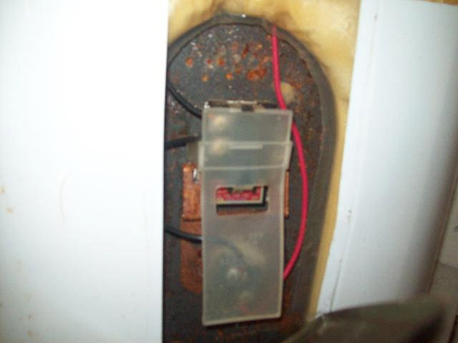
82. Water Heater Control 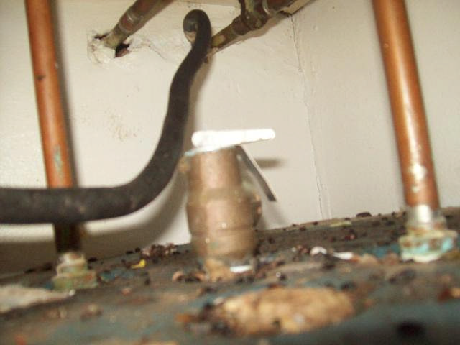
83. Relief Valve 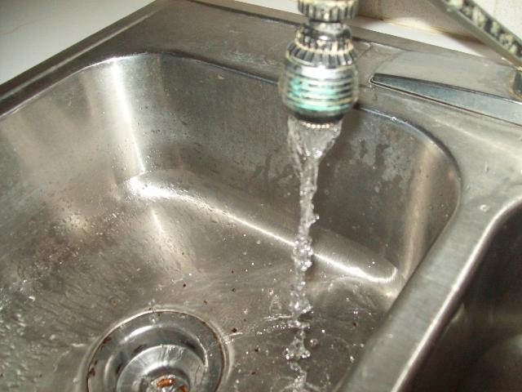
84. Active Water

Case Number: 093-601378
27
Snow Enterprises, LLC 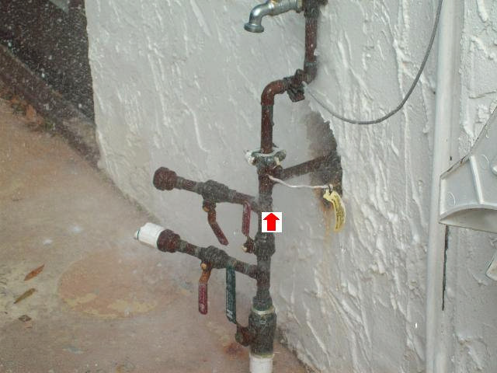
85. Shut Off Leak 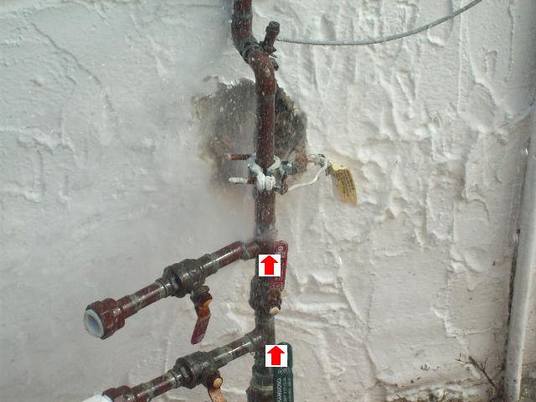
86. Shut Off Leak 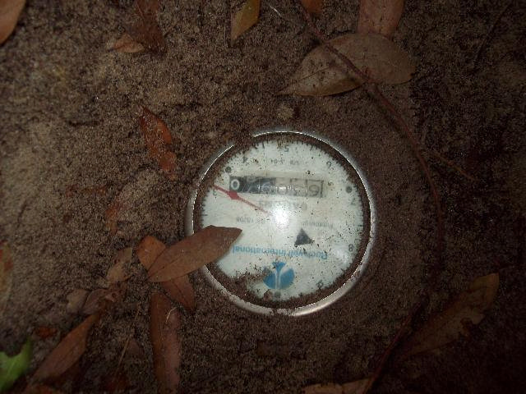
87. Water Meter 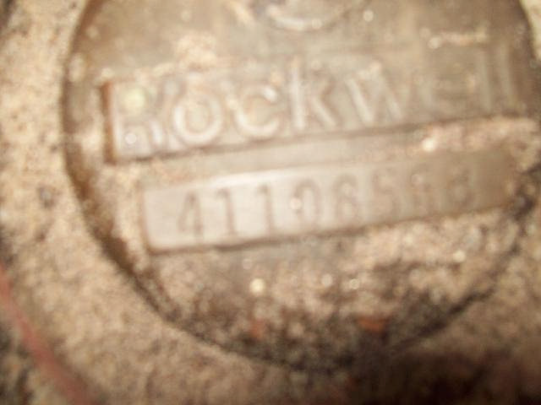
88. Water Meter Serial Number 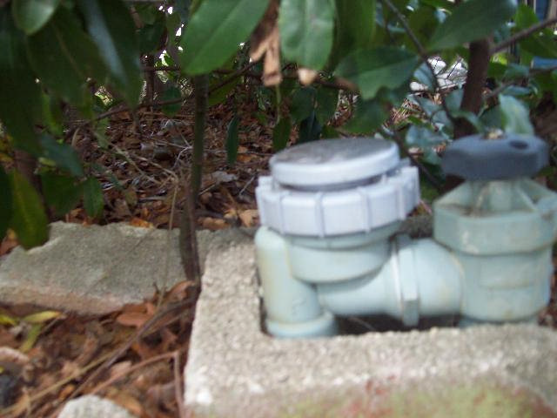
89. Irrigation Vlave 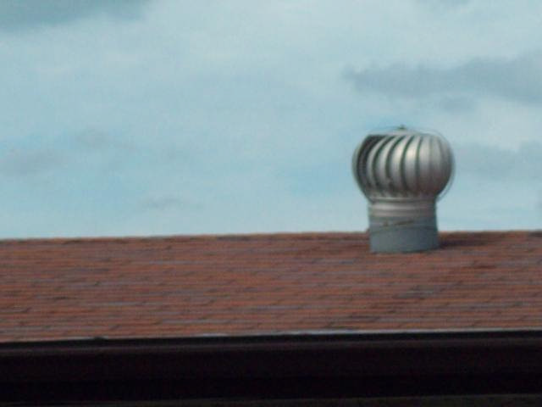
90. Roof 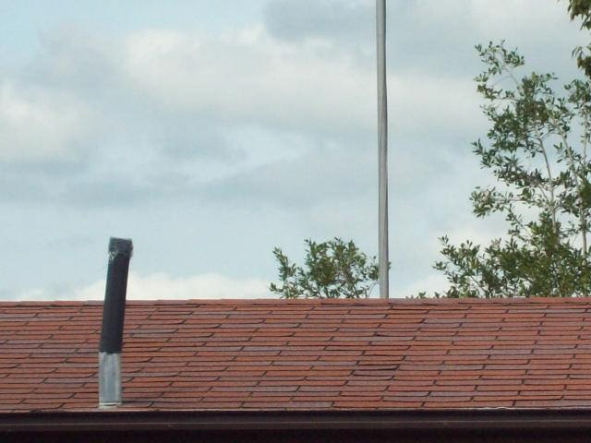
91. Roof 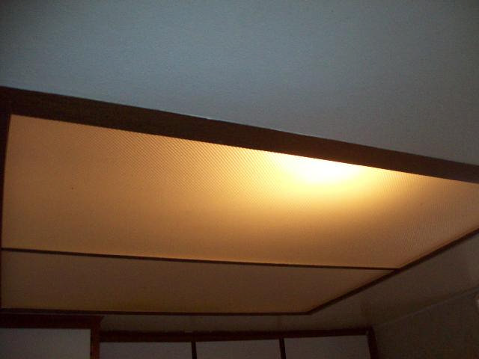
92. Illumination 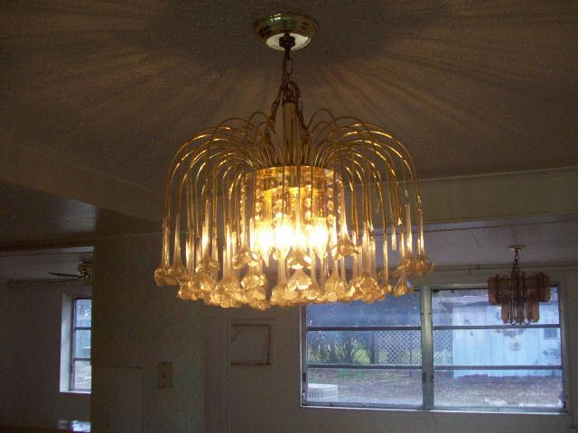
93. Illumination 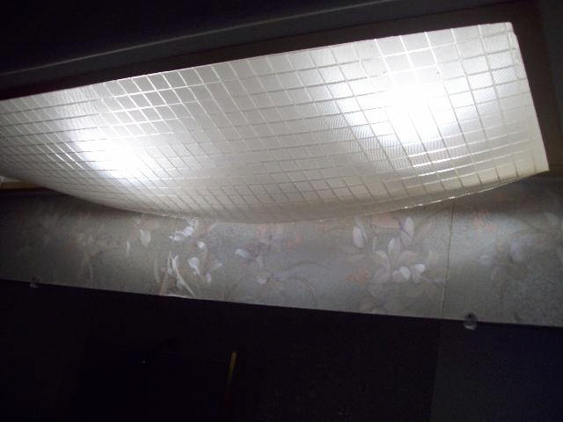
94. Illuminaton 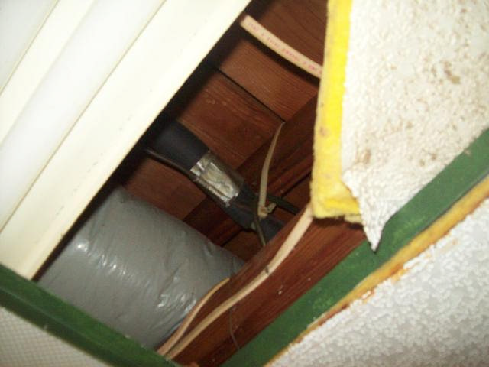
95. Attic 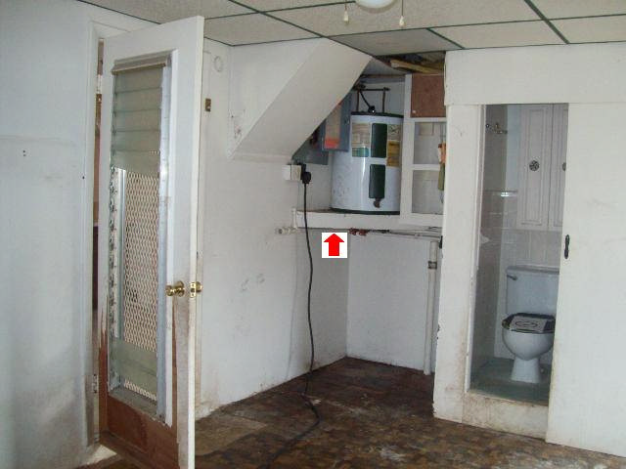
96. Hookup

Case Number: 093-601378
28
Snow Enterprises, LLC 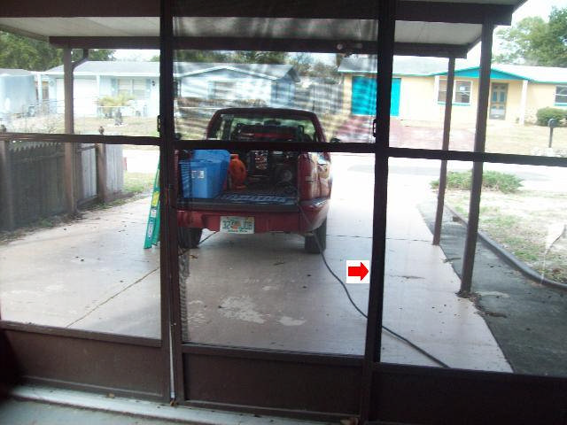
97. Hookup 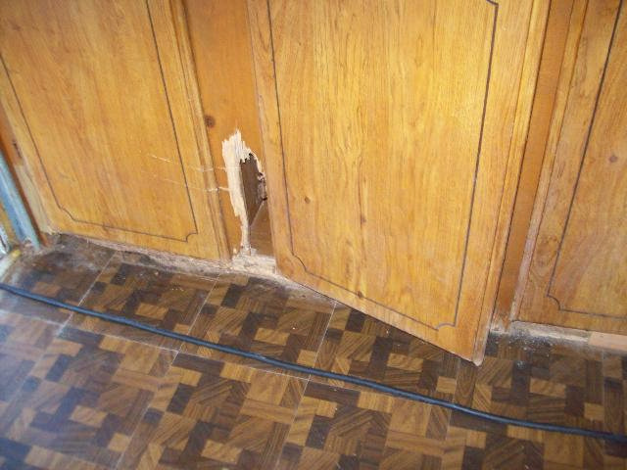
98. Damaged Cabinet 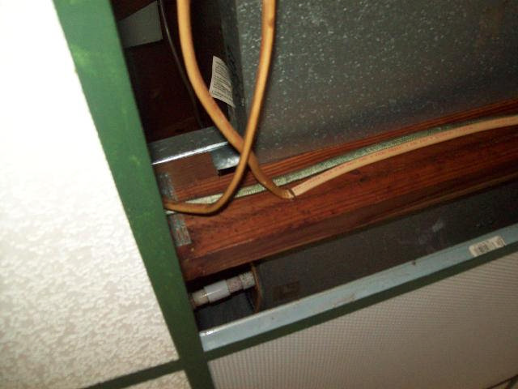
99. Roof 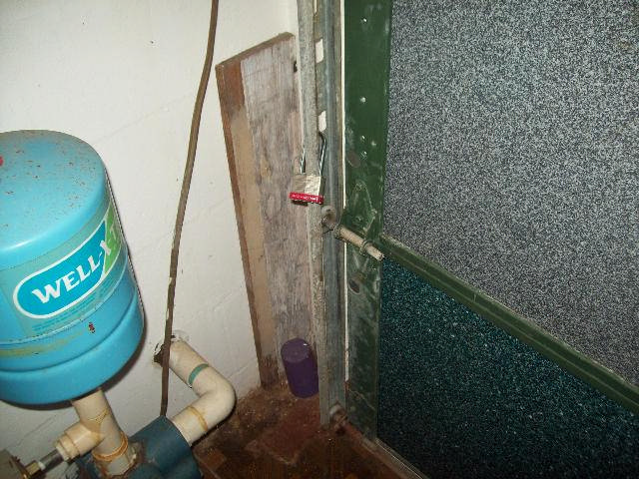
100. Garage Secured 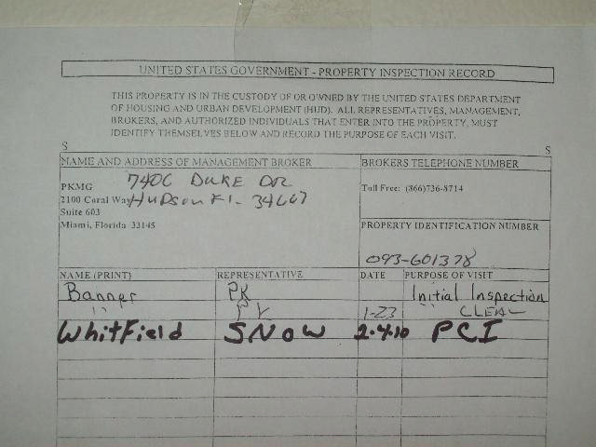
101. Sign In Sheet 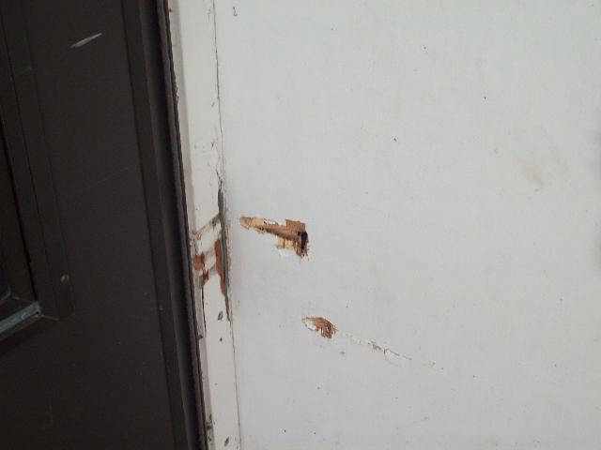
102. Damaged Door 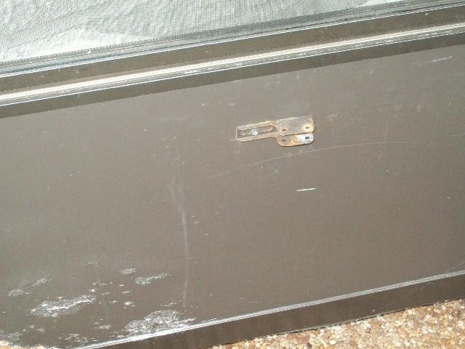
103. Missing Hardware 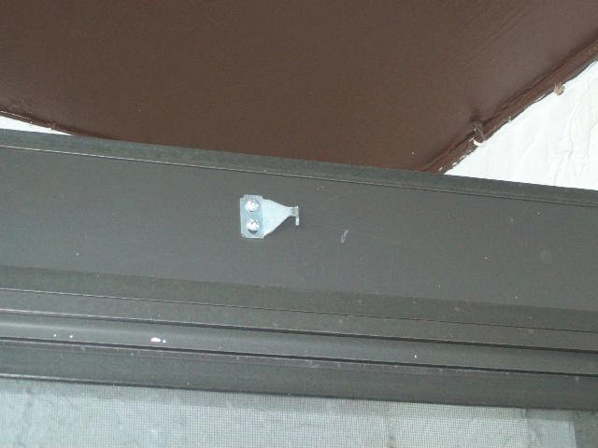
104. Missing Hardware 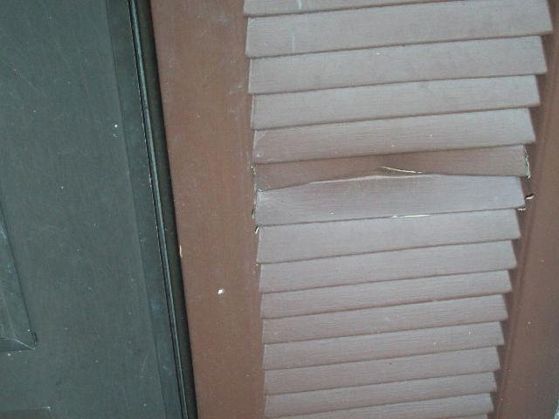
105. Damaged Shutter 
106. Septic Service

