Street Address
Unit Number or Details
City, ST Zip
details/description
Property Address:
Date: January 1, 2005
Time: 12:30 a.m. p.m.
Inspection Report Number:
Customer(s): Customer Name(s)

RESIDENTIAL PROPERTY INSPECTION AGREEMENT
THIS IS A LEGALLY BINDING CONTRACT. CONSULTATION WITH AN ATTORNEY OR OTHER PROFESSIONAL MAY BE APPROPRIATE. THIS AGREEMENT ALSO CONTAINS AN ARBITRATION CLAUSE. PLEASE READ THE ENTIRE AGREEMENT CAREFULLY BEFORE SIGNING.

Customer named above hereby requests a Residential Property Inspection of the primary residence and all appurtenant structures at the above address, to be conducted by the above inspection company (herein referred to as the Inspector), for the Customer’s sole use and benefit. Customer agrees to carefully read the entire Agreement and Inspection Report as they receive them and promptly call the Inspector with any questions Customer may have. To the extent any information discussed in any said oral communications are important to Customer, such discussions shall be incorporated into this Agreement in writing and signed by each of the parties or such discussions shall be superceded by the Inspection Report. Customer warrants that all necessary approvals have been secured for Inspector’s safe entrance onto the subject property.
SCOPE OF SERVICES PROVIDED
The Residential Property Inspection the Inspector will perform for Customer (it being understood and agreed that the person or persons signing this Agreement as “Customer(s)” do so on behalf of all those on whose behalf the Inspection and Report is being obtained) is a non-invasive physical and visual observation of the visible portions of the structures, components, features, systems or items on the property identified and described below. Based on that observation, the Inspector will provide Customer with an Inspection Report. This Agreement and all printed and written statements in the Inspection Report define the limited scope of the Residential Property Inspection and the Inspection Report.
The Inspection Report will inform the Customer of significant visible defects or conditions that were observed at the time of the Residential Property Inspection. The Inspector will not be obligated to comment upon or disclose conditions that are aesthetic in nature.
This Residential Property Inspection is limited to a visual examination of the structures, components, features, systems or items that are normally exposed and readily accessible during the time of the Residential Property Inspection. The Residential Property Inspection does not contemplate or involve the dismantling, removal or moving of any object or portion of the premises. Generally, this means that the following major structures, components, features, systems or items will be observed and evaluated to the extent possible under the circumstances: the building’s foundation; subfloor framing; site drainage as it affects the structure(s); electrical system and equipment; plumbing system and fixtures; heating, ventilation and air conditioning system, controls and ducting; water heating; exterior walls, eaves, windows, doors, trim, and appurtenances; roof and gutters; attic; venting; fireplaces and chimneys; interior walls, ceilings, floors and their coverings, stairs, doors, windows. Additional property features that may be included in the scope of the Residential Property Inspection, if they are within 12 feet of the primary structure(s), include decks, fencing and paving. Any minor defects that may be mentioned in the Inspection Report are included as a courtesy only and in no way expand or redefine the scope. The inspection will be performed in accordance with the Standards of Practice enclosed with this report or otherwise provided to Customer. Inherent, latent and concealed defects and deficiencies are excluded from the Inspection Report. Inspector shall have no liability for defects or conditions in structures, components, features, systems or items which are concealed from view or not readily accessible to the Inspector at the time of the Residential Property Inspection, for whatever reason. Weather conditions at the time of the Residential Property Inspection may limit the inspection of some structures, components, features, systems or items, or the ability of the Inspector to detect defects, damage or potential for problems.
The Residential Property Inspection and Inspection Report thereon is not a warranty, guarantee, or insurance policy. The Residential Property Inspection and Inspection Report are not intended and should not be used as a substitute for or relied upon as real estate transfer disclosures, which may be required by law. Home warranty policies, which include coverage for appliances, electrical, plumbing, heating and air conditioning systems are available, if desired. For information on such insurance, consult a licensed real estate professional. Your use or reference to the Inspection Report may help you identify some deficiencies in the property that is the subject of this Residential Property Inspection, but it cannot, and is not intended to, eliminate all risk.
The Residential Property Inspection and the Inspection Report are limited to the real property and do not include any personal property unless otherwise indicated in this Inspection Report. In the case of those items that are present in multiples in a typical residence, a representative sample of such items (e.g., cabinets, windows, the presence of safety glass in doors and windows, the operation and safety of electrical outlets and switches) is selected and checked. No representation is made as to the remaining useful life of any structure, component, feature, system, equipment or item that is covered by this Residential Property Inspection. Maintenance conditions may be discussed, but they are not a part of this Residential Property Inspection.
The Residential Property Inspection covers only those structures, components, features, systems or items expressly listed in the Inspection Report. Unless specifically agreed in advance between the Inspector and the Customer, the areas, structures, components, features, systems, equipment, items, risks, hazards or conditions excluded from the Residential Property Inspection and Inspection Report include, but are not limited to the following:
1. Evaluating or reporting on compliance or non-compliance with: international, state or local building, use, or zoning codes; ordinances; regulations; covenants; charters or other restrictions; requirements of the federal Americans with Disabilities Act (A.D.A.) and similar state or local laws or regulations. Researching, evaluating or reporting on permits and/or their verification. Researching, evaluating or reporting on compliance or non-compliance with set-backs and easements; rights of way; property boundaries; conditions of title; previous ownership(s), events, use or occupancies relative to the subject property.
2. Seeking, obtaining, evaluating or reporting on information that may be available from any third parties, including but not limited to: sellers, occupants, contractors, consultants, managers, government agencies, attorneys, agents, manufacturers, or homeowner associations. Researching, evaluating or reporting on compliance with manufacturers’ specifications or installation guidelines.
3. Inspecting, testing, evaluating or reporting on common areas or systems, structures or components thereof, including, but not limited to, those systems, structures or components maintained by a homeowners association or similar common management.
4. Inspecting, evaluating or reporting on conditions related to animals, rodents, insects, wood-destroying insects or organisms, mold and mildew, or damage(s) caused thereby.
5. Researching, testing, evaluating or reporting on information and/or conditions pertaining to the history or likelihood of wildfires or floods.
6. Performing or reporting any form of engineering analysis such as: structural, geological, seismic, hydrological stability, or soil condition and/or erosion evaluations; land surveying; or architectural evaluations. Performing or reporting any technically exhaustive or technically specialized inspections, evaluations, or tests of any type. Performing or reporting evaluations regarding the fire-resistive properties of any system, structure or component of the building. Testing, analysis, evaluation or reporting on unique, custom and/or technically complex systems or devices, such as: heat exchangers; solar and radiant heat performance of buildings; insulative performance; remote control systems; light, motion or pressure sensing devices used in conjunction with lighting and/or security systems; security, emergency or fire safety systems (other than smoke alarms); security bars and/or safety/escape equipment; secured, safety or panic rooms and their systems; seismic safety valves or controls; solar heating and/or solar electric systems; air filters and/or air quality systems; radio-, telephone- or computer-controlled devices or systems; automatic timer controls; elevators, lifts and dumbwaiters; satellite dishes; automatic gates, their sensors and controls; clocks, thermostats, etc.
7. Researching, inspecting, testing, evaluating or reporting on information and/or conditions pertaining to environmental and health hazards, concerns or conditions, including, but not limited to: toxic, reactive, combustible and corrosive contaminants, such as asbestos, lead, radon, electromagnetic fields, urea formaldehyde, PCB’s, or chlordane; soil quality or contamination; water quality or contamination; underground storage tanks; proximity or other exposure to toxic waste sites; mold or mildew; organic or inorganic allergens; and chemical sensitizers.
8. Performing or reporting any electrical load calculations. Testing, evaluation or reporting on low voltage electrical systems, such as TV antennae, TV signal cables, telephones, telephone cables and lines, intercoms, security systems and their wiring, speaker wires, automated equipment, landscape lighting, etc. Testing, evaluation or reporting on gas shutoff valves. Inspecting for, detection of, or evaluation or reporting of any active or potential gas leaks.
9. Researching, inspecting, testing, evaluating or reporting on private water or private sewage systems or related equipment, such as wells, septic systems, sewage ejector pumps, water softeners, water purification systems, etc. Researching, inspecting, testing, evaluating or reporting on fire sprinklers. Inspecting, testing, evaluating or reporting on landscaping sprinklers and irrigation systems, except as otherwise noted. Inspecting, testing, evaluating or reporting on swimming pools, spas or hot tubs; fountains, ponds or water features; saunas or steam baths; or similar fixtures and equipment.
10. Researching, inspecting, evaluating or reporting on building or property line measurements, property value appraisal, and costs for any corrective work that might result from information provided in the Inspection Report or otherwise. Inspecting, evaluating or reporting on detached ancillary buildings (except for parking structures if included or as otherwise noted in the Inspection Report).
11. Inspecting, testing, evaluating or reporting on awnings, sun shades/screens, window films or coatings, sealed multi-pane window systems, storm windows, storm doors, shutters, and other such accessories.
12. Evaluating or reporting on the adequacy, efficiency, durability or quality of any system, structure or component. Researching, identifying or reporting on any product recalls, reported defects, or similar notices. Researching, inspecting, identifying or reporting on inherent or latent defects or known impairments to the useful life expectancy of systems, structures or components.
13. Inspecting, testing, evaluating or reporting on appliances and systems, structures, or components that are not permanently installed and are not typically sold as part of a residential property. Inspecting, testing, evaluating or reporting on window-mount or through-the-wall air conditioners or gas-powered air conditioners. Inspecting, testing, evaluating or reporting on gas and electrical appliances such as fire pits, barbecues, outside heaters and lamps.
14. Researching, evaluating or reporting on the desirability, advisability of purchase, the fair market value, or the current or potential marketability of the subject property. Examining, testing, evaluating or reporting on noise, vibration, odor, light or other nuisance characteristics of any system, structure, or component on the subject property, or of any adjoining or nearby property, neighborhood or region. Researching, evaluating or reporting on regional weather patterns or animal migratory habits, and/or their potential effects on the subject property and its desirability, marketability or enjoyment. Researching, identifying, testing, evaluating and/or reporting on any condition located off the subject property that may adversely affect the desirability, marketability or enjoyment of the property, including, but not limited to: railroad tracks and yards; roadways and highways; agricultural, commercial and industrial establishments; and airplane routes or airports.
15. Inspecting, evaluating or reporting on cosmetic finishes and/or their condition, trees, lawns, landscaping and plants.
16. Items specifically noted as excluded in the Inspection Report or items not specifically identified as included in the Inspection Report.
Inspecting and reporting on some of the excluded items listed above may be available from Inspector for an additional fee.
INSPECTOR QUALIFICATIONS
Customer understands that the Inspector is a generalist, with only a general and non-specialized knowledge of residential property construction and related fields. The Inspector is not and does not represent him/herself as an expert in any specific field unless otherwise indicated in writing. The Residential Property Inspection and the Inspection Report provides the Customer with an independent evaluation of the subject property, based upon the experience of the individual Inspector. The Inspection Report identifies general, visible conditions that are believed to currently affect the subject property. The Inspector may recommend specialized experts for further evaluations or repairs; the decision to contact and employ any such experts is at the Customer’s sole discretion and expense. Customer’s failure to consult specialized experts as recommended by the Inspector or as would otherwise be prudent under the circumstances shall absolve the Inspector of all liability.
INDEMNITY
Customer shall ensure that all portions of the subject property to be made available to Inspector shall be in a condition suitable for safe entry and/or other safe access including but not limited to the removal of any potentially dangerous animals. Customer further warrants that Inspector shall have all lawful right to enter upon the subject property. Customer shall defend, indemnify and hold harmless Inspector from and against any injury, loss, damage, claims, penalties, fines, and/or other liability incurred as a result of any breach of the foregoing, any breach of any other representation, warranty or agreement on the part of Customer, the condition of the subject property, and/or any negligent act or omission by or on behalf of Customer. The foregoing defense, indemnity and hold harmless in favor of Inspector shall supersede any waiver by Inspector of damages, consequential or otherwise, elsewhere herein provided.
SEVERABILITY
Should a court of competent jurisdiction determine that any portion of this contract is void or unenforceable, the remaining provisions shall remain in full force and effect.
COPIES/CONFIDENTIALITY
The Inspection Report is confidential and is provided by the Inspector solely and exclusively for the private use of the Customer. Customer may provide copies of the Inspection Report to other party(ies) for informational purposes and real estate agent/broker(s) directly involved in a transaction involving the subject property; otherwise, Customer agrees not to loan, transfer, copy, transmit or disseminate it to any third party (including but not limited to lenders and insurance companies) without the express written consent of the Inspector. Any copy of the Inspection Report provided to any third party with such consent shall be complete, unaltered, and shall include this Agreement.
DISPUTE RESOLUTION
Customer understands and agrees that any claim for failure to accurately report any defect or condition in the subject property, as limited herein above, shall be made in writing and reported to the Inspector within 10 business days of discovery by the Customer, and Customer shall take all reasonable and prudent measures to prevent damage or loss. Inspector agrees to respond within 10 business days after actual receipt of any such notice. Customer and Customer’s agents, employees or independent contractors shall make no alterations, repairs or replacements to the reported condition that is the subject of the notice prior to a reinspection by the Inspector and/or the Inspector’s designated representative(s). Customer waives any and all claims relating to conditions that are altered or repaired without said notice or reinspection.
MEDIATION
Any dispute, controversy, interpretation of, or claims of any kind or nature whatsoever, including, but not limited to, claims for breach of contract, any form of negligence, fraud or misrepresentation arising out of, from, or related to this contract or arising out of, from, or related to the Residential Property Inspection and Inspection Report shall be submitted to mediation as the initial venue for dispute resolution. The mediation will be non-binding.
ARBITRATION
If mediation proves unsuccessful in resolving a dispute, controversy, or claim of any type as described above, said claim shall be submitted to final and binding arbitration under the Rules and Procedures of the American Arbitration Association. The Arbitrator shall be knowledgeable in the business of residential property inspections, shall have at least five (5) years experience as a home and building inspector, and be a member in good standing of a recognized association of professional property inspectors, as evidenced by his/her date of full membership. An arbitrator must be selected within one (1) month’s time from the request for arbitration. The accepted standard against which the Residential Property Inspection shall be judged is the “Standards of Practice” of that professional association in effect at the time of the inspection. The decision of the Arbitrator shall be final and binding, and judgment on the award may be entered in any Court of competent jurisdiction. By initialing immediately below, I certify that I have read, understood, and agree to this provision, and herewith waive my right to a trial.
CUSTOMER’S INITIALS: ______ / ______
STATUTE OF LIMITATIONS
THE PARTIES AGREE THAT NO LEGAL ACTION OR PROCEEDING OF ANY KIND, INCLUDING THOSE SOUNDING IN TORT OR CONTRACTS MAY BE COMMENCED AGAINST THE INSPECTOR OR THE INSPECTION COMPANY, OR ITS OFFICERS, AGENTS OR EMPLOYEES MORE THAN ONE YEAR AFTER THE DATE OF THE SUBJECT RESIDENTIAL PROPERTY INSPECTION. TIME IS EXPRESSLY OF THE ESSENCE HEREIN. CUSTOMER(S) UNDERSTAND(S) THAT THIS TIME PERIOD MAY BE SHORTER THAN OTHERWISE PROVIDED BY LAW. BY INITIALING IMMEDIATELY BELOW, I CERTIFY THAT I HAVE READ, UNDERSTOOD, AND AGREE TO THIS PROVISION.
CUSTOMER’S INITIALS: ______ / ______
WAIVER OF CONSEQUENTIAL AND PUNITIVE DAMAGES; LIQUIDATED DAMAGES
IT IS UNDERSTOOD AND AGREED TO BY THE PARTIES HERETO THAT THE INSPECTOR IS NOT AN INSURER, THAT THE PAYMENT FOR THE RESIDENTIAL PROPERTY INSPECTION AND INSPECTION REPORT IS BASED SOLELY ON THE VALUE OF THE SERVICE PROVIDED BY THE INSPECTOR IN THE PERFORMANCE OF THE LIMITED VISUAL RESIDENTIAL PROPERTY INSPECTION AND PRODUCTION OF THE INSPECTION REPORT AS DESCRIBED HEREIN, THAT IT IS IMPRACTICABLE AND EXTREMELY DIFFICULT TO FIX ACTUAL DAMAGES, IF ANY, WHICH MAY RESULT FROM A FAILURE TO PERFORM SUCH SERVICES, AND IN THE CASE OF FAILURE TO PERFORM SUCH SERVICES AND A RESULTING LOSS, INSPECTOR’S LIABILITY HEREUNDER SHALL BE LIMITED AND FIXED IN AMOUNT EQUAL TO THE INSPECTION FEE MULTIPLIED BY FOUR AS LIQUIDATED DAMAGES, AND NOT AS A PENALTY, AND THIS LIABILITY SHALL BE EXCLUSIVE. FURTHERMORE, EXCEPT AS OTHERWISE HEREIN EXPRESSLY PROVIDED, AS MATERIAL CONSIDERATION HEREUNDER, THE PARTIES EACH WAIVE AGAINST THE OTHER, ALL DAMAGES OF A CONSEQUENTIAL NATURE AS WELL AS ALL THOSE WHICH MAY BE CHARACTERIZED OR DEEMED PUNITIVE OR EXEMPLARY. BY INITIALING IMMEDIATELY BELOW, I CERTIFY THAT I HAVE READ, UNDERSTOOD, AND AGREE TO THIS PROVISION.
CUSTOMER’S INITIALS: ______ / ______
ACCEPTANCE
The Inspection Report shall be considered the final and exclusive findings of the Inspector regarding the Residential Property Inspection. Customer shall not rely on any oral statements made by the Inspector prior to or incident to issuance of the written Inspection Report.
All the provisions, limitations, exceptions and exclusions of this agreement shall apply to any optional services that Customer requests and Inspector provides.
Each party signing this Agreement warrants and represents that he/she has the full capacity and authority to execute this Agreement. This Agreement shall be binding upon and inure to the benefit of the parties hereto, their heirs, successors, and assigns however this Agreement may not be enforced by or on behalf of any alleged third party beneficiary. This Agreement and the printed terms, descriptions, conditions, limitations, exceptions and exclusions contained in the printed Inspection Report constitute the entire agreement between the parties hereto pertaining to the subject matter hereof, and may be modified only by a mutual written agreement signed by the Customer and the Inspector. No oral agreements, understandings, or representations shall in any way modify this Agreement.

INSPECTION COMPANY (“Inspector”)

Property Inspection Fee:
Additional Fees:
TOTAL:

Paid: Cash
Check: Check #
Credit Card
 Visa  MasterCard Amex  Discover
Card No.
Expiration Date
Customer acknowledges that he/she/they have read and understood all the terms, conditions and limitations of this Agreement. The Customer agrees to be bound thereby, and in consideration for the services provided by Inspector, the Customer agrees to pay the Property Inspection Fee listed above. Customer specifically acknowledges and agrees to the mediation, arbitration, waiver of jury trial, waiver of consequential and punitive damages, and liquidated damages provisions hereof.

Customer X Date:
Customer X Date:

Inspector X Date:

SPECIAL COMMENTS:

Concrete
Bricks/Pavers
Railroad Ties
Asphalt
Flagstone
Pop-ups
Drip
Impulse
Automatic Timer
Concrete
Asphalt
Brick
Other
Concrete
Block
Brick
Wood
Other

Concrete
Block
Brick
Other
Wood
Chain Link
Masonry
Wrought Iron
Other

Concrete
Bricks/Pavers
Flagstones
Other
Concrete
Brick
Wood
Other
Covered Roof
Open Design
Wood
Other
Concrete
Bricks/Pavers
Wood
Other
GROUNDS
ITEM / AREA | GOOD | FAIR | POOR | N/A | COMMENTS
Walkways
Driveways
Retaining Walls / Planters
Sprinkler / Irrigation System
Property Walls
Fences and Gates
Patio (Rear)
Porch (Front)
Patio Cover
Exterior Lighting
Exterior Electrical Outlet(s) |  |  |  |  | G.F.C.I.: Yes No
Drainage
Stairs
NOTES / COMMENTS / RECOMMENDATIONS
GROUNDS
WALKWAYS
SPRINKLER/ IRRIGATION SYSTEM
DRIVEWAYS
RETAININGWALLS
PROPERTYWALLS
FENCES AND GATES
PATIOS (REAR)
PORCH FRONT
PATIO COVER
STAIRS

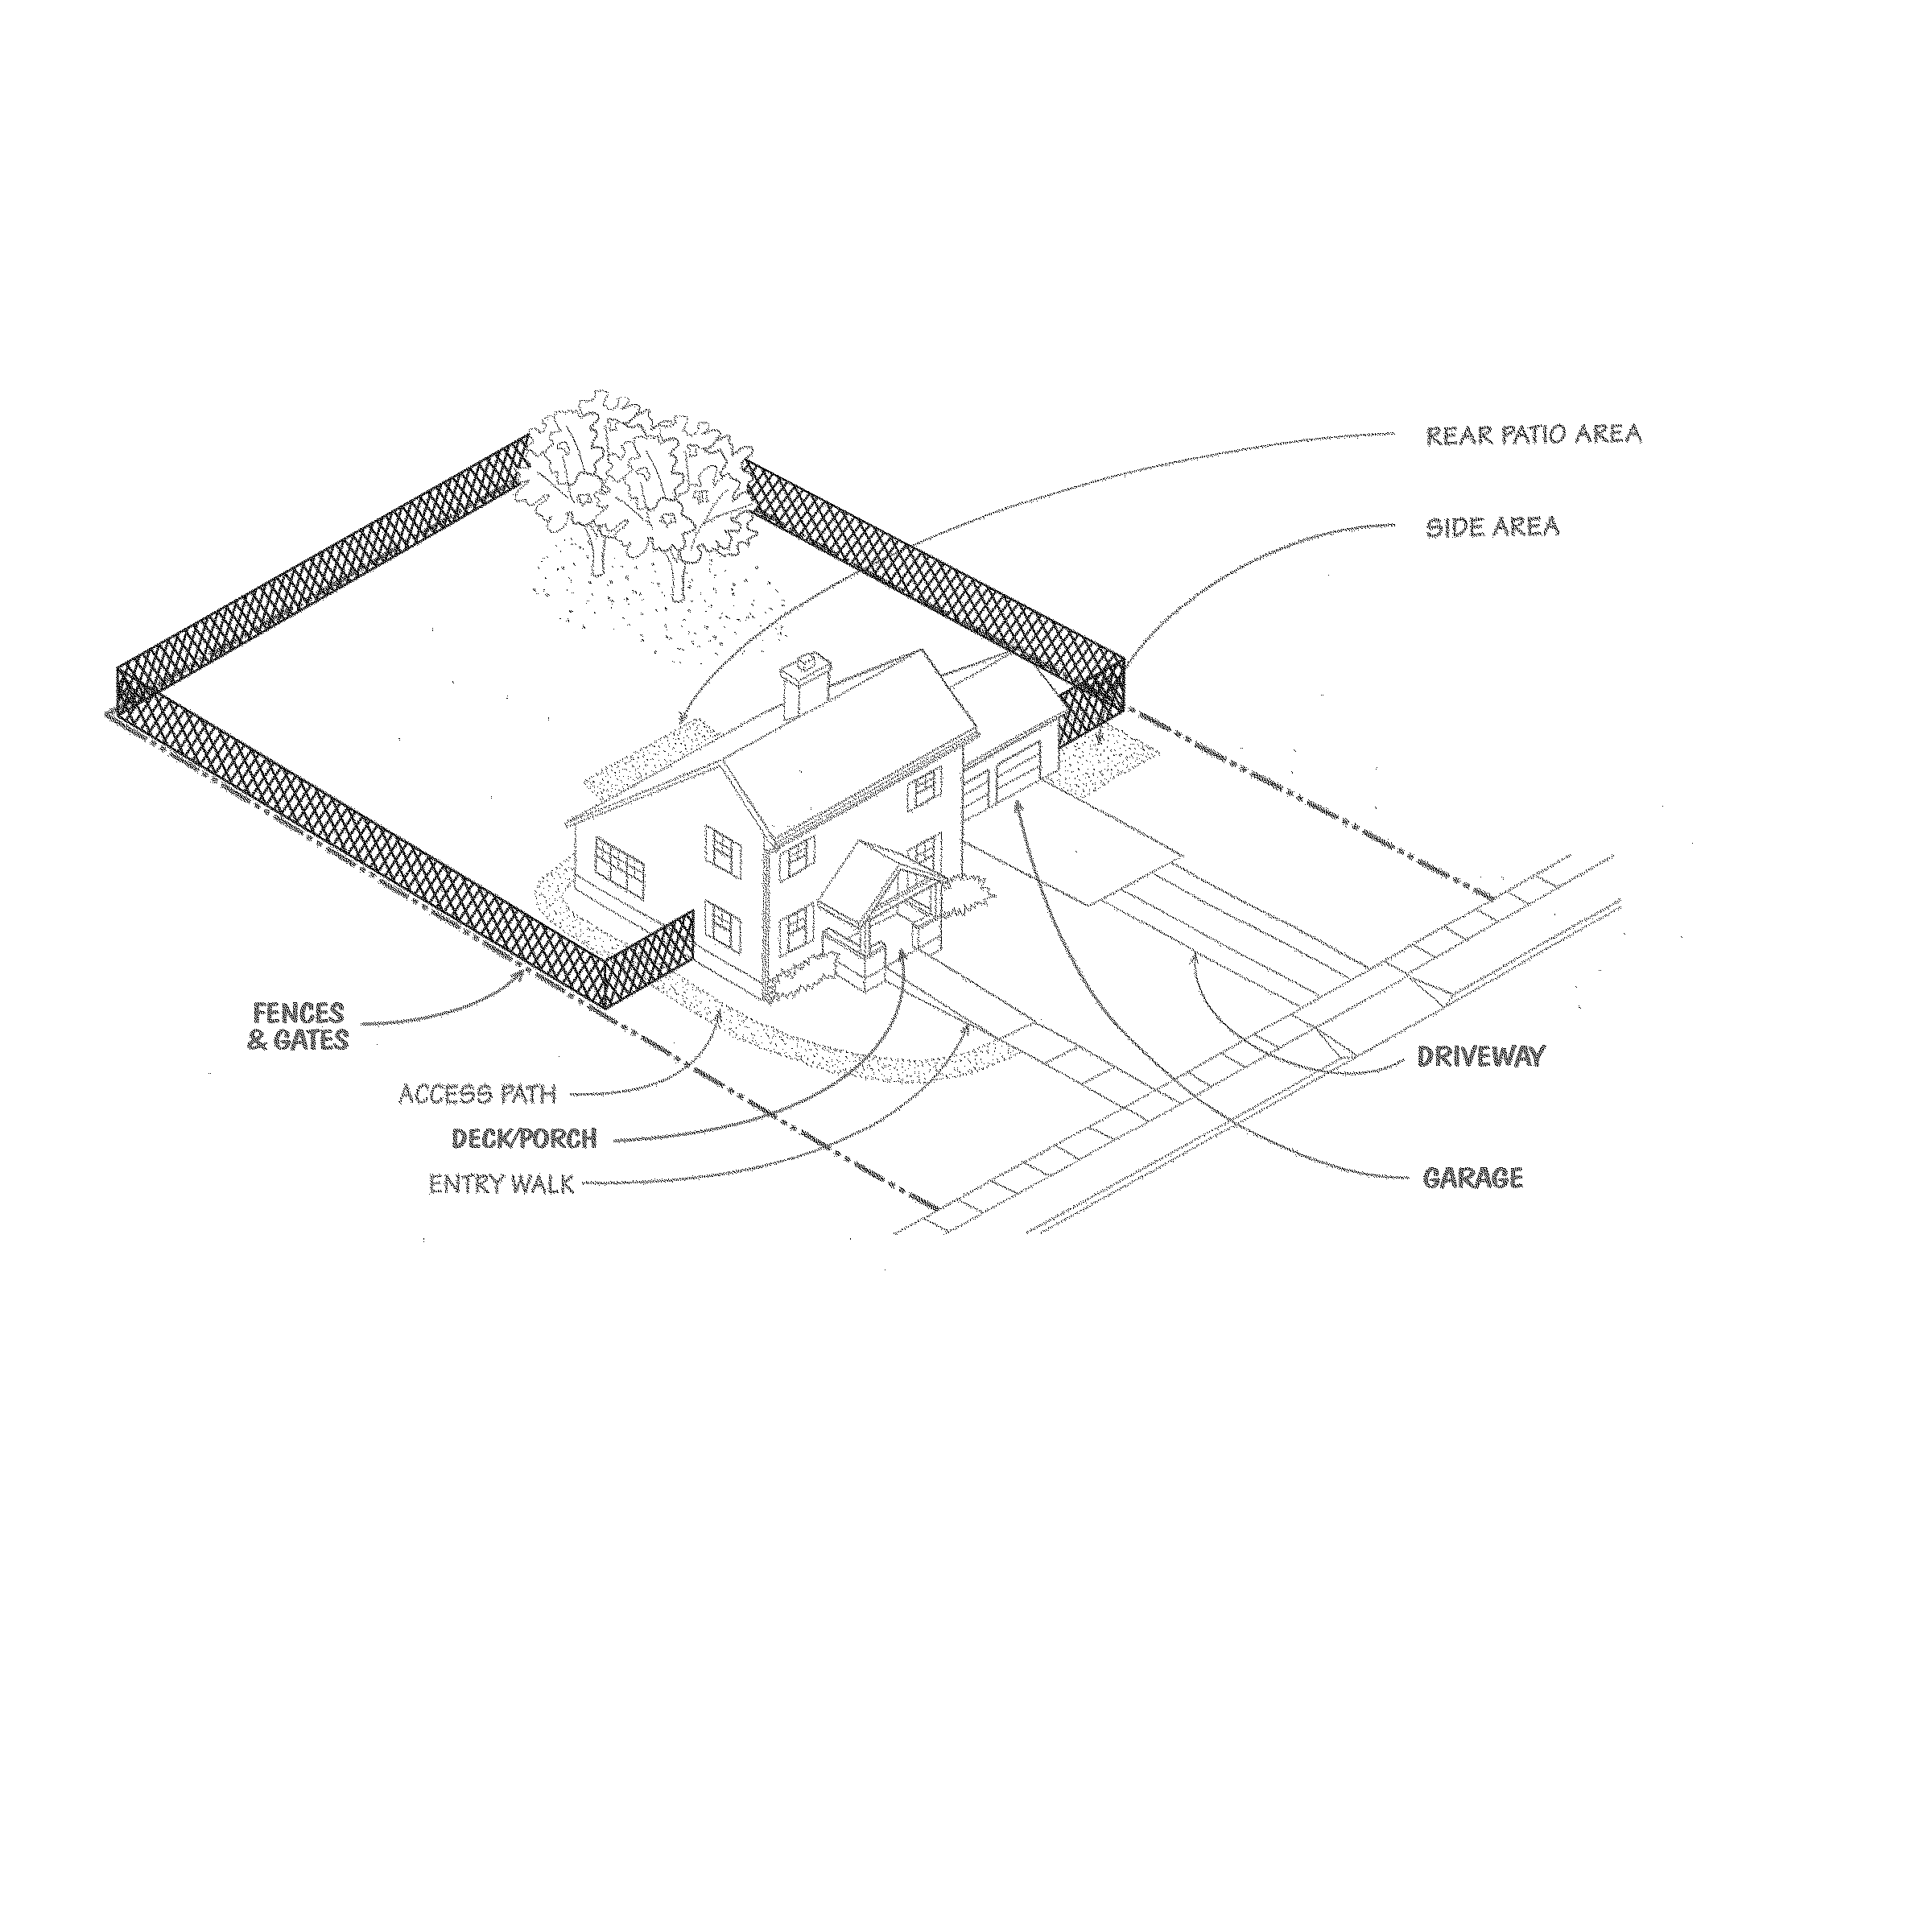
GROUNDS
Limitations/Exclusions
Except as otherwise and expressly stated in this INSPECTION REPORT, only those items, systems, structures or components that are listed in the INSPECTION REPORT have been reviewed or evaluated. Grounds are inspected only for their possible impact on the primary structure(s) which is/are the focus of this INSPECTION REPORT. In the context of GROUNDS section of this report, the items, systems, structures or components EXCLUDED from this RESIDENTIAL PROPERTY INSPECTION include, but are not limited to: the adequacy and effectiveness of drainage; appropriateness, health or condition of plantings; lighting and other electrical systems/devices used in landscaping; and fences or gates on lots greater than 1/3 acre. Refer to the Agreement under which this RESIDENTIAL PROPERTY INSPECTION was performed for additional conditions, limitations, exceptions and exclusions.

Aluminum/Steel
Wood
Single Glazed
Stucco
Wood Lab/T&G
Brick/Block
Wood Shingles
Stone
Asbestos Cement
Concrete
Metal/Vinyl
Other

Double Glazed
Double Hung
Glass Block
Fixed (Picture)
Casement
Sliders
Swing-Out
Jalousie/Louvered
Bay
Garden
Skylight(s)
Crank Operated
Other

Solid Core
Metal
Glass (lg & sm)
French Door
Security Door
Wood
Stucco
Metal
Other

Appear intact
Not fully visible
N/A
Repairs needed as noted (see Recommendations below)
Bricks
N/A
Masonry
Stucco
Spark Arrester
Combustion Air
EXTERIOR / SUBSTRUCTURE
ITEM / AREA | GOOD | FAIR | POOR | N/A | COMMENTS
Exterior Walls
Glass and Windows
Skylights
Exterior Doors
Garden Window
Balcony(s)
Crawl Space
Ventilation/Vents
Plumbing
Chimney(s)
Eaves / Fascia
Gutters / Roof Drain
NOTES / COMMENTS / RECOMMENDATIONS
EXTERIOR
EXTERIORWALLS
WINDOWS / GLASS / SKYLIGHTS
EXTERIOR DOORS
EAVES / SOFFITS / FASCIAS / RAKE
EAVES
CHIMNEY

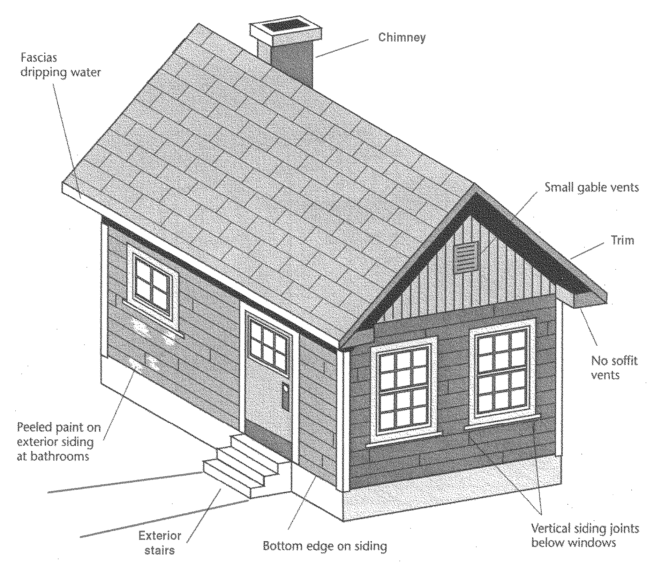
EXTERIOR
Limitations/Exclusions
Except as otherwise and expressly stated in this INSPECTION REPORT, only those items, systems, structures or components that are listed in the INSPECTION REPORT have been reviewed or evaluated. In the context of the EXTERIOR section of this report, the items, systems, structures or components EXCLUDED from this RESIDENTIAL PROPERTY INSPECTION include, but are not limited to: those portions of decks, balconies or patios where carpeting or furnishings prevented visual inspection; portions of exterior walls that are obscured from visual inspection by plants, adjacent structures, fences, latticework, shutters, awnings, etc. Refer to the Agreement under which this RESIDENTIAL PROPERTY INSPECTION was performed for additional conditions, limitations, exceptions and exclusions.

Full Basement
Post & Piers / Post & Beams
Concrete
Entire Building
Concrete Block
Partial Building
Brick
Other
Stone
Slab on Grade

Crawl Space
Fully Traversed
Ventilation/Vents
Partially Traversed
Partial Basement
Combination
FOUNDATION
ITEM / AREA | GOOD | FAIR | POOR | N/A | COMMENTS
Foundation Walls
Foundation Slab
Sub-Flooring
Crawl Space
Sill Plates
Anchor Bolting
Post & Beam
Floor Joists
Ventilation / Vents
Electrical
Plumbing
Ducting
Basement
Basement Floor
Stairs
Insulation
NOTES / COMMENTS / RECOMMENDATIONS
FOUNDATION
PERIMETER FOUNDATION
RAISED SUB-FLOORING

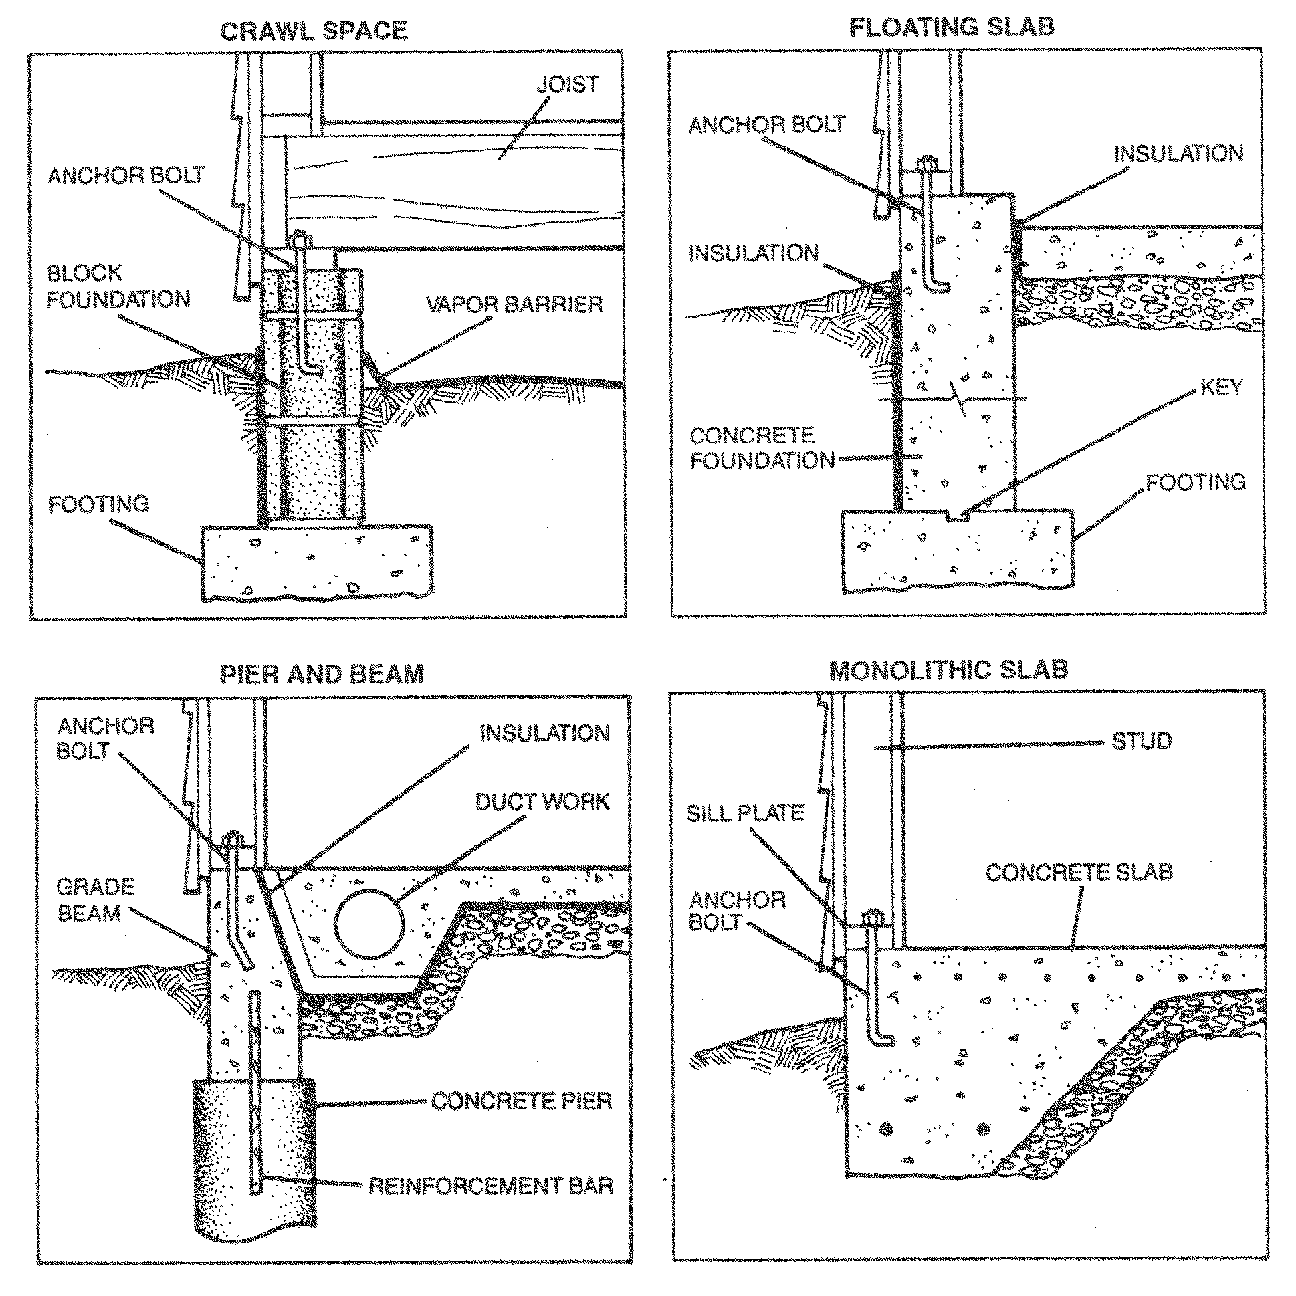
FOUNDATION
Limitations/Exclusions
Except as otherwise and expressly stated in this INSPECTION REPORT, only those items, systems, structures or components that are listed in the INSPECTION REPORT have been reviewed or evaluated. In the context of the FOUNDATION section of this report, the items, systems, structures or components EXCLUDED from this RESIDENTIAL PROPERTY INSPECTION include, but are not limited to: slab foundation obscured by floor coverings; normal slab cracking due to shrinkage/drying; posts, columns, piers, anchors, and other floor framing and foundation components that are inaccessible to ready inspection; possibility or likelihood for soil movement, soil instabilities, seismic risks, or other geologic conditions; improper or inadequate surface water and French drains; drainage problems or leakage in basements or crawlspaces; adequacy of sump pump(s); presence and adequacy of anchor bolts due to finished walls and other obstructions. Refer to the Agreement under which this RESIDENTIAL PROPERTY INSPECTION was performed for additional conditions, limitations, exceptions and exclusions.

Single
Double
None
Attached
Semi-Detached
Detached
Multiple

Carport
Asphalt shingles
Tile
Metal
Wood Shake/Shingles
Polyurethane foam
Rolled roofing
Rock over rolled roofing
Roll-up
Automatic opener
Tilt-up
Wood
Sliding
Aluminum
Hinged door
GARAGE/CARPORT
ITEM / AREA | GOOD | FAIR | POOR | N/A | COMMENTS
Exterior Wall
Foundation: Wall
Foundation: Floor/Slab
Flooring Material
Anchor Bolting
Roof Area
Exterior Door
Vehicle Door
Hardware / Springs
Walls and Ceiling
Interior Wall (fire wall)
Interior Door (fire door) |  |  |  |  | Self-Closing Safety Feature: Yes No
Electrical |  |  |  |  | G.F.C.I.: Yes No
Plumbing
Window
Ventilation /Vents
Automatic Openers |  |  |  |  | Auto-Reverse Safety Feature: Yes No
NOTES / COMMENTS / RECOMMENDATIONS
GARAGE/CARPORT
GARAGE
ROOF AREA (TYPE)
VEHICLE DOOR (TYPE)

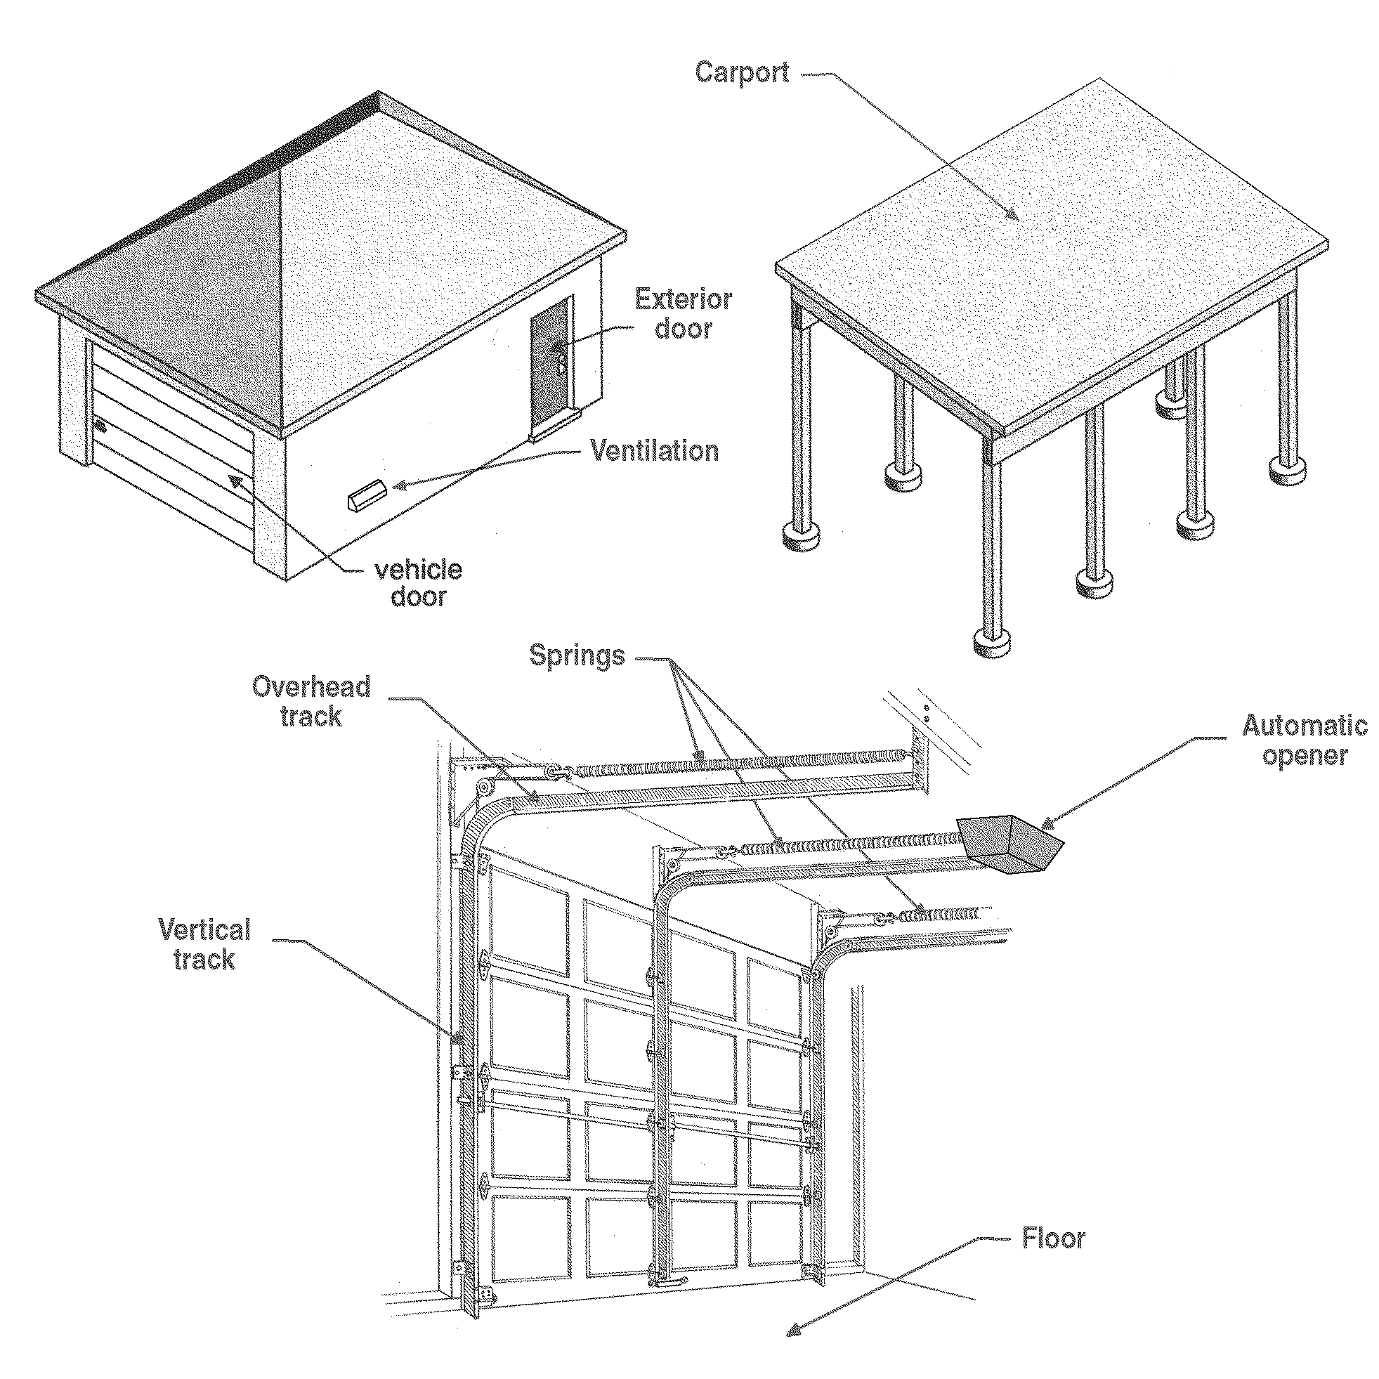
GARAGE/CARPORT
Limitations/Exclusions
Except as otherwise and expressly stated in this INSPECTION REPORT, only those items, systems, structures or components that are listed in the INSPECTION REPORT have been reviewed or evaluated. In the context of the GARAGE/CARPORT section of this report, the items, systems, structures or components EXCLUDED from this RESIDENTIAL PROPERTY INSPECTION include, but are not limited to: non-visible or inaccessible interior and exterior structure and finish elements, including walls, doors and windows, due to storage, other structures or plants; adequacy of drainage away from garage; condition of garage floor obscured or inaccessible because of flooring materials, storage, etc.; fire rating of the firewall (garage wall directly adjacent to living spaces); estimate or opinion regarding remaining useful life of the automatic door opener. Refer to the Agreement under which this RESIDENTIAL PROPERTY INSPECTION was performed for additional conditions, limitations, exceptions and exclusions.

Shed
Single Ply
Gable
Hip
Mansard
Flat / Low-Slope
Asphalt Shingles
Tar & Gravel
Metal Ribbed
Composition Shingles
Rolled Roofing
Wood Shake/Shingles
Concrete
Clay
Tile
Slate
Metal
Vinyl
Copper
None observed
Other:
Aluminum
Galv. steel
Copper
Vinyl
Built-In
Scupper Drain
Complete
Partial
None

ROOF/DECK
ITEM / AREA | GOOD | FAIR | POOR | N/A | COMMENTS
Condition
Flashing
Gutters
Downspouts
Style:
Style:
Chimney
Flat / Low Slope
Vents /Vent Caps
Skylights
Method of Observation: Fully Traversed Viewed from Ladder Viewed from Ground
NOTES / COMMENTS / RECOMMENDATIONS
ROOF
ROOF STYLE
ROOF COVERING
NOTE: Roofs of these materials are often not walked upon, to avoid causing damage.
FLASHING
GUTTERS / DOWNSPOUTS

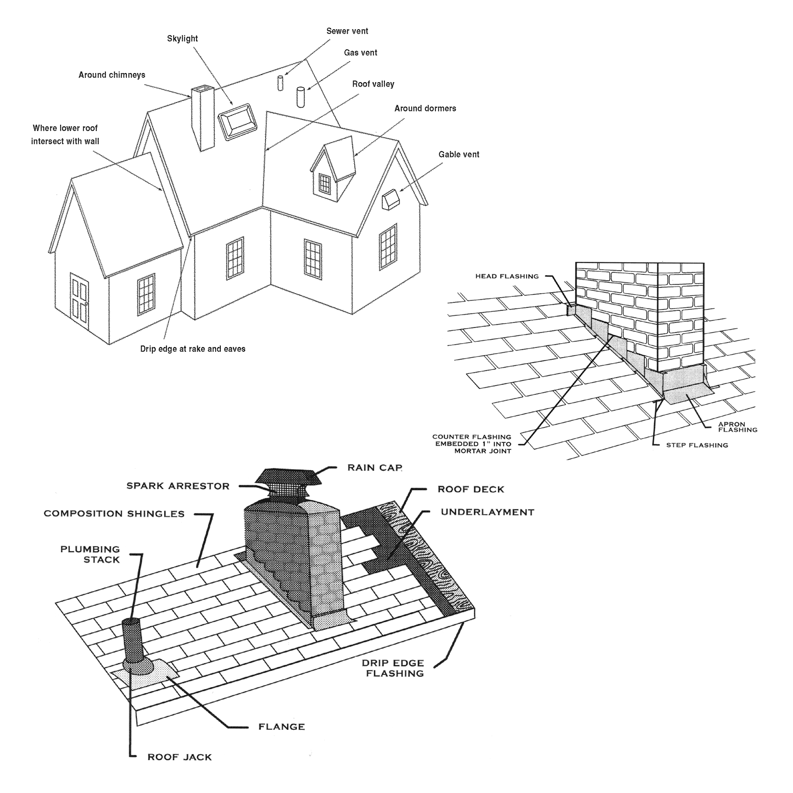
ROOF
Limitations/Exclusions
Except as otherwise and expressly stated in this INSPECTION REPORT, only those items, systems, structures or components that are listed in the INSPECTION REPORT have been reviewed or evaluated. In the context of the ROOF section of this report, the items, systems, structures or components EXCLUDED from this RESIDENTIAL PROPERTY INSPECTION include, but are not limited to: areas of the roof, flashing, gutters or downspouts which do not drain properly because of inadequate slope, design or installation; improper installation or inadequate caulking of skylights or similar features; non-visible aspects of the roof construction and condition, including the adequacy of non-visible caulking or sealing; portions of the roof obscured by solar panels, debris, plants, etc.; flashing that is not visible because it is covered by the roof material or other construction features; underground/French drains used to move downspout drainage away from the structure(s). In the case of tile, slate or metal roofs, the inspector will base his/her report on visible evidence from perimeter locations, and will not walk on the roof, both to avoid damaging the roof materials and to avoid personal injury. If a more definitive review of the roof's condition is desired, you should contact a licensed roofing contractor. This INSPECTION REPORT provides no warranty or opinion whether the roof currently leaks or whether the roof may leak in the future. Refer to the Agreement under which this RESIDENTIAL PROPERTY INSPECTION was performed for additional conditions, limitations, exceptions and exclusions.

Above-Ground
Below-Ground
Plaster/Gunite
Fiberglas
Vinyl
Redwood/Wood
Other:

Electric
Natural Gas
LP Gas
Solar Panels
CeramicTile
Stone
Brick/Pavers
Concrete
Wood

Concrete Block
Wood
Chain Link
Stucco
Wrought Iron
Spa Jets
Circulation
Pool Sweep
Pumps Installed
Cartridge Filter
Sand Filter
Diatomaceous Earth Filter
Air Bubbler
Supplemental to Jet Pump
Skimmer
Pool Sweep
Sub-Panel
Addl. Outlets
Romex
PVC
POOL / SPA
ITEM / AREA | GOOD | FAIR | POOR | N/A | COMMENTS
Pool Surface
Heater
Deck
Safety Fence / Gates / Latches
Pump(s)
Filter(s)
Jets / Blowers
Skimmer(s)
Pool / Spa Lights
Electrical |  |  |  |  | G.F.C.I.: Yes No
Pool / Spa Cover(s)
NOTES / COMMENTS / RECOMMENDATIONS
POOL / SPA
POOL/SPATYPE
HEATER
DECK
SAFETY FENCE / GATES minimum height:
ft.
in.
PUMP(S)
FILTER(S)
JETS / BLOWERS
SKIMMER/ POOL SWEEP
ELECTRICAL

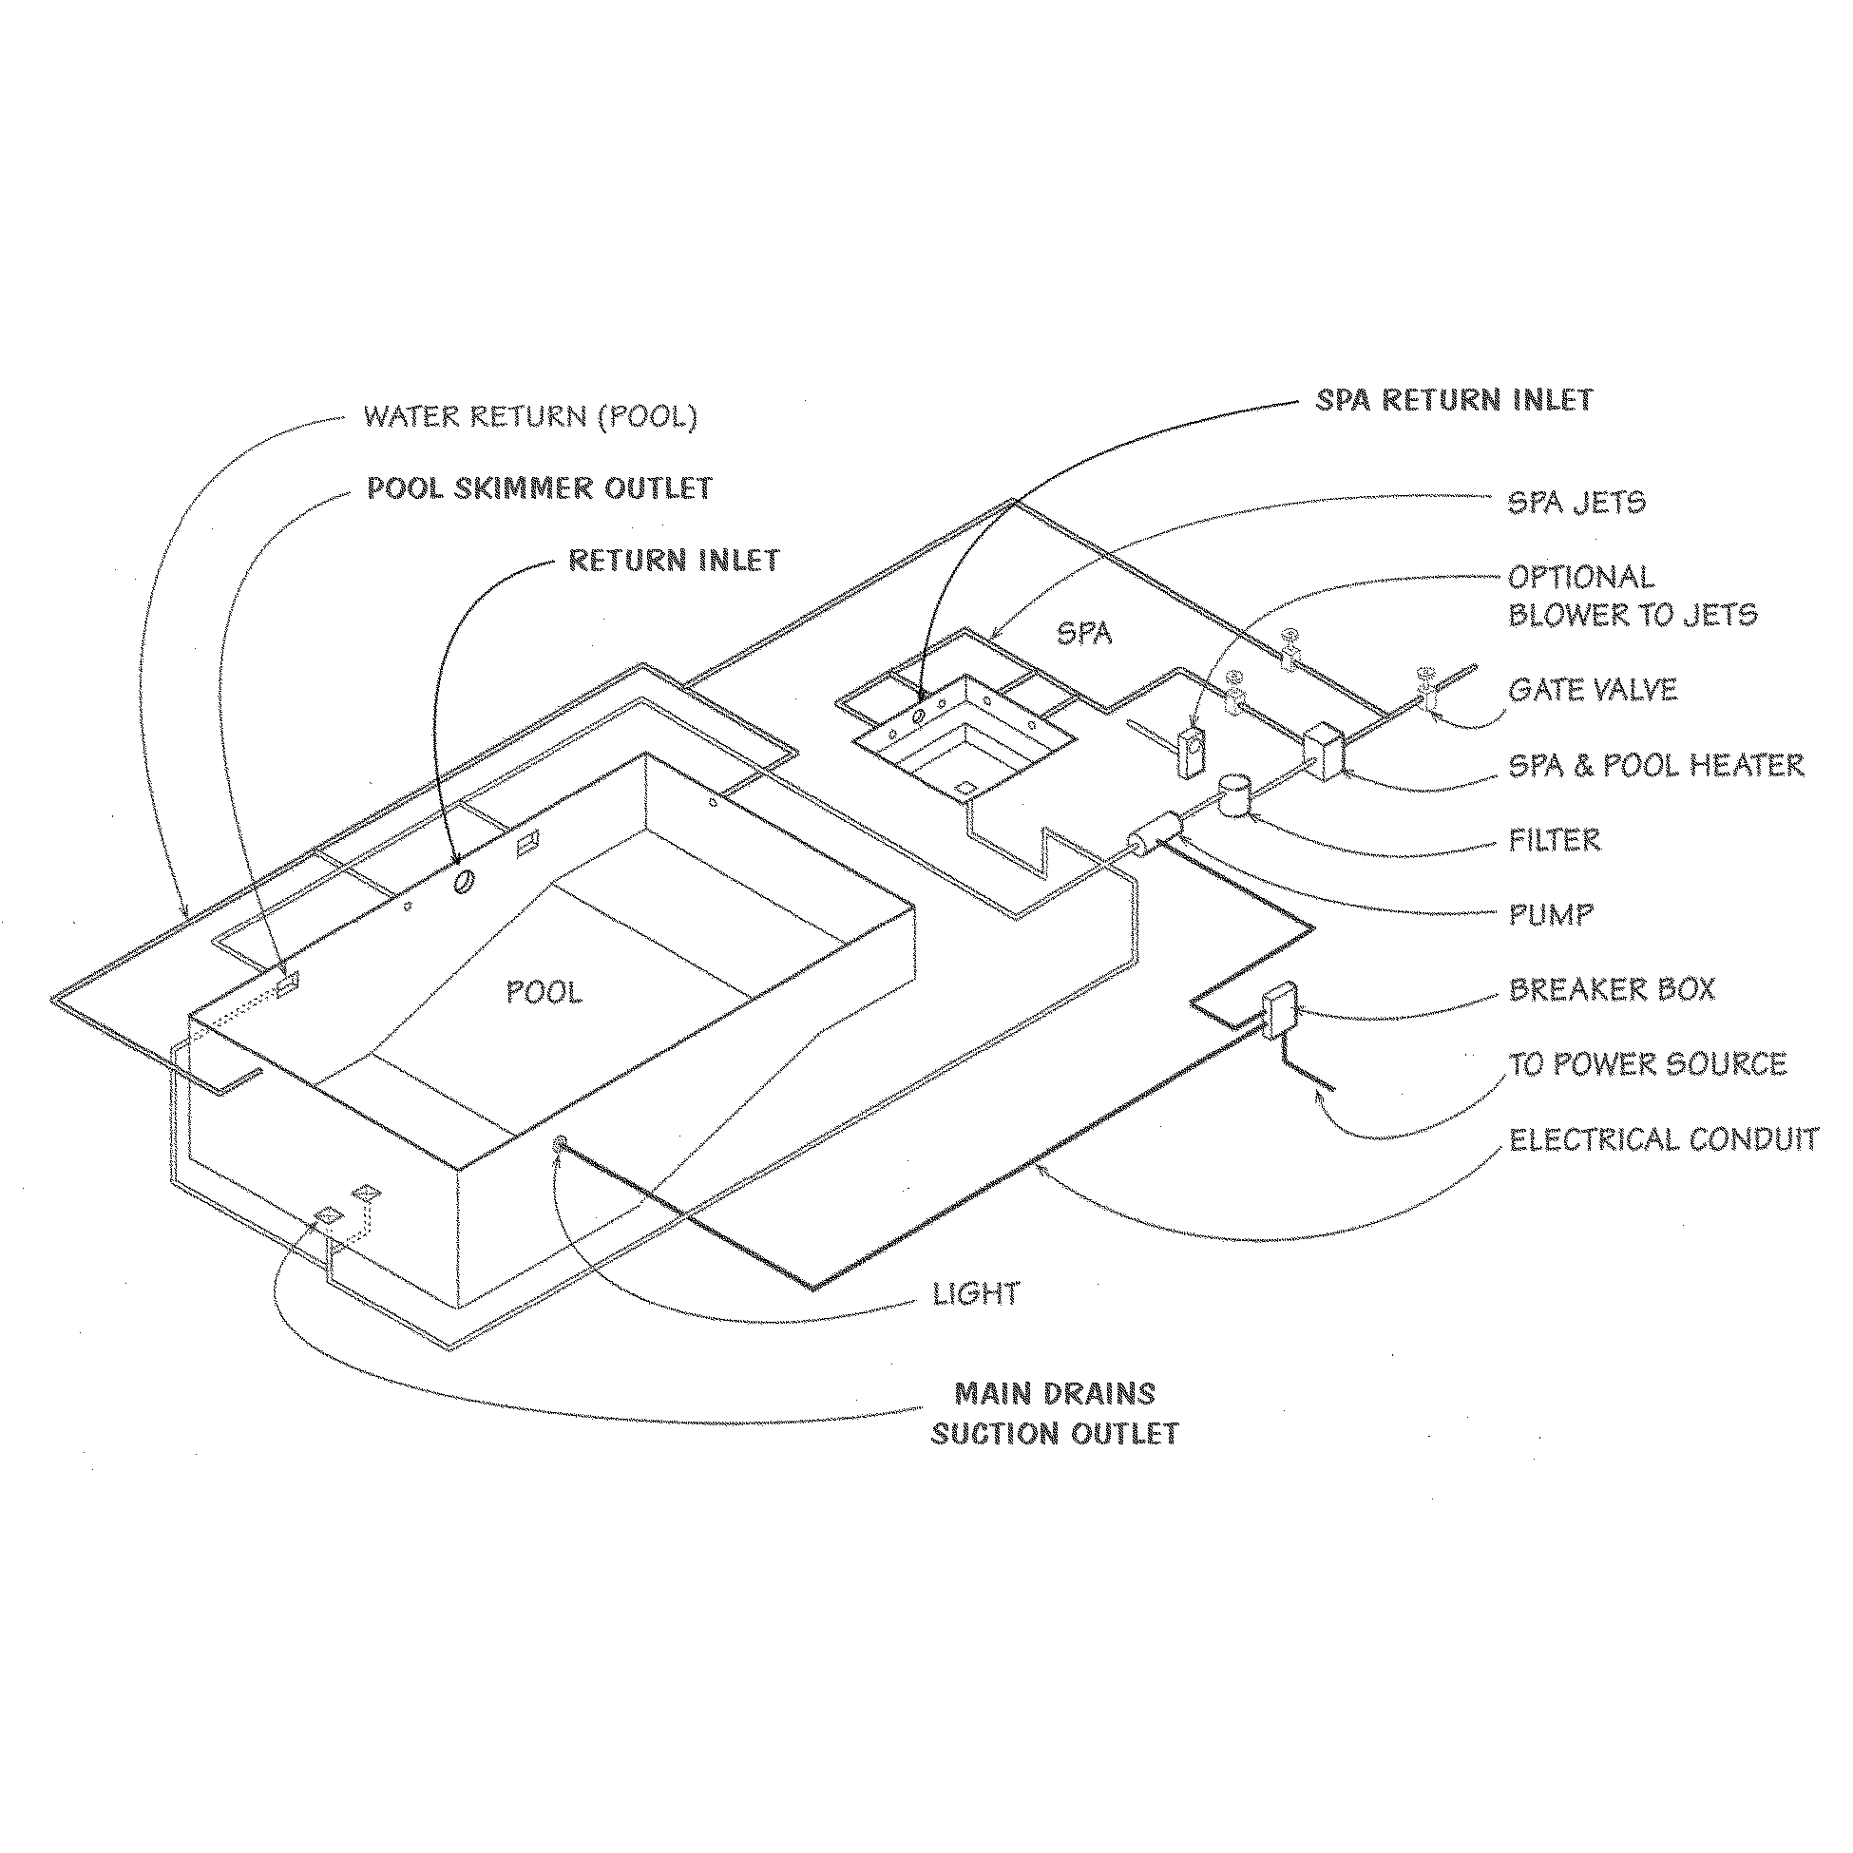
POOL / SPA
Limitations/Exclusions
Except as otherwise and expressly stated in this INSPECTION REPORT, only those items, systems, structures or components that are listed in the INSPECTION REPORT have been reviewed or evaluated. In the context of a POOL/SPA, the items, systems, structures or components EXCLUDED from this RESIDENTIAL PROPERTY INSPECTION include, but are not limited to: condition of pool and/or spa bodies and any leaks therein; accuracy of pool/spa depth markings; adequacy, safety functioning and accuracy of timers, controls and thermostats in pool/spa water supply, heating or filtration systems; safety, functioning or efficiency of electrical, heating or filtration systems. Any information provided regarding GFCI and/or pool/spa body is provided as a courtesy only and does not represent a definitive, expert opinion. For a complete evaluation of any pool/spa, consult a licensed pool contractor. Refer to the Agreement under which this RESIDENTIAL PROPERTY INSPECTION was performed for additional conditions, limitations, exceptions and exclusions.

Overhead
Underground
Number of Conductors:
Exterior
Interior
Location:
70 Amps
Undetermined
125 Amps
150 Amps
200 Amps
400 Amps
Copper
Copper
Aluminum
Aluminum
Undetermined
Undetermined

Present
None / N/A
Connect to water pipe
Connect to Ufer Rod
ELECTRICAL
ELECTRICAL
ITEM / AREA | GOOD | FAIR | POOR | N/A | COMMENTS
Service Line
Main Panel
Breakers
Fuses
Conductors
Sub-Panel(s)
Wiring
Ground Fault Circuit Interrupter
Grounding
Lights
Outlets
Switches
NOTES / COMMENTS / RECOMMENDATIONS
SERVICE LINE
MAIN PANEL
PANEL CAPACITY
CONDUCTORS
Entrance Cable:
Branch Cable:
SUB-PANEL(S)
Number of 120V Circuits:
Number of 240V Circuits:
GROUND FAULT CIRCUIT INTERRUPTERS (G.F.C.I.)
SYSTEM GROUND

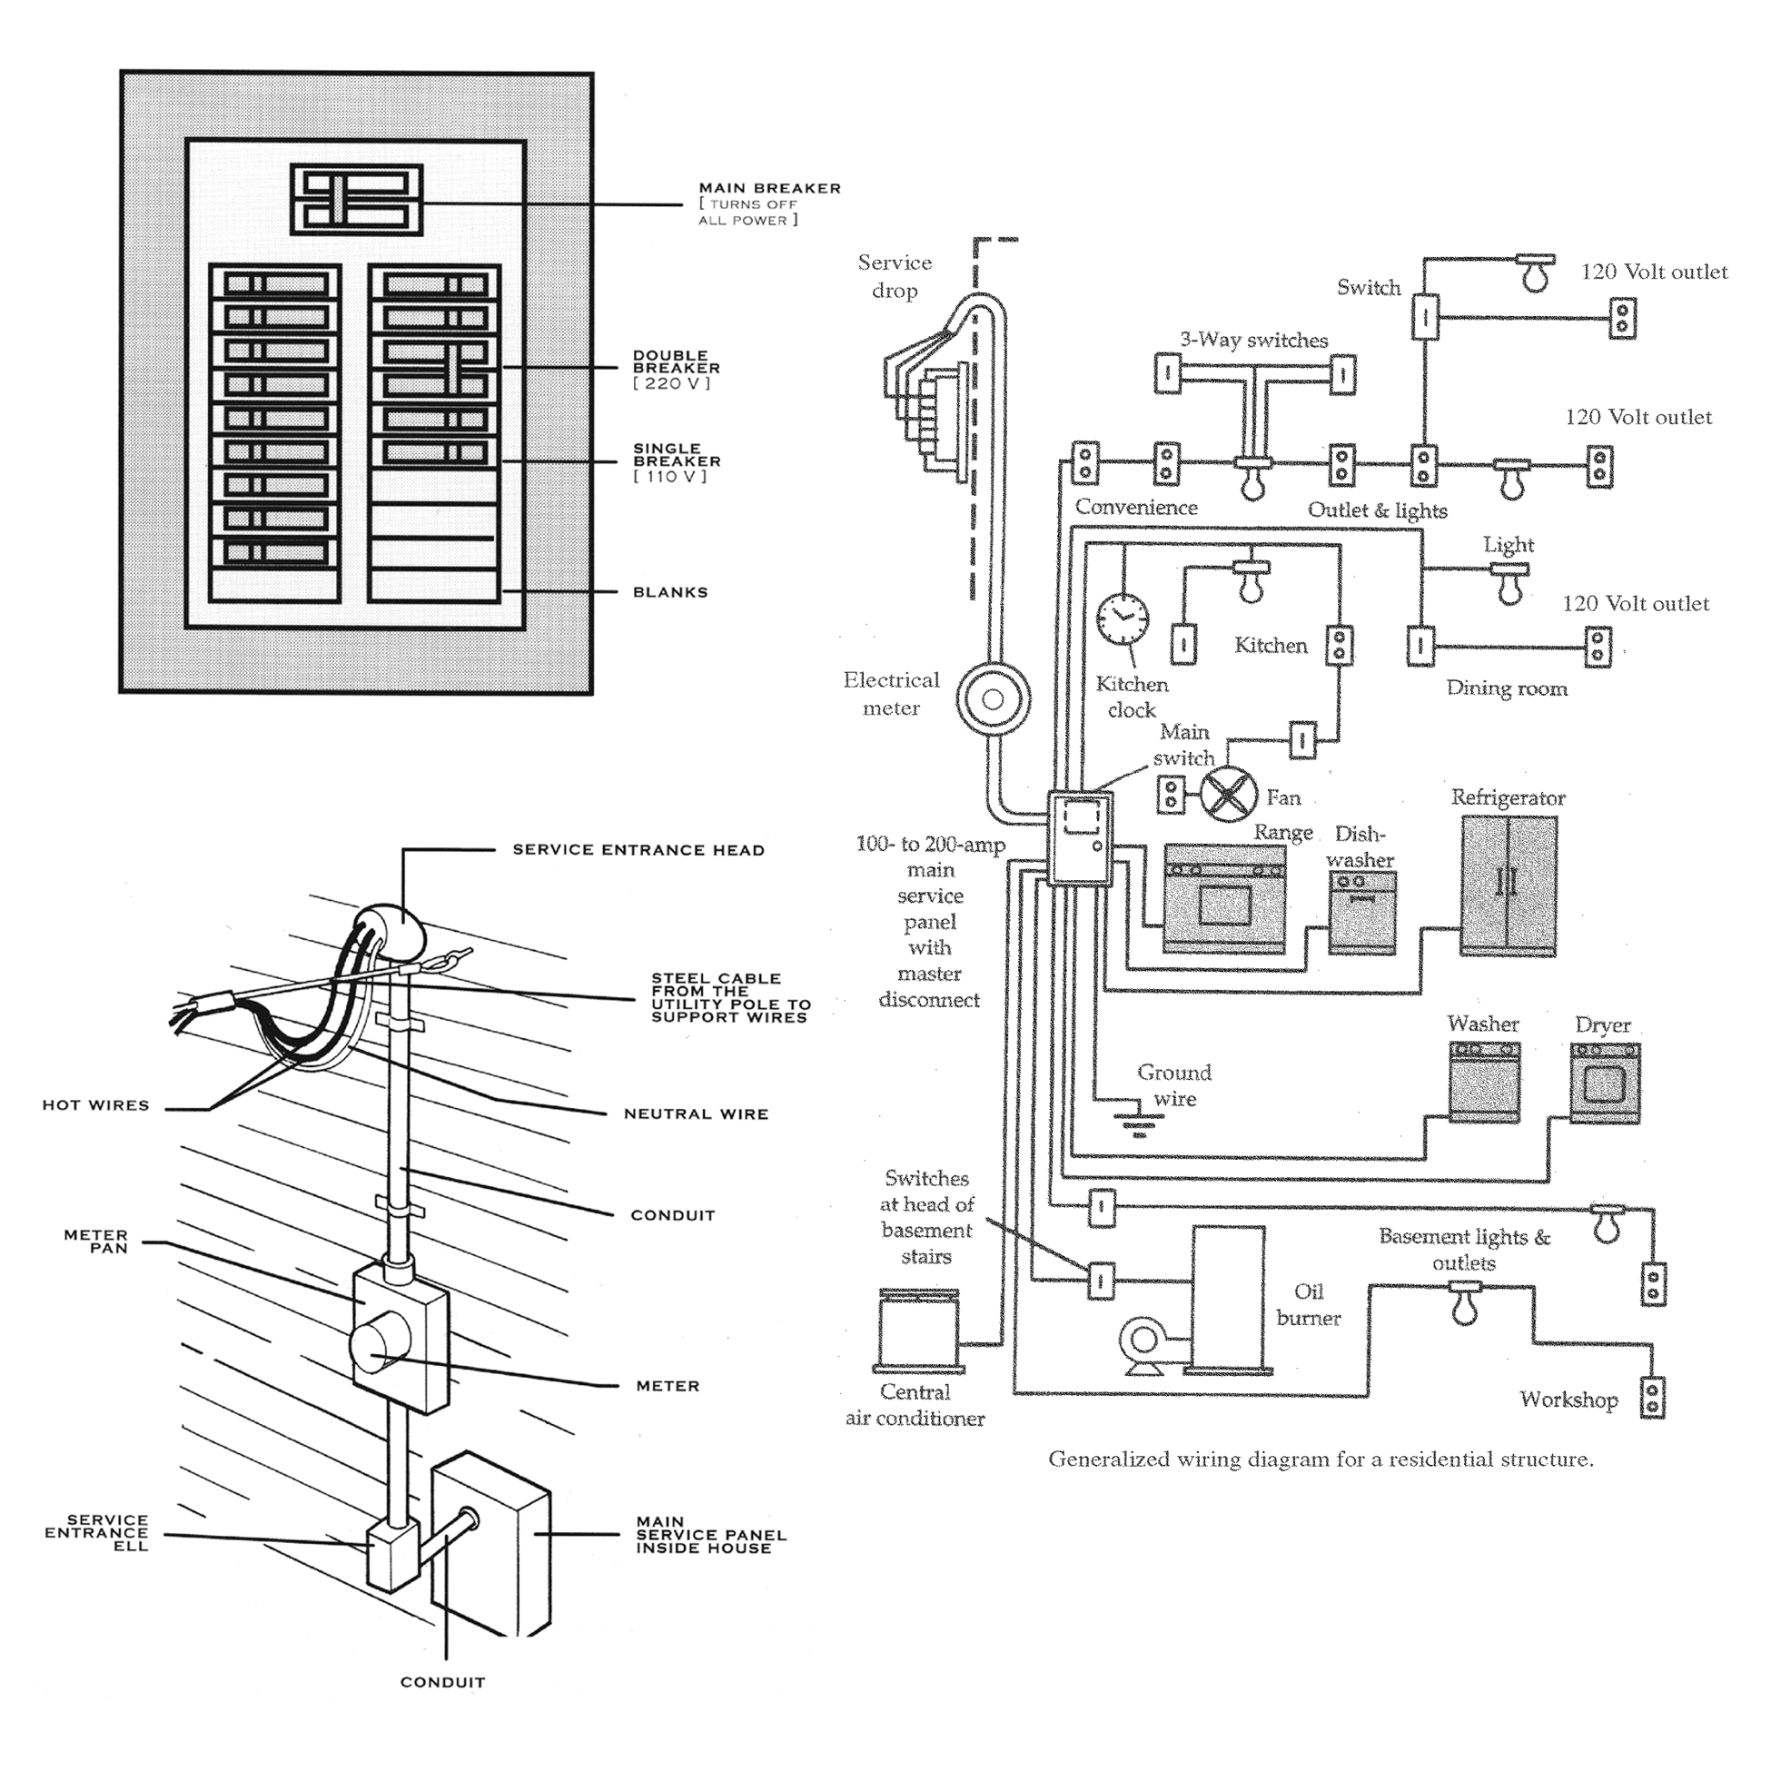
ELECTRICAL
Limitations/Exclusions
Except as otherwise and expressly stated in this INSPECTION REPORT, only those items, systems, structures or components that are listed in the INSPECTION REPORT have been reviewed or evaluated. In the context of the ELECTRICAL section of this report, the items, systems, structures or components EXCLUDED from this RESIDENTIAL PROPERTY INSPECTION include, but are not limited to: electrical load calculations; outlets, switches, lights and sub-panels obscured or inaccessible because of furnishings, plants, etc.; lighting fixtures that cannot be inspected due to burned out or missing light bulbs; tripping or testing circuit breakers or fuses; improper splitting of circuits; wiring hidden by finished walls, trim and other building elements; adequacy of grounding and bonding of the ground; estimate or opinion regarding remaining useful life of Ground Fault Circuit Interrupter system, outlets and switches; potential or history of power surge, spike, brownout or power outages due to electrical supply; potential risks posed by use of aluminum wiring; absence or incorrect installation of proper conduit, junction boxes and connectors where required. With regard to SMOKE DETECTORS covered in this inspection, the items, systems, structures or components EXCLUDED from this RESIDENTIAL PROPERTY INSPECTION include, but are not limited to: wiring methods used; estimate or opinion regarding remaining useful life of any smoke detectors and/or their batteries. Refer to the Agreement under which this RESIDENTIAL PROPERTY INSPECTION was performed for additional conditions, limitations, exceptions and exclusions.

Galvanized
Copper
PVC
Lead
Undetermined / unobserved
1/2-inch
3/4-inch
1-1/2-inch
Undetermined / unobserved
Location:
Galvanized
Copper
PVC
Undetermined
East
West
North
South

Cast Iron
Galvanized
ABS (Plastic)
Not fully visible
Other

Natural Gas
LPG Tank
Oil Tank
Location:
PLUMBING SYSTEM
ITEM / AREA | GOOD | FAIR | POOR | N/A | COMMENTS
Main Line
Water Line
Main Shut-Off |  |  |  |  | Yes None
Water Pressure
Pressure Regulator |  |  |  |  | Yes None
Pressure Relief Valve |  |  |  |  | Yes None
Waste Disposal |  |  |  |  | Yes None
Waste Line
Sump Pump |  |  |  |  | Yes None
Water Softener |  |  |  |  | Yes None
Anti-Siphon Device |  |  |  |  | Yes None
Hose Bib |  |  |  |  | Yes None
Fuel Line(s) |  |  |  |  | On Off No meter
NOTES / COMMENTS / RECOMMENDATIONS
PLUMBING SYSTEM
MAIN LINE
DIAMETER
MAINVALVE
WATER LINE
HOSE BIB LOCATION(S)
PRESSURETEST
PSI:
Time:
WASTE LINE
FUEL SYSTEM

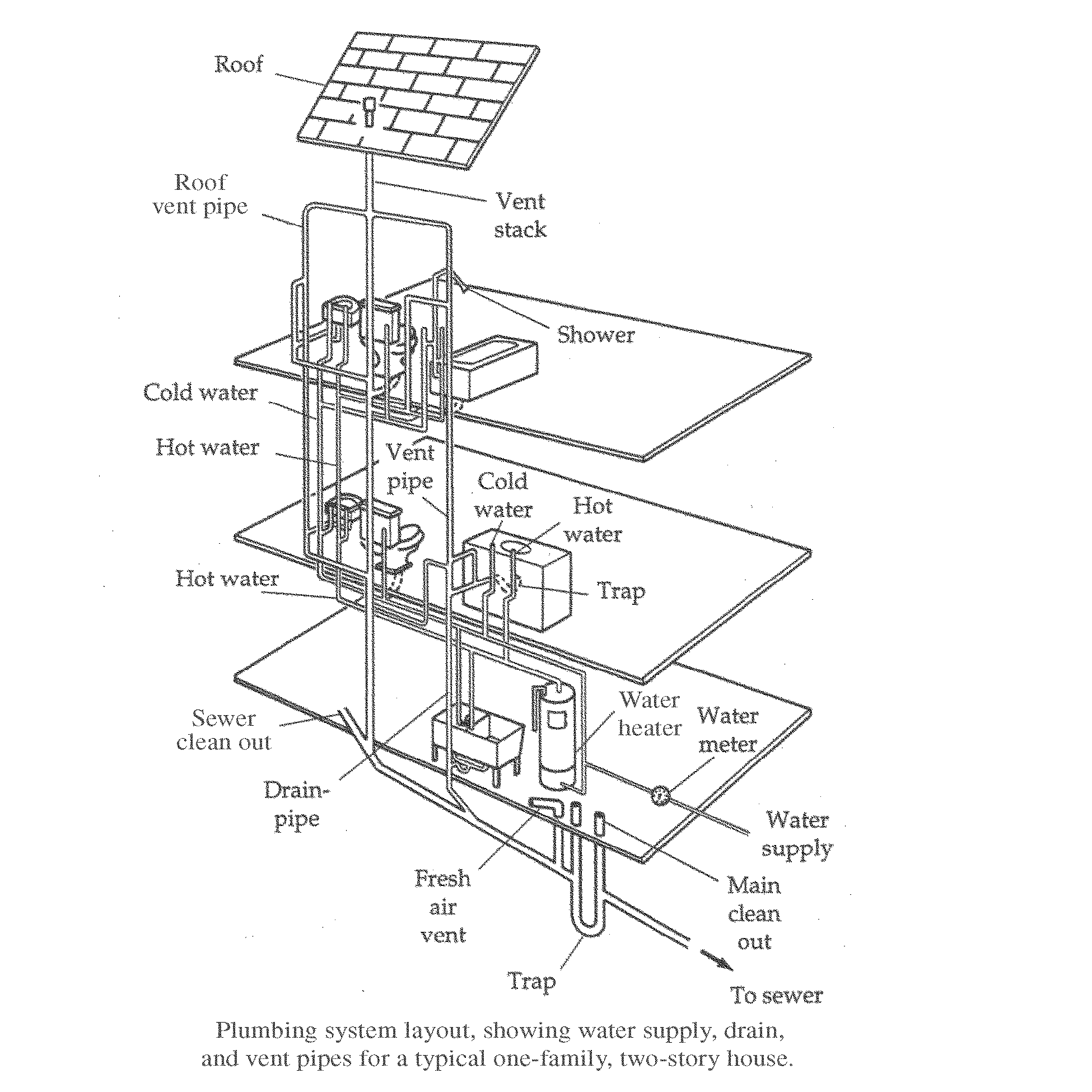
PLUMBING SYSTEM
Limitations/Exclusions
Except as otherwise and expressly stated in this INSPECTION REPORT, only those items, systems, structures or components that are listed in the INSPECTION REPORT have been reviewed or evaluated. In the context of the PLUMBING SYSTEM section of this report, the items, systems, structures or components EXCLUDED from this RESIDENTIAL PROPERTY INSPECTION include, but are not limited to: drinking and cooking water quality and safety; type and condition of underground piping related to water supply, drainage, sewage, sprinklers and waste disposal; main sewer lines, septic tanks, distribution fields and their piping, gray water systems, backflow prevention devices, etc.; sewer lateral or drainage tests; sewage ejector pumps; the proper placement of sprinkler heads to protect the structure from unnecessary exposure to water, water conservation, and maintain landscaping; non-visible leaks or weaknesses in pipes, fittings, valves or fixtures; lead solder; water Mitering or softening systems; roof sprinkler systems; inherent defects in polybutylene and ABS plastic piping; overflow drains for bathtubs and sinks; adequacy of cleanouts; future drainage performance of waste system; estimate or opinion regarding remaining useful life of any pump(s). Refer to the Agreement under which this RESIDENTIAL PROPERTY INSPECTION was performed for additional conditions, limitations, exceptions and exclusions.

LOCATION:
Gas
Electric
Solar
LPG
Undetermined

Copper
Galvanized
Other:

Galvanized
Wood Frame
Stucco
N/A
Natural Gas
Oil Tank/LPG
Electric
Concrete
Block
Wood
Metal
WATER HEATER
ITEM / AREA | GOOD | FAIR | POOR | N/A | COMMENTS
Water Heater
Temp Pressure Relief (TPR) Valve
Water Shut-Off Valve
Seismic Straps
Thermal Blanket
Vent Flue
Enclosure
Plumbing
Combustion Air
Venting
Base
Overflow Line
NOTES / COMMENTS / RECOMMENDATIONS
WATER HEATER
TYPE
Manufacturer:
Capacity:
Gallons
Approx. Age:
Years
PLUMBINGTYPE
ENCLOSURETYPE
FUEL SYSTEM
BASE

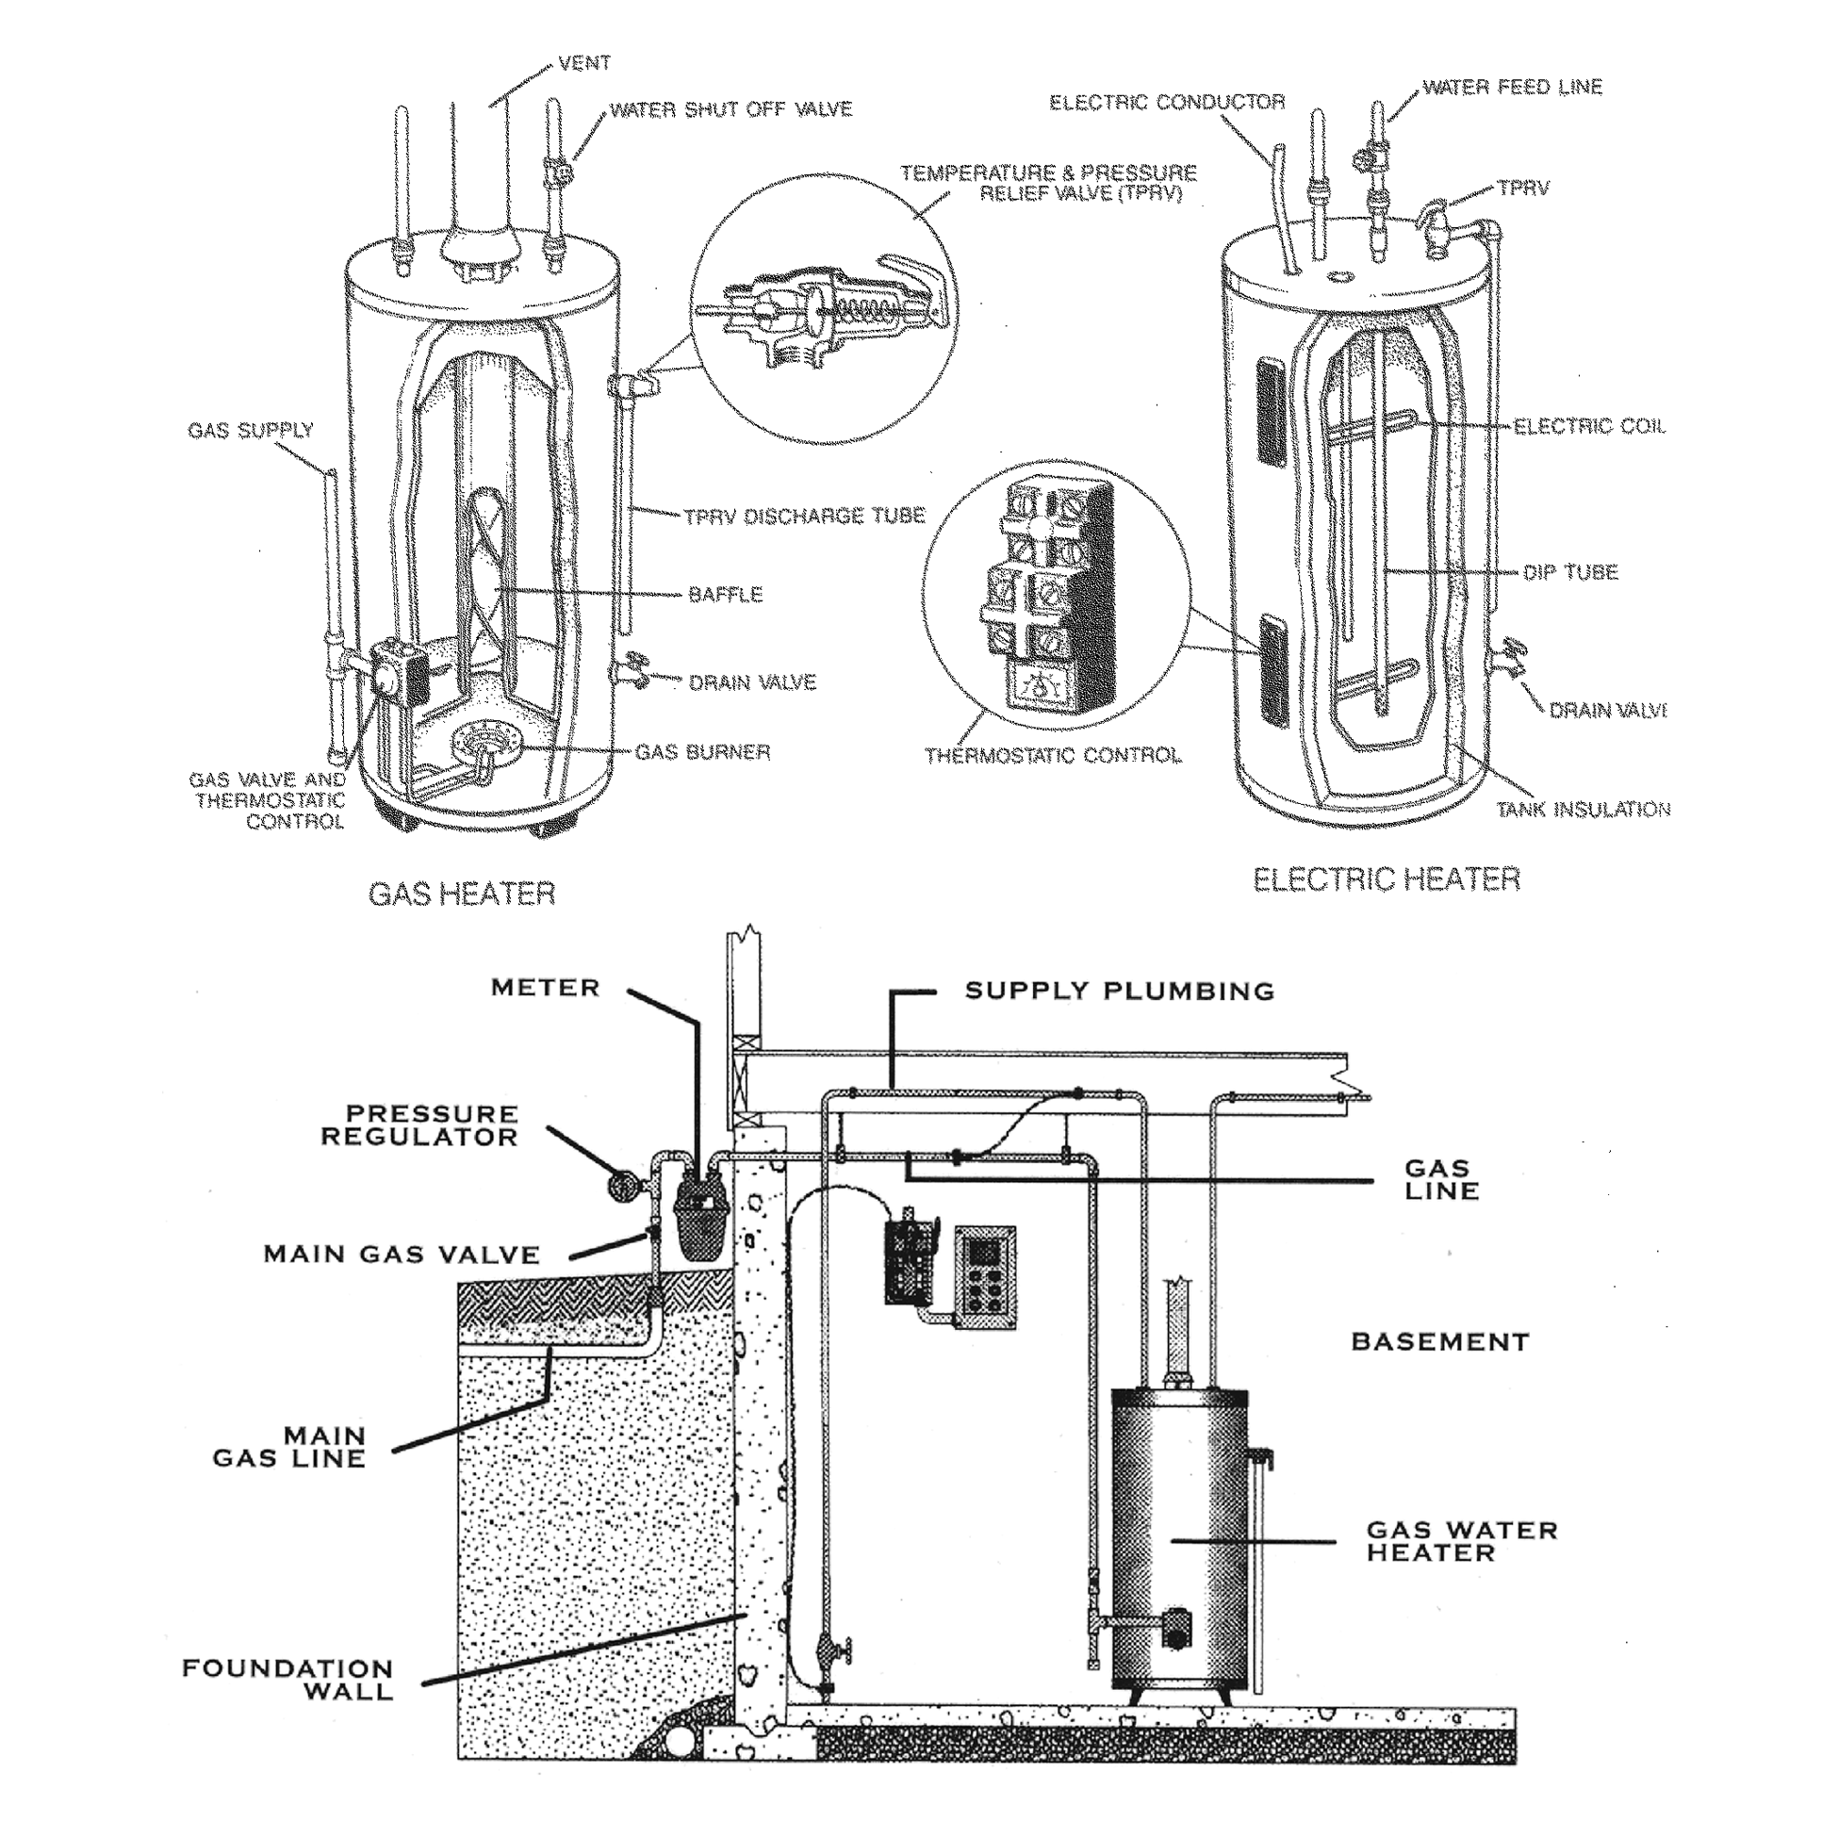
WATER HEATER
Limitations/Exclusions
Except as otherwise and expressly stated in this INSPECTION REPORT, only those items, systems, structures or components that are listed in the INSPECTION REPORT have been reviewed or evaluated. In the context of the WATER HEATER section of this report, the items, systems, structures or components EXCLUDED from this RESIDENTIAL PROPERTY INSPECTION include, but are not limited to: working condition of temperature pressure relief (TPR) valve; hot water circulation pumps; estimate or opinion regarding remaining useful life of the water heater; adequacy or safety of combustion gas venting. Refer to the Agreement under which this RESIDENTIAL PROPERTY INSPECTION was performed for additional conditions, limitations, exceptions and exclusions.

Location #1:
Location #2:
Location #3:
Manufacturer:
Manufacturer:
Manufacturer:
Forced Air
Heat Pump
Radiant
Gravity
Wall
Floor Heater
Natural Gas
Electrical
LP-Propane
Undetermined
Solar
Not Inspected
Not Connected

Location #1:
Location #2:
Location #3:
Manufacturer:
Manufacturer:
Manufacturer:
Heat Pump
Fan Motor
Central Air
One Speed Only
Window/Wall
Defects observed
Swamp Cooler
120 V
240 V
Electr. Disconnect
Gas not inspected
Gas not connected

HEATING SYSTEM
ITEM / AREA | GOOD | FAIR | POOR | N/A | COMMENTS
Burner
Venting
Combustion Air
Duct Work
Air Filters
Thermostat / Controls
Distribution
Gas Valve(s)
AIR CONDITIONING
Compressor(s)
Air Filter
Blower
Duct Work
Electrical
Base
NOTES / COMMENTS / RECOMMENDATIONS
HEATING/ AIR CONDITIONING

HEATING SYSTEM
HEATINGTYPE
FUELTYPE
APPROXIMATE BTU’S:

AIR CONDITIONING
TYPE
POWER

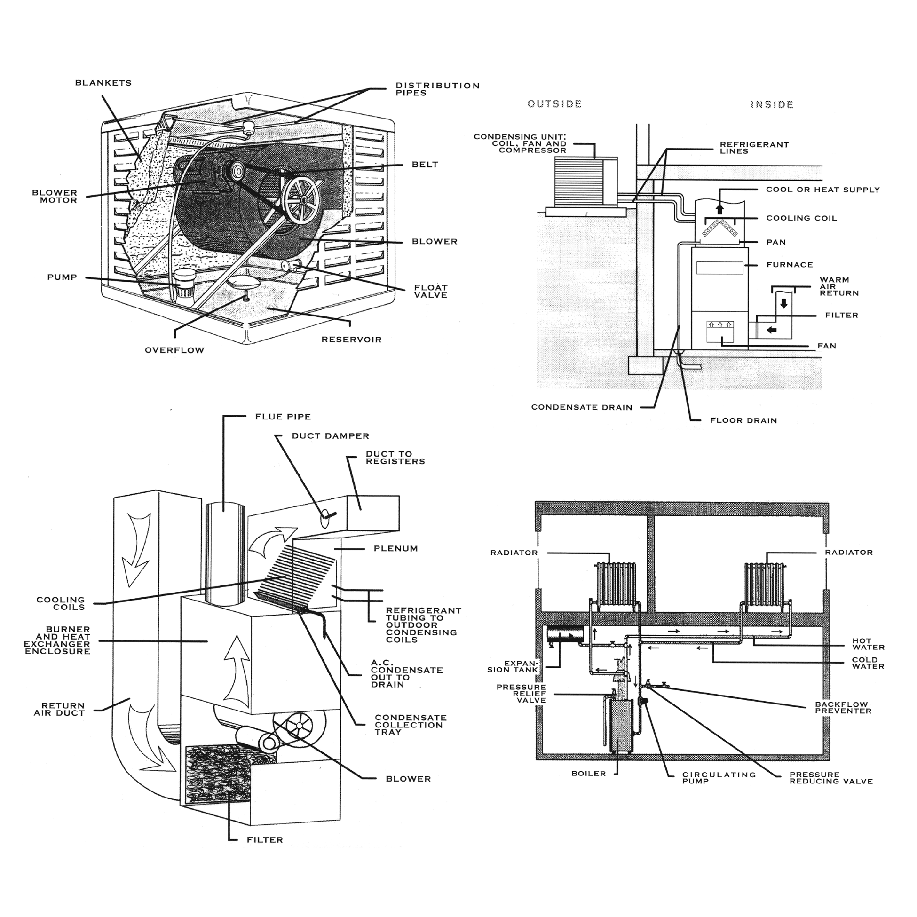
HEATING/ AIR CONDITIONING
Limitations/Exclusions
Except as otherwise and expressly stated in this INSPECTION REPORT, only those items, systems, structures or components that are listed in the INSPECTION REPORT have been reviewed or evaluated. In the context of a HEATING/AIR CONDITIONING section of this report, the items, systems, structures or components EXCLUDED from this RESIDENTIAL PROPERTY INSPECTION include, but are not limited to: condition or safety of natural gas or propane gas lines, whether buried underground or exposed; condition or safety of propane tanks, including clearance from structures and vegetation; condition or safety of gas meters or shut-offs; power efficiency, performance and condition of the system and its components; even distribution of heat and cooling; estimate or opinion regarding remaining useful life of the system or any of its components; identification, testing or evaluation for presence of asbestos; electronic air cleaners, ionizers, ozone generators, humidifiers, de-humidifiers, standalone filter systems; heating systems where pilot lights are unlit or where the gas is disconnected at the time of inspection; cracks or holes in heat exchangers which would require disassembly for their visual inspection; adequacy or safety of combustion air sources and combustion gas venting; accuracy or timed functions of thermostats; pressure, coolant charge or integrity of refrigerant lines; use or presence of refrigerants now considered environmental hazards; water valves on evaporative coolers; condition of evaporative cooler components that are inaccessible to simple visual inspection. Refer to the Agreement under which this RESIDENTIAL PROPERTY INSPECTION was performed for additional conditions, limitations, exceptions and exclusions.

Present
None
Drywall
Acoustic
Plaster
Open Beam
Plywood Paneling
Solid Wood Paneling
Other

Carpet
Ceramic Tile
Wood
Marble
Linoleum/Vinyl
Other

Masonry
Hearth
Pre-Fab
Gas
Metal
Damper
Stucco
Vent Flue
Concrete
N/A
LIVING ROOM
ITEM / AREA | GOOD | FAIR | POOR | N/A | COMMENTS
Ceilings /Walls
Floor
Window(s)
Fireplace
Bar / Refreshment Center
Exterior Door(s)
Interior Door(s)
Light Fixture(s)
Switches
Outlets
Smoke Detector
Heating / Air Conditioning |  |  |  |  | Register Type/Location:
NOTES / COMMENTS / RECOMMENDATIONS
LIVING ROOM
WALLS AND CEILING
FLOORING
INTERIOR CHIMNEY/ FIREPLACE

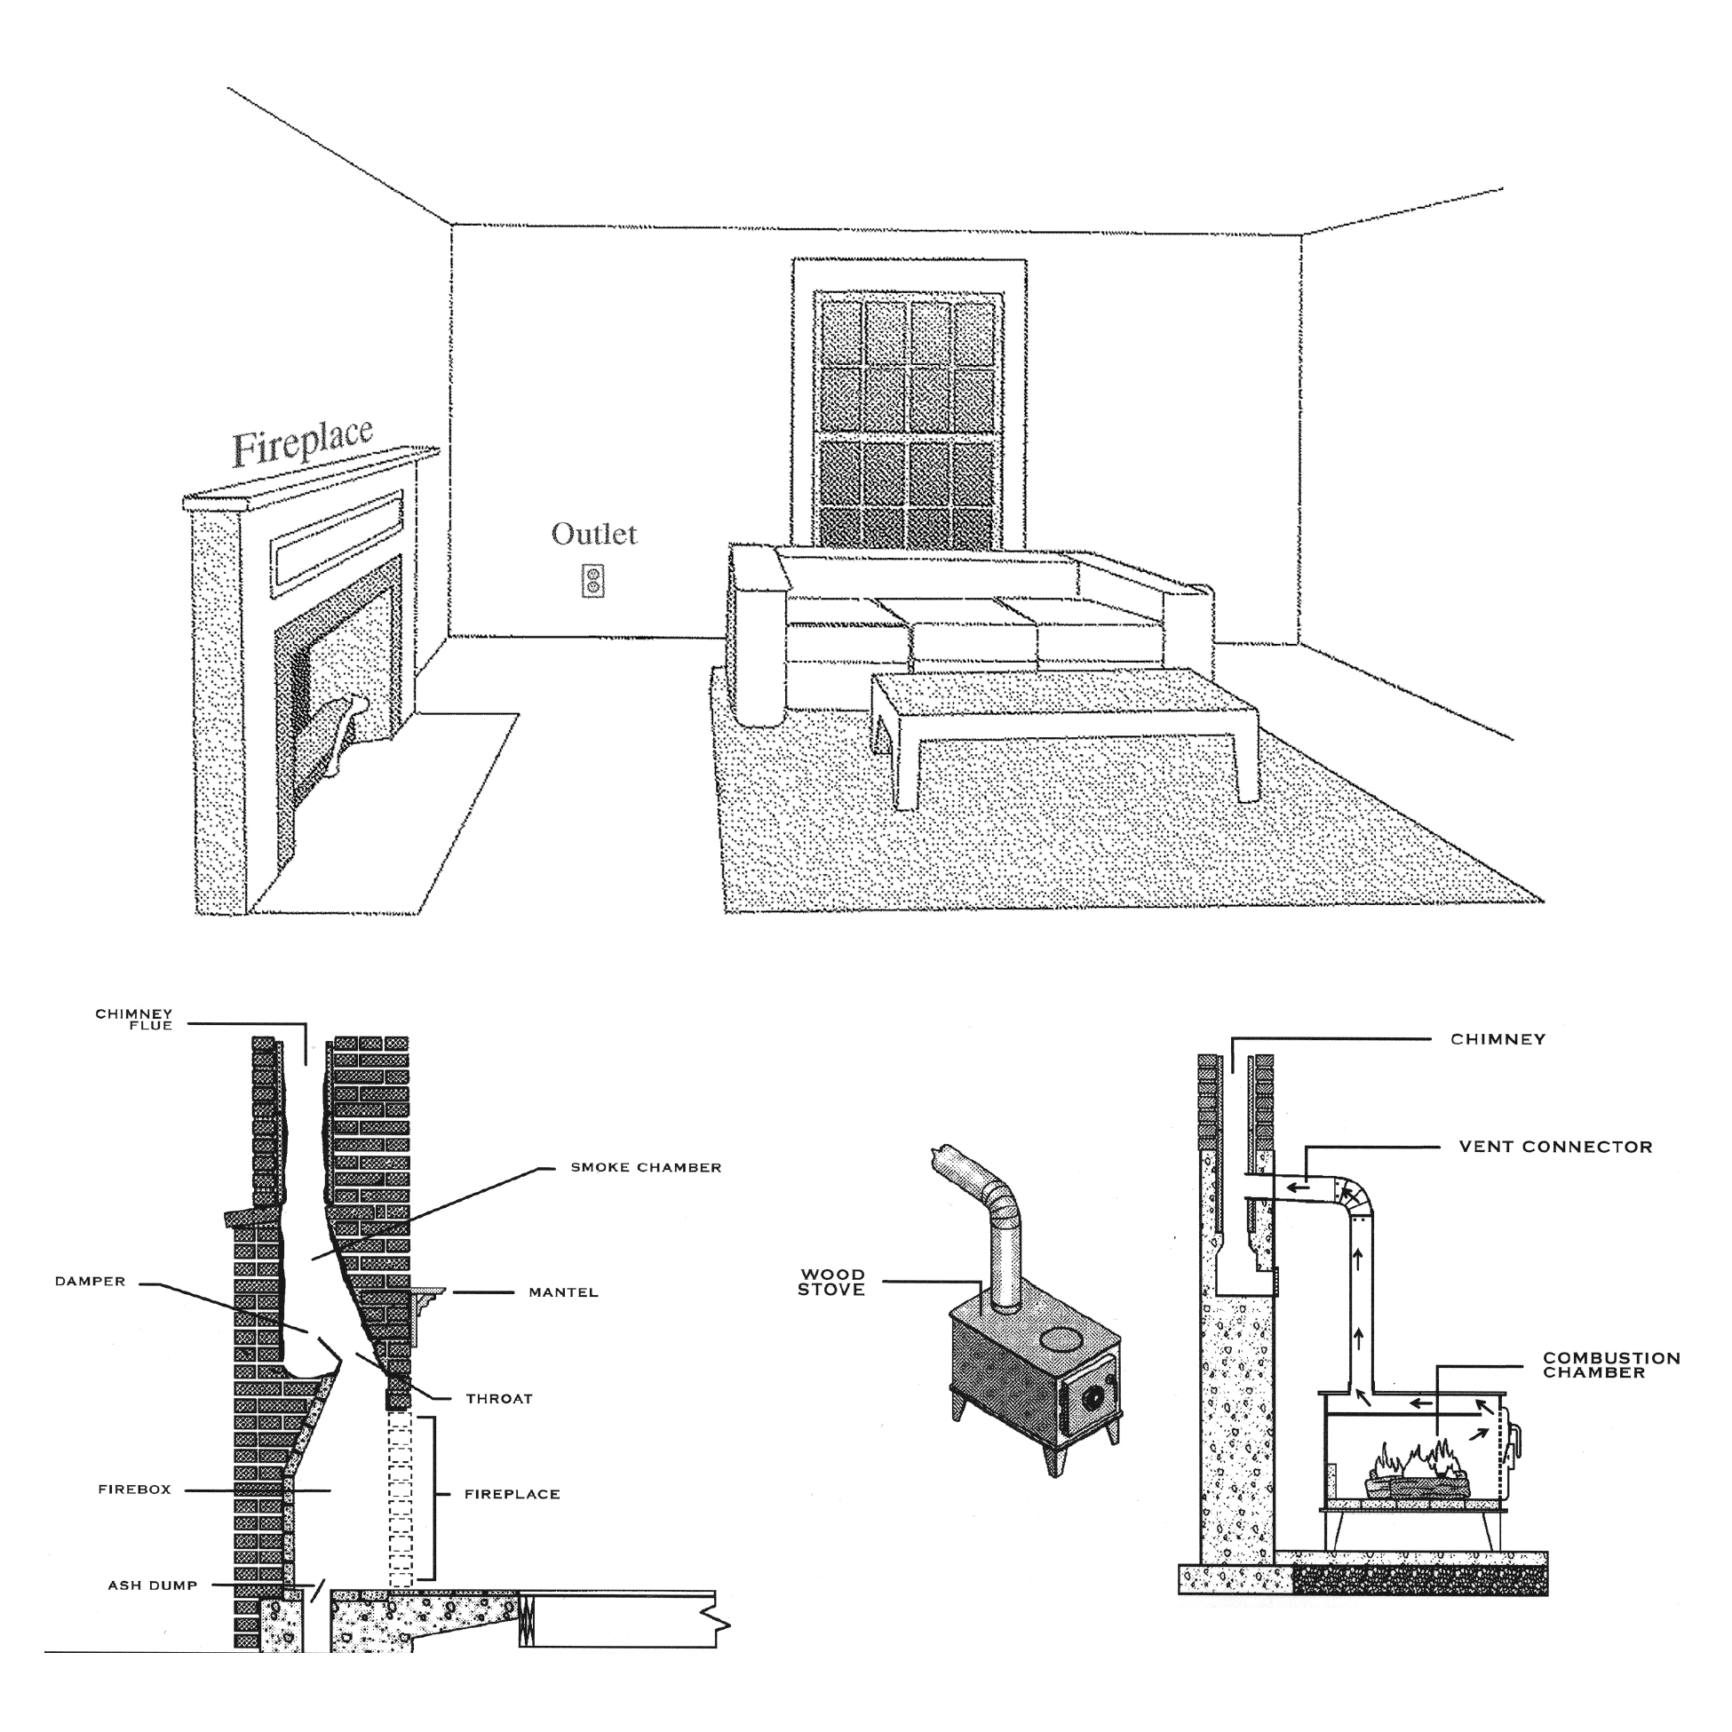
LIVING ROOM
Limitations/Exclusions
Except as otherwise and expressly stated in this INSPECTION REPORT, only those items, systems, structures or components that are listed in the INSPECTION REPORT have been reviewed or evaluated. With respect to FLOORS, items or conditions EXCLUDED from this RESIDENTIAL PROPERTY INSPECTION include, but are not limited to: minor or cosmetic defects or cracks; odors and hidden stains; floor condition and materials used when storage, floor coverings or other furnishings obstruct or otherwise prevent visual inspection; identification, testing or evaluation for presence of asbestos in floor ties. With respect to WALLS or CEILINGS, items or conditions EXCLUDED from this RESIDENTIAL PROPERTY INSPECTION include, but are not limited to: wall or ceiling condition and materials used when storage, wall or ceiling coverings, moldings, or other furnishings obstruct or otherwise prevent visual inspection; small cracks indicating normal age and settling; hidden mold, rot or deterioration; identification, testing or evaluation for presence of asbestos. With respect to DOORS and WINDOWS, items or conditions EXCLUDED from this RESIDENTIAL PROPERTY INSPECTION include, but are not limited to: determination whether tempered glass (where required) has been used when no clear marking is visible; presence of or potential for leakage in multi-pane window seals. With respect to FIREPLACES, items or conditions EXCLUDED from this RESIDENTIAL PROPERTY INSPECTION include, but are not limited to: proper installation, fireproofing, condition and safety of fireplaces, chimneys, flues and inserts that cannot be determined by visual inspection; estimate or opinion regarding remaining useful life of any fans. With regard to SMOKE DETECTORS covered in this inspection, the items, systems, structures or components EXCLUDED from this RESIDENTIAL PROPERTY INSPECTION include, but are not limited to: wiring methods used; estimate or opinion regarding remaining useful life of any smoke detectors and/or their batteries. Refer to the Agreement under which this RESIDENTIAL PROPERTY INSPECTION was performed for additional conditions, limitations, exceptions and exclusions.

Present
None
Drywall
Acoustic
Plaster
Open Beam
Plywood Paneling
Solid Wood Paneling
Other

Carpet
Ceramic Tile
Wood
Marble
Linoleum/Vinyl
Other

Masonry
Hearth
Pre-Fab
Gas
Metal
Damper
Stucco
Vent Flue
Concrete
N/A
DINING ROOM
ITEM / AREA | GOOD | FAIR | POOR | N/A | COMMENTS
Ceilings /Walls
Floor
Window(s)
Fireplace
Exterior Door(s)
Interior Door(s)
Light Fixture(s)
Switches
Outlets |  |  |  |  | G.F.C.I.: Yes No
Smoke Detector
Heating / Air Conditioning |  |  |  |  | Register Type/Location:
NOTES / COMMENTS / RECOMMENDATIONS
DINING ROOM
WALLS AND CEILING
FLOORING
INTERIOR CHIMNEY/ FIREPLACE

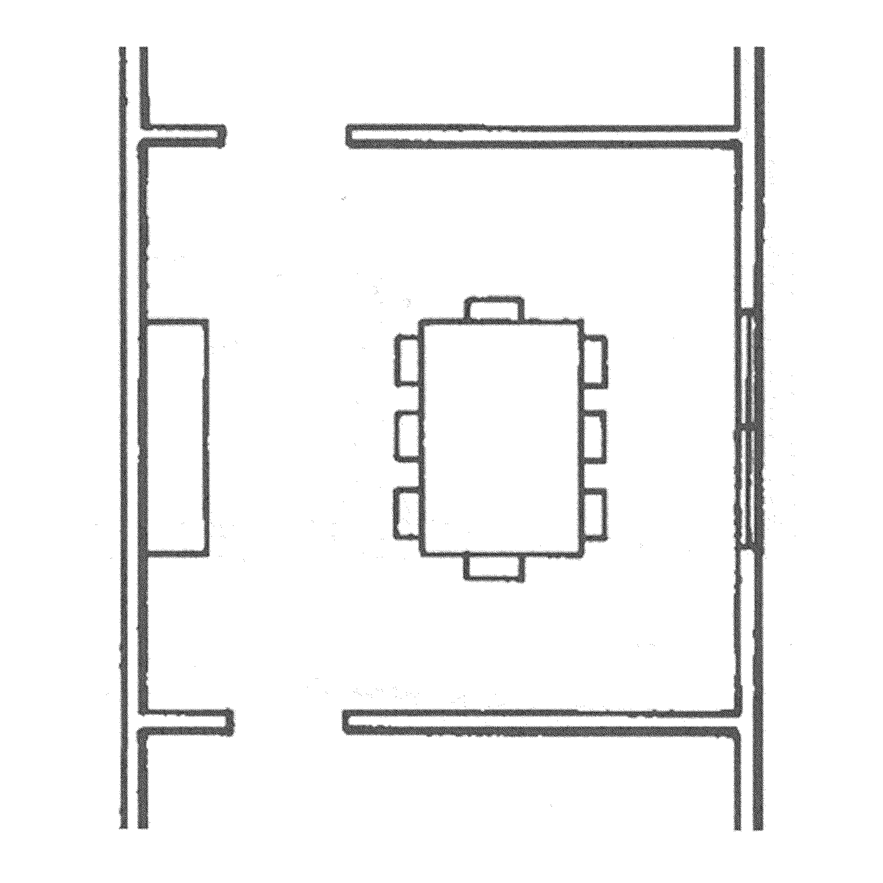
DINING ROOM
Limitations/Exclusions
Except as otherwise and expressly stated in this INSPECTION REPORT, only those items, systems, structures or components that are listed in the INSPECTION REPORT have been reviewed or evaluated. With respect to FLOORS, items or conditions EXCLUDED from this RESIDENTIAL PROPERTY INSPECTION include, but are not limited to: minor or cosmetic defects or cracks; odors and hidden stains; floor condition and materials used when storage, floor coverings or other furnishings obstruct or otherwise prevent visual inspection; identification, testing or evaluation for presence of asbestos in floor tiles. With respect to WALLS or CEILINGS, items or conditions EXCLUDED from this RESIDENTIAL PROPERTY INSPECTION include, but are not limited to: wall or ceiling condition and materials used when storage, wall or ceiling coverings, moldings, or other furnishings obstruct or otherwise prevent visual inspection; small cracks indicating normal age and settling; hidden mold, rot or deterioration; identification, testing or evaluation for presence of asbestos. With respect to DOORS and WINDOWS, items or conditions EXCLUDED from this RESIDENTIAL PROPERTY INSPECTION include, but are not limited to: determination whether tempered glass (where required) has been used when no clear marking is visible; presence of or potential for leakage in multi-pane window seals. With respect to FIREPLACES, items or conditions EXCLUDED from this RESIDENTIAL PROPERTY INSPECTION include, but are not limited to: proper installation, fireproofing, condition and safety of fireplaces, chimneys, flues and inserts that cannot be determined by visual inspection; estimate or opinion regarding remaining useful life of any fans. With regard to SMOKE DETECTORS covered in this inspection, the items, systems, structures or components EXCLUDED from this RESIDENTIAL PROPERTY INSPECTION include, but are not limited to: wiring methods used; estimate or opinion regarding remaining useful life of any smoke detectors and/or their batteries. Refer to the Agreement under which this RESIDENTIAL PROPERTY INSPECTION was performed for additional conditions, limitations, exceptions and exclusions.

Present
None
Drywall
Acoustic
Plaster
Open Beam
Plywood Paneling
Solid Wood Paneling
Other

Carpet
Ceramic Tile
Wood
Marble
Linoleum/Vinyl
Other

Masonry
Hearth
Pre-Fab
Gas
Metal
Damper
Stucco
Vent Flue
Concrete
N/A
FAMILY ROOM #1
ITEM / AREA | GOOD | FAIR | POOR | N/A | COMMENTS
Ceilings /Walls
Floor
Window(s)
Fireplace
Bar / Refreshment Center
Exterior Door(s)
Interior Door(s)
Light Fixture(s)
Switches
Outlets |  |  |  |  | G.F.C.I.: Yes No
Smoke Detector
Heating / Air Conditioning |  |  |  |  | Register Type/Location:
NOTES / COMMENTS / RECOMMENDATIONS
FAMILY ROOM #1
WALLS AND CEILING
FLOORING
INTERIOR CHIMNEY/ FIREPLACE

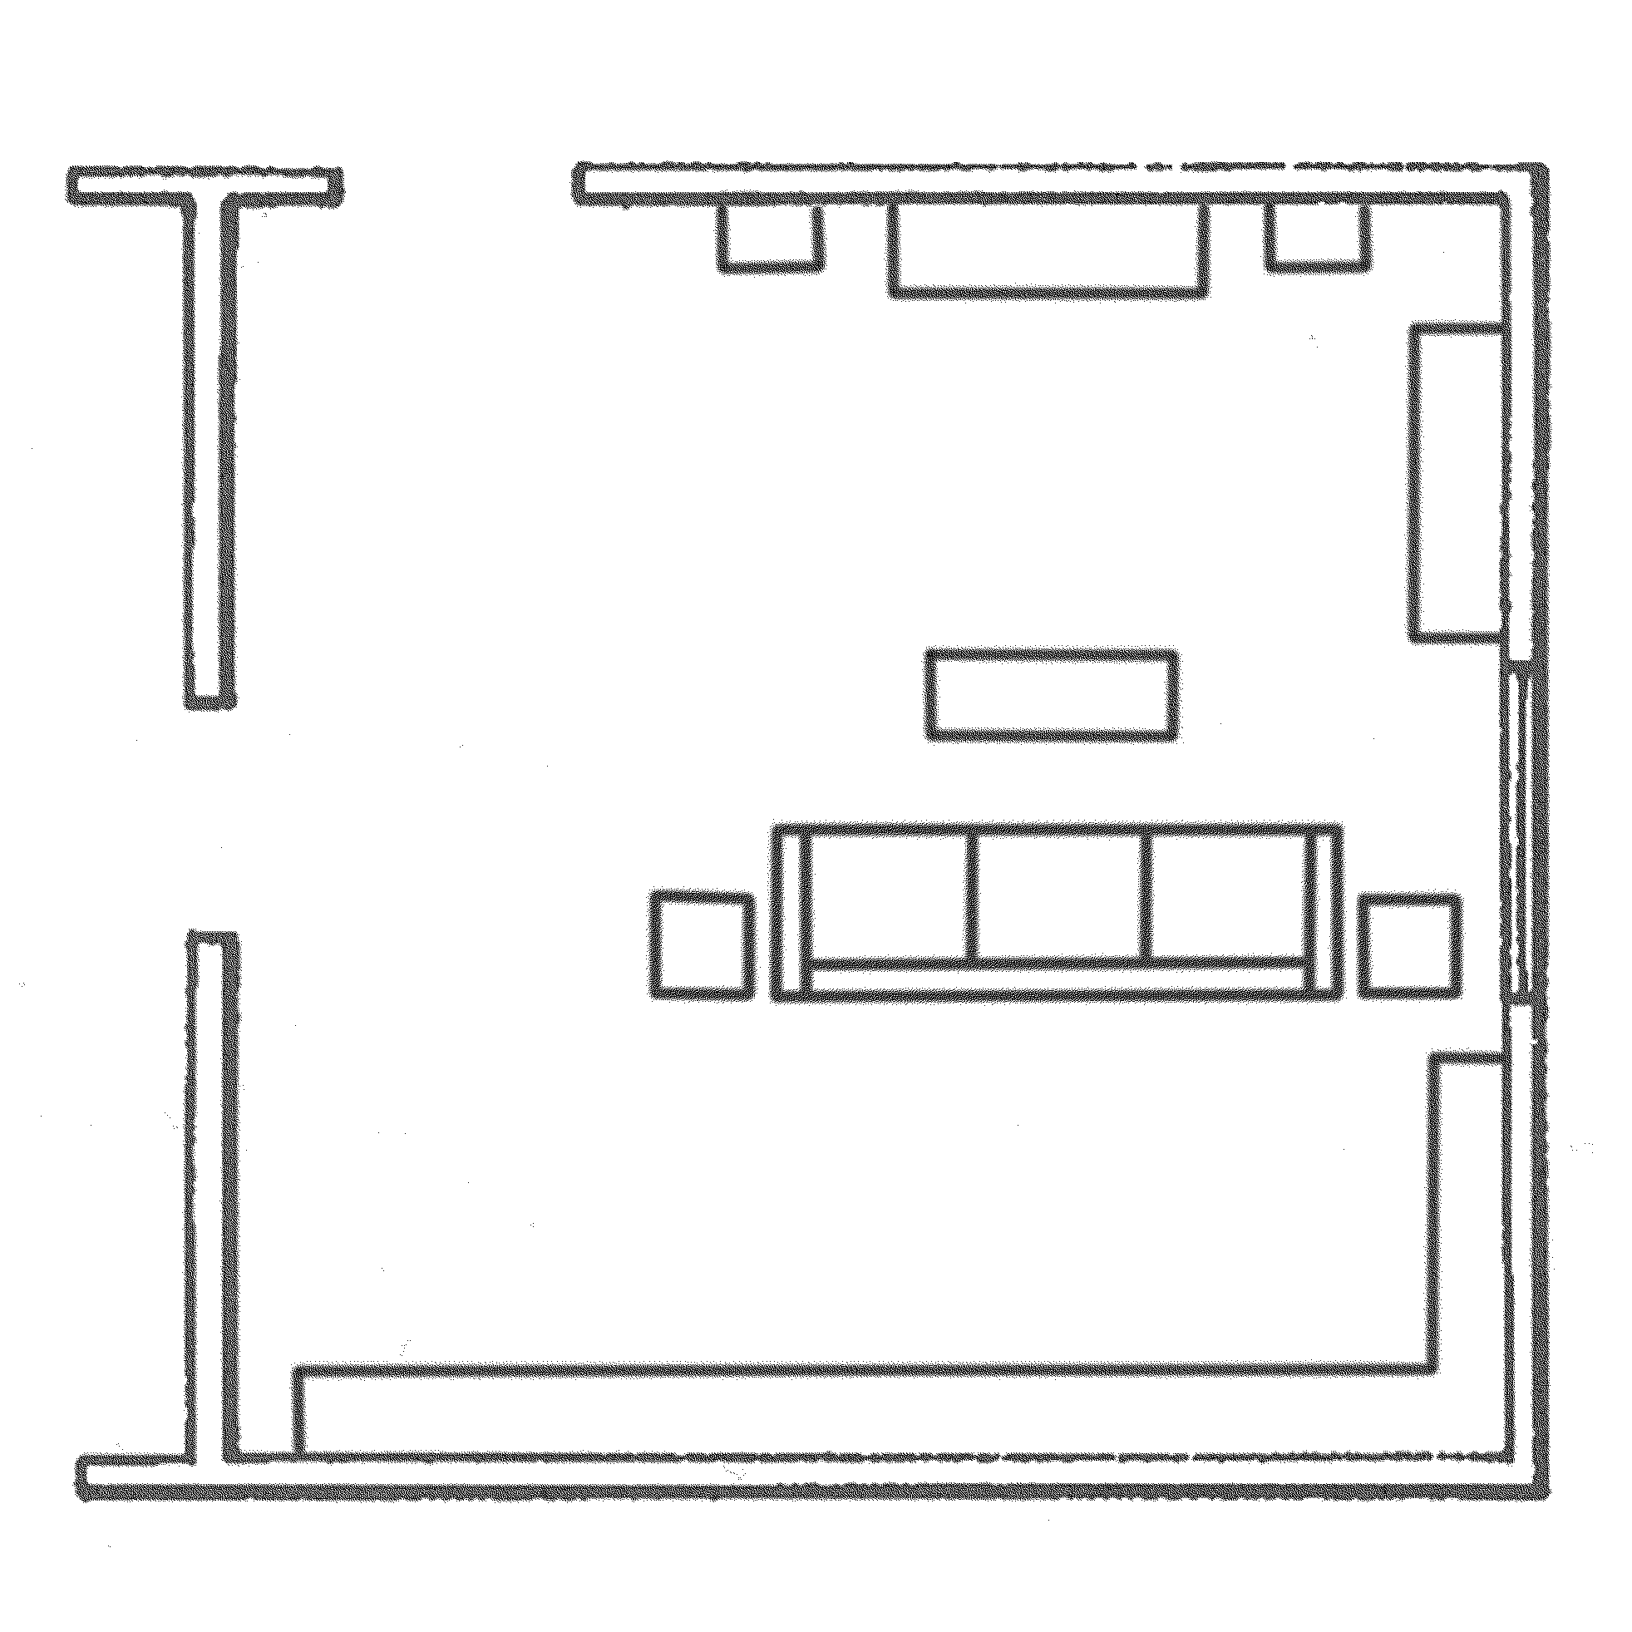
FAMILY ROOM
Limitations/Exclusions
Except as otherwise and expressly stated in this INSPECTION REPORT, only those items, systems, structures or components that are listed in the INSPECTION REPORT have been reviewed or evaluated. With respect to FLOORS, items or conditions EXCLUDED from this RESIDENTIAL PROPERTY INSPECTION include, but are not limited to: minor or cosmetic defects or cracks; odors and hidden stains; floor condition and materials used when storage, floor coverings or other furnishings obstruct or otherwise prevent visual inspection; identification, testing or evaluation for presence of asbestos in floor tiles. With respect to WALLS or CEILINGS, items or conditions EXCLUDED from this RESIDENTIAL PROPERTY INSPECTION include, but are not limited to: wall or ceiling condition and materials used when storage, wall or ceiling coverings, moldings, or other furnishings obstruct or otherwise prevent visual inspection; small cracks indicating normal age and settling; hidden mold, rot or deterioration; identification, testing or evaluation for presence of asbestos. With respect to DOORS and WINDOWS, items or conditions EXCLUDED from this RESIDENTIAL PROPERTY INSPECTION include, but are not limited to: determination whether tempered glass (where required) has been used when no clear marking is visible; presence of or potential for leakage in multi-pane window seals. With respect to FIREPLACES, items or conditions EXCLUDED from this RESIDENTIAL PROPERTY INSPECTION include, but are not limited to: proper installation, fireproofing, condition and safety of fireplaces, chimneys, flues and inserts that cannot be determined by visual inspection; estimate or opinion regarding remaining useful life of any fans. With regard to SMOKE DETECTORS covered in this inspection, the items, systems, structures or components EXCLUDED from this RESIDENTIAL PROPERTY INSPECTION include, but are not limited to: wiring methods used; estimate or opinion regarding remaining useful life of any smoke detectors and/or their batteries. Refer to the Agreement under which this RESIDENTIAL PROPERTY INSPECTION was performed for additional conditions, limitations, exceptions and exclusions.

Present
None
Drywall
Acoustic
Plaster
Open Beam
Plywood Paneling
Solid Wood Paneling
Other

Carpet
Ceramic Tile
Wood
Marble
Linoleum/Vinyl
Other

Masonry
Hearth
Pre-Fab
Gas
Metal
Damper
Stucco
Vent Flue
Concrete
N/A
FAMILY ROOM #2 / DEN / STUDY
ITEM / AREA | GOOD | FAIR | POOR | N/A | COMMENTS
Ceilings /Walls
Floor
Window(s)
Fireplace
Bar / Refreshment Center
Exterior Door(s)
Interior Door(s)
Light Fixture(s)
Switches
Outlets |  |  |  |  | G.F.C.I.: Yes No
Smoke Detector
Heating / Air Conditioning |  |  |  |  | Register Type/Location:
NOTES / COMMENTS / RECOMMENDATIONS
FAMILY ROOM #2 / DEN / STUDY
WALLS AND CEILING
FLOORING
INTERIOR CHIMNEY/ FIREPLACE

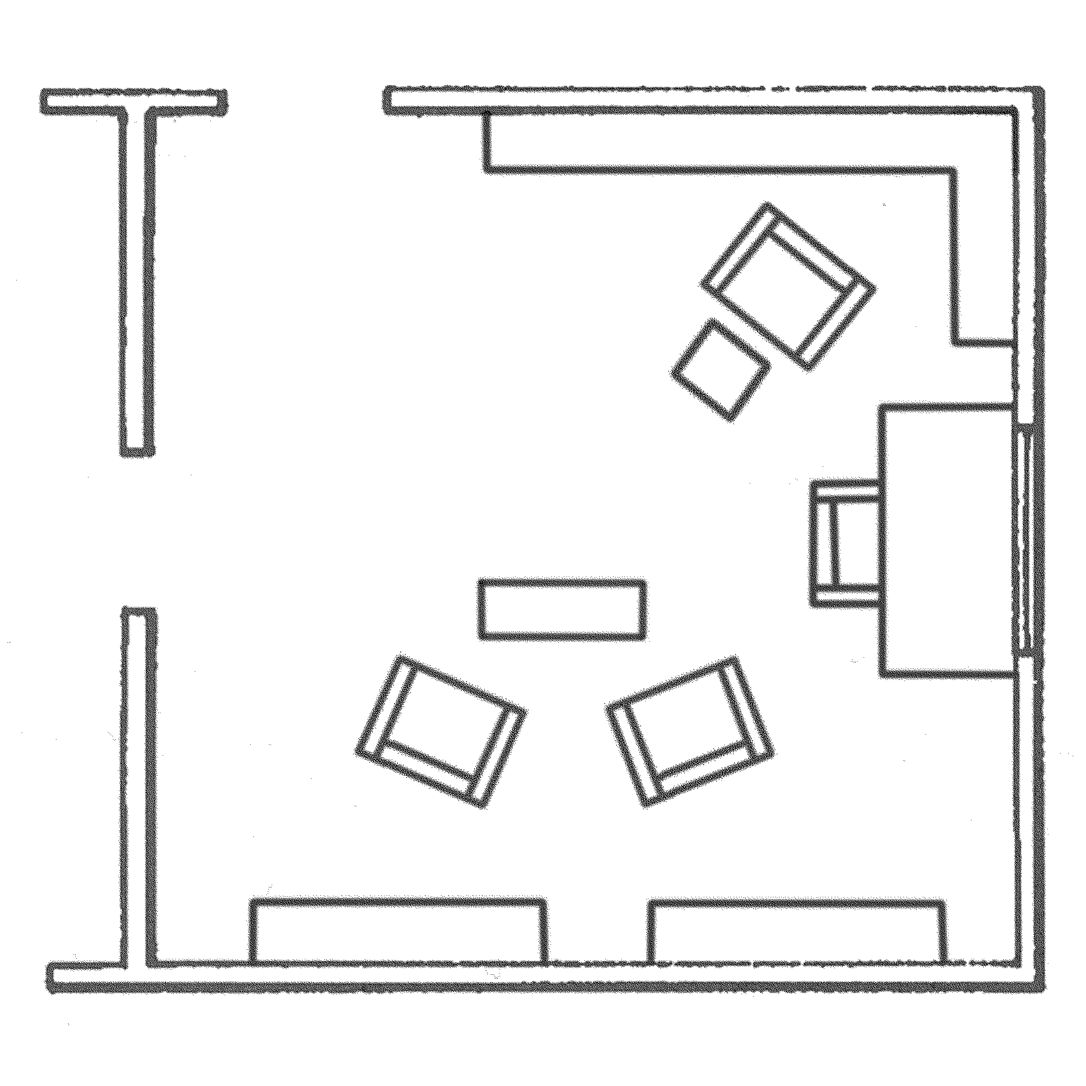
FAMILY ROOM / DEN / STUDY
Limitations/Exclusions
Except as otherwise and expressly stated in this INSPECTION REPORT, only those items, systems, structures or components that are listed in the INSPECTION REPORT have been reviewed or evaluated. With respect to FLOORS, items or conditions EXCLUDED from this RESIDENTIAL PROPERTY INSPECTION include, but are not limited to: minor or cosmetic defects or cracks; odors and hidden stains; floor condition and materials used when storage, floor coverings or other furnishings obstruct or otherwise prevent visual inspection; identification, testing or evaluation for presence of asbestos in floor tiles. With respect to WALLS or CEILINGS, items or conditions EXCLUDED from this RESIDENTIAL PROPERTY INSPECTION include, but are not limited to: wall or ceiling condition and materials used when storage, wall or ceiling coverings, moldings, or other furnishings obstruct or otherwise prevent visual inspection; small cracks indicating normal age and settling; hidden mold, rot or deterioration; identification, testing or evaluation for presence of asbestos. With respect to DOORS and WINDOWS, items or conditions EXCLUDED from this RESIDENTIAL PROPERTY INSPECTION include, but are not limited to: determination whether tempered glass (where required) has been used when no clear marking is visible; presence of or potential for leakage in multi-pane window seals. With respect to FIREPLACES, items or conditions EXCLUDED from this RESIDENTIAL PROPERTY INSPECTION include, but are not limited to: proper installation, fireproofing, condition and safety of fireplaces, chimneys, flues and inserts that cannot be determined by visual inspection; estimate or opinion regarding remaining useful life of any fans. With regard to SMOKE DETECTORS covered in this inspection, the items, systems, structures or components EXCLUDED from this RESIDENTIAL PROPERTY INSPECTION include, but are not limited to: wiring methods used; estimate or opinion regarding remaining useful life of any smoke detectors and/or their batteries. Refer to the Agreement under which this RESIDENTIAL PROPERTY INSPECTION was performed for additional conditions, limitations, exceptions and exclusions.

Present
None
Drywall
Acoustic
Plaster
Open Beam
Plywood Paneling
Solid Wood Paneling
Other

Carpet
Ceramic Tile
Wood
Marble
Linoleum/Vinyl
Other

Masonry
Hearth
Pre-Fab
Gas
Metal
Damper
Stucco
Vent Flue
Concrete
N/A
THEATER ROOM
ITEM / AREA | GOOD | FAIR | POOR | N/A | COMMENTS
Ceilings /Walls
Floor
Window(s)
Fireplace
Exterior Door(s)
Interior Door(s)
Light Fixture(s)
Switches
Outlets |  |  |  |  | G.F.C.I.: Yes No
A/V Equipment/ Screen
Bar / Refreshment Center
Smoke Detector
Heating / Air Conditioning |  |  |  |  | Register Type/Location:
NOTES / COMMENTS / RECOMMENDATIONS
THEATER ROOM
WALLS AND CEILING
FLOORING
INTERIOR CHIMNEY/ FIREPLACE

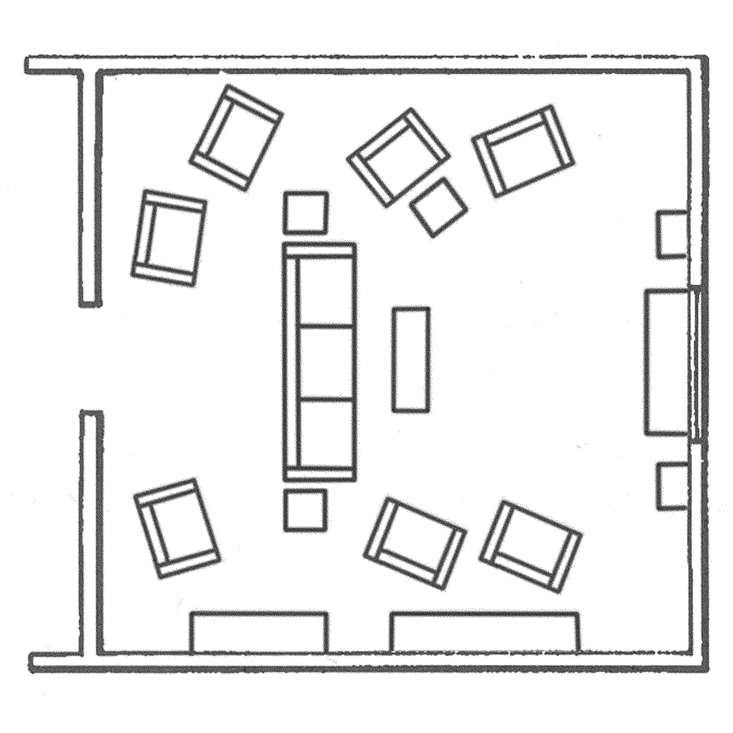
THEATER ROOM
Limitations/Exclusions
Except as otherwise and expressly stated in this INSPECTION REPORT, only those items, systems, structures or components that are listed in the INSPECTION REPORT have been reviewed or evaluated. With respect to any permanently installed audio, video or projection equipment, items or conditions EXCLUDED from this RESIDENTIAL PROPERTY INSPECTION include, but are not limited to: sound or visual reproduction fidelity, operating condition or remaining useful life of such equipment; appropriateness or adequacy of the installed equipment relative to the size/space of the THEATER ROOM. With respect to FLOORS, items or conditions EXCLUDED from this RESIDENTIAL PROPERTY INSPECTION include, but are not limited to: minor or cosmetic defects or cracks; odors and hidden stains; floor condition and materials used when storage, floor coverings or other furnishings obstruct or otherwise prevent visual inspection; identification, testing or evaluation for presence of asbestos in floor tiles. With respect to WALLS or CEILINGS, items or conditions EXCLUDED from this RESIDENTIAL PROPERTY INSPECTION include, but are not limited to: wall or ceiling condition and materials used when storage, wall or ceiling coverings, moldings, or other furnishings obstruct or otherwise prevent visual inspection; small cracks indicating normal age and settling; hidden mold, rot or deterioration; identification, testing or evaluation for presence of asbestos. With respect to DOORS and WINDOWS, items or conditions EXCLUDED from this RESIDENTIAL PROPERTY INSPECTION include, but are not limited to: determination whether tempered glass (where required) has been used when no clear marking is visible; presence of or potential for leakage in multi-pane window seals. With respect to FIREPLACES, items or conditions EXCLUDED from this RESIDENTIAL PROPERTY INSPECTION include, but are not limited to: proper installation, fireproofing, condition and safety of fireplaces, chimneys, flues and inserts that cannot be determined by visual inspection; estimate or opinion regarding remaining useful life of any fans. With regard to SMOKE DETECTORS covered in this inspection, the items, systems, structures or components EXCLUDED from this RESIDENTIAL PROPERTY INSPECTION include, but are not limited to: wiring methods used; estimate or opinion regarding remaining useful life of any smoke detectors and/or their batteries. Refer to the Agreement under which this RESIDENTIAL PROPERTY INSPECTION was performed for additional conditions, limitations, exceptions and exclusions.

Present
None
Drywall
Acoustic
Plaster
Open Beam
Plywood Paneling
Solid Wood Paneling
Other

Carpet
Ceramic Tile
Wood
Marble
Linoleum/Vinyl
Other

ENTRY HALL
ITEM / AREA | GOOD | FAIR | POOR | N/A | COMMENTS
Ceilings /Walls
Floor
Stairs / Railing
Window(s)
Exterior Door(s)
Interior Door(s)
Light Fixture(s)
Switches
Outlets
Smoke Detector
Heating / Air Conditioning |  |  |  |  | Register Type/Location:
NOTES / COMMENTS / RECOMMENDATIONS
ENTRY HALL
WALLS AND CEILING
FLOORING

Present
None
Drywall
Acoustic
Plaster
Open Beam
Plywood Paneling
Solid Wood Paneling
Other

Carpet
Ceramic Tile
Wood
Marble
Linoleum/Vinyl
Other

HALLWAY (FIRST FLOOR)
ITEM / AREA | GOOD | FAIR | POOR | N/A | COMMENTS
Ceilings /Walls
Floor
Window(s)
Exterior Door(s)
Interior Door(s)
Light Fixture(s)
Switches
Outlets
Smoke Detector
Heating / Air Conditioning |  |  |  |  | Register Type/Location:
NOTES / COMMENTS / RECOMMENDATIONS
HALLWAY (FIRST FLOOR)
WALLS AND CEILING
FLOORING

Present
None
Drywall
Acoustic
Plaster
Open Beam
Plywood Paneling
Solid Wood Paneling
Other

Carpet
Ceramic Tile
Wood
Marble
Linoleum/Vinyl
Other

HALLWAY (SECOND FLOOR)
ITEM / AREA | GOOD | FAIR | POOR | N/A | COMMENTS
Ceilings /Walls
Floor
Window(s)
Exterior Door(s)
Interior Door(s)
Light Fixture(s)
Switches
Outlets
Smoke Detector
Heating / Air Conditioning |  |  |  |  | Register Type/Location:
NOTES / COMMENTS / RECOMMENDATIONS
HALLWAY (SECOND FLOOR)
WALLS AND CEILING
FLOORING

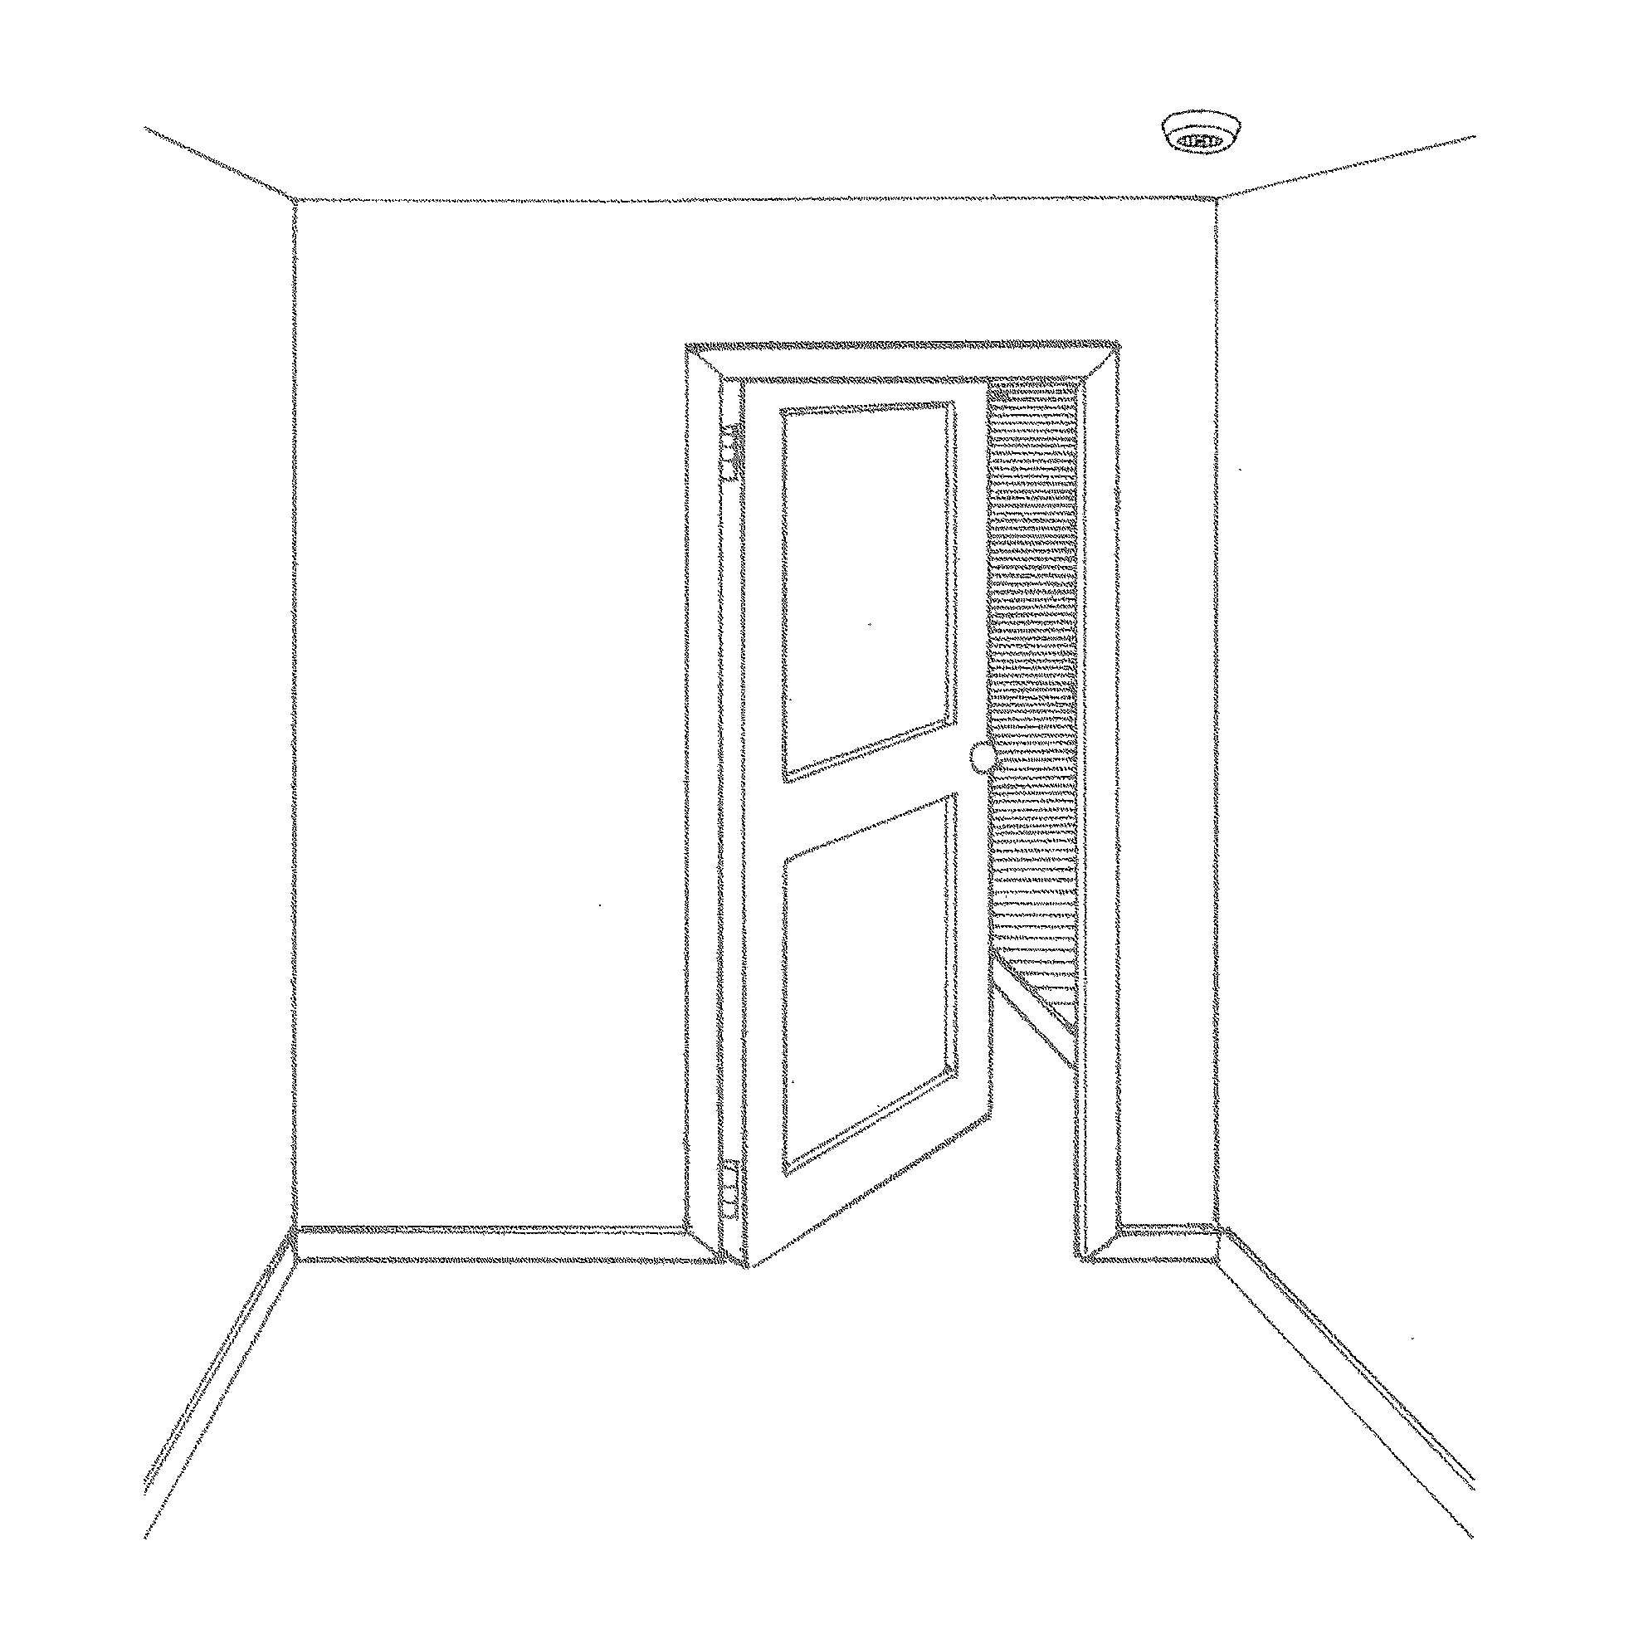
HALLWAYS (ENTRY HALL, HALLWAY 1ST FLOOR, HALLWAY 2ND FLOOR)
Limitations/Exclusions
Except as otherwise and expressly stated in this INSPECTION REPORT, only those items, systems, structures or components that are listed in the INSPECTION. Except as otherwise and expressly stated in this INSPECTION REPORT, only those items, systems, structures or components that are listed in the INSPECTION REPORT have been reviewed or valuated. With respect to FLOORS, items or conditions EXCLUDED from this RESIDENTIAL PROPERTY INSPECTION include, but are not limited to: minor or cosmetic defects or cracks; odors and hidden stains; floor condition and materials used when storage, floor coverings or other furnishings obstruct or otherwise prevent visual inspection; identification, testing or evaluation for presence of asbestos in floor ties. With respect to WALLS or CEILINGS, items or conditions EXCLUDED from this RESIDENTIAL PROPERTY INSPECTION include, but are not limited to: wall or ceiling condition and materials used when storage, wall or ceiling coverings, moldings, or other furnishings obstruct or otherwise prevent visual inspection; small cracks indicating normal age and settling; hidden mold, rot or deterioration; identification, testing or evaluation for presence of asbestos. With respect to DOORS and WINDOWS, items or conditions EXCLUDED from this RESIDENTIAL PROPERTY INSPECTION include, but are not limited to: determination whether tempered glass (where required) has been used when no clear marking is visible; presence of or potential for leakage in multi-pane window seals. With regard to SMOKE DETECTORS covered in this inspection, the items, systems, structures or components EXCLUDED from this RESIDENTIAL PROPERTY INSPECTION include, but are not limited to: wiring methods used; estimate or opinion regarding remaining useful life of any smoke detectors and/or their batteries. Refer to the Agreement under which this RESIDENTIAL PROPERTY INSPECTION was performed for additional conditions, limitations, exceptions and exclusions.

Present
None
Drywall
Acoustic
Plaster
Open Beam
Plywood Paneling
Solid Wood Paneling
Other

Carpet
Ceramic Tile
Wood
Marble
Linoleum/Vinyl
Other

Masonry
Hearth
Pre-Fab
Gas
Metal
Damper
Stucco
Vent Flue
Concrete
N/A
BREAKFAST ROOM
ITEM / AREA | GOOD | FAIR | POOR | N/A | COMMENTS
Ceilings /Walls
Floor
Window(s)
Exterior Door(s)
Interior Door(s)
Light Fixture(s)
Fireplace
Switches
Outlets
Smoke Detector
Heating / Air Conditioning |  |  |  |  | Register Type/Location:
NOTES / COMMENTS / RECOMMENDATIONS
BREAKFAST ROOM
WALLS AND CEILING
FLOORING
INTERIOR CHIMNEY/ FIREPLACE

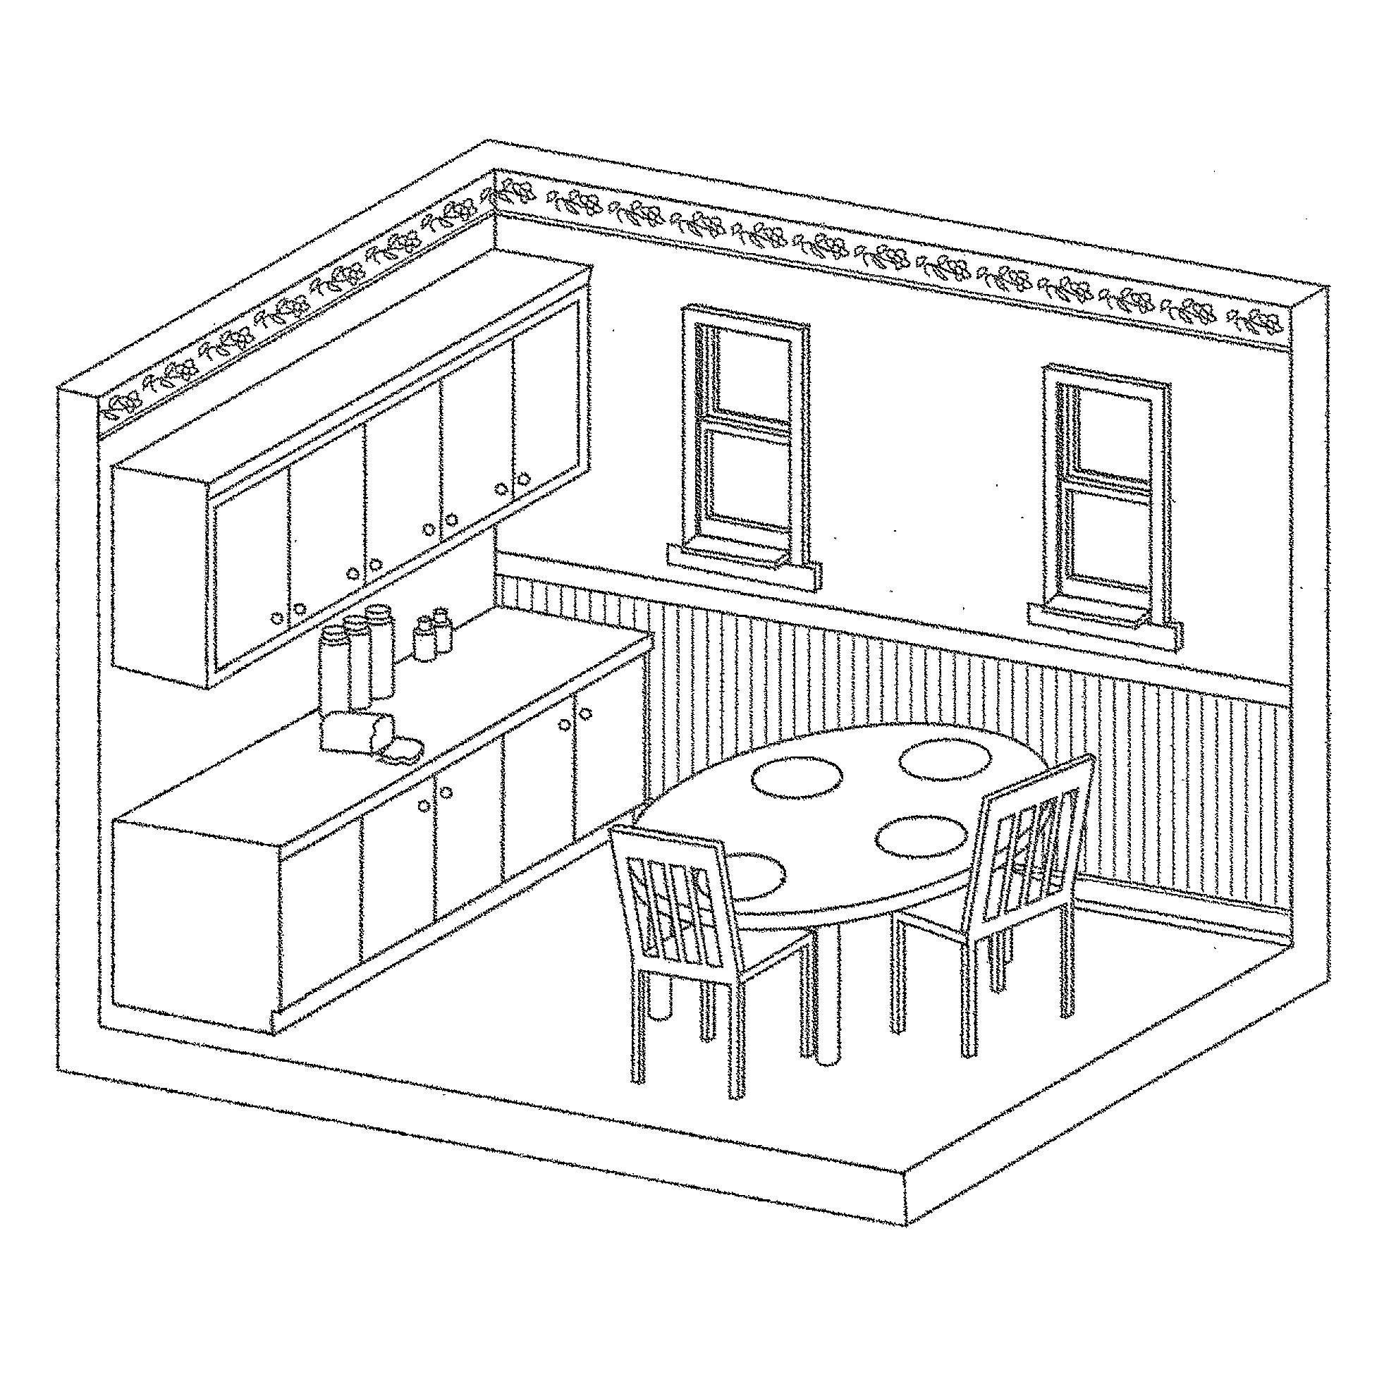
BREAKFAST ROOM
Limitations/Exclusions
Except as otherwise and expressly stated in this INSPECTION REPORT, only those items, systems, structures or components that are listed in the INSPECTION REPORT have been reviewed or evaluated. With respect to FLOORS, items or conditions EXCLUDED from this RESIDENTIAL PROPERTY INSPECTION include, but are not limited to: minor or cosmetic defects or cracks; odors and hidden stains; floor condition and materials used when storage, floor coverings or other furnishings obstruct or otherwise prevent visual inspection; identification, testing or evaluation for presence of asbestos in floor tiles. With respect to WALLS or CEILINGS, items or conditions EXCLUDED from this RESIDENTIAL PROPERTY INSPECTION include, but are not limited to: wall or ceiling condition and materials used when storage, wall or ceiling coverings, moldings, or other furnishings obstruct or otherwise prevent visual inspection; small cracks indicating normal age and settling; hidden mold, rot or deterioration; identification, testing or evaluation for presence of asbestos. With respect to DOORS and WINDOWS, items or conditions EXCLUDED from this RESIDENTIAL PROPERTY INSPECTION include, but are not limited to: determination whether tempered glass (where required) has been used when no clear marking is visible; presence of or potential for leakage in multi-pane window seals. With respect to FIREPLACES, items or conditions EXCLUDED from this RESIDENTIAL PROPERTY INSPECTION include, but are not limited to: proper installation, fireproofing, condition and safety of fireplaces, chimneys, flues and inserts that cannot be determined by visual inspection; estimate or opinion regarding remaining useful life of any fans; actual performance and/or safety of Ground Fault Circuit Interruption protection, beyond inspection using the built-in test feature. With regard to SMOKE DETECTORS covered in this inspection, the items, systems, structures or components EXCLUDED from this RESIDENTIAL PROPERTY INSPECTION include, but are not limited to: wiring methods used; estimate or opinion regarding remaining useful life of any smoke detectors and/or their batteries. Refer to the Agreement under which this RESIDENTIAL PROPERTY INSPECTION was performed for additional conditions, limitations, exceptions and exclusions.

Full
Half
Other:

Present
None
Stairs
Pulldown
Scuttlehole
Pulldown
Other:

Location:

Window(s)
Attic Fan
Ridge Vent(s)
Roof Vent(s)
Soffit Vent(s)

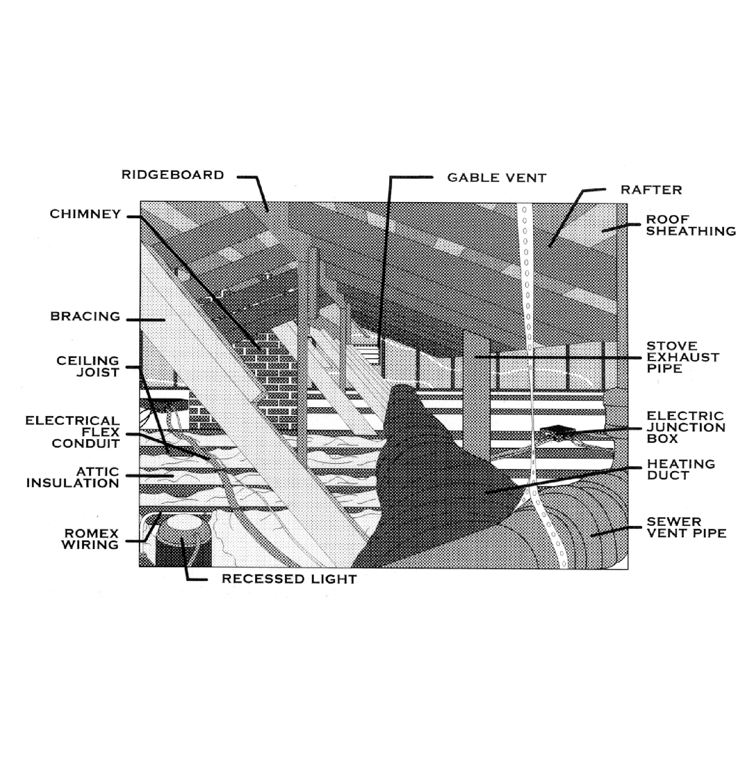

ATTIC
ITEM / AREA | GOOD | FAIR | POOR | WA | COMMENTS
Structural
Insulation
Ventilation
Duct Work
Electrical
Plumbing
Access
ATTIC
ACCESS
COVERAGE
VENTILATION
NOTES / COMMENTS / RECOMMENDATIONS
Limitations/Exclusions
Except as otherwise and expressly stated in this INSPECTION REPORT, only those items, systems, structures or components that are listed in the INSPECTION REPORT have been reviewed or evaluated. In the context of the ATTIC section of this report, the items, systems, structures or components EXCLUDED from this RESIDENTIAL PROPERTY INSPECTION include, but are not limited to: those portions of the attic that provide limited or no access (e.g., low clearance areas, areas with ductwork or insulation); estimate or opinion regarding remaining useful life of an attic fan (if any). Roof leakage cannot be determined with any degree of confidence during dry weather. Water stains observed in the attic (when observed) may not indicate recent or current roof leakage. Refer to the Agreement under which this RESIDENTIAL PROPERTY INSPECTION was performed for additional conditions, limitations, exceptions and exclusions.

Tile
Formica/Laminate
Corian
Marble
Granite
Wood
Ceramic Tile
Linoleum/Vinyl
Marble
Granite
Other

Air Gap Device
Door Liner/Rack
Door Seal
N/A
Wiring
N/A
Gas
Electric Igniter
Electric
Combination
Power / Gas Disconnected / Not inspected
Number of Ovens:
Built-In Microwave
Trash Compactor
Built-In Blender
N/A
KITCHEN
ITEM / AREA | GOOD | FAIR | POOR | N/A | COMMENTS
Ceilings/Walls
Floor Covering
Counter Top
Cabinets
Sink(s)
Sink Faucet(s)
Drain(s)
Dishwasher(s)
Garbage Disposal(s)
Range / Cook Top
Oven(s)
Vent Hood(s)
Light Fixture(s)
Exterior Door(s)
Interior Door(s)
Window(s)
Switches
Outlets |  |  |  |  | G.F.C.I.: Yes No
Heating / Air Conditioning |  |  |  |  | Register Type/Location:
NOTES / COMMENTS / RECOMMENDATIONS
KITCHEN
COUNTERS / CABINETS
FLOORING
DISHWASHER(S)
GARBAGE DISPOSAL(S)
RANGE / COOKTOP / OVEN(S)
MISCELLANEOUS APPLIANCES

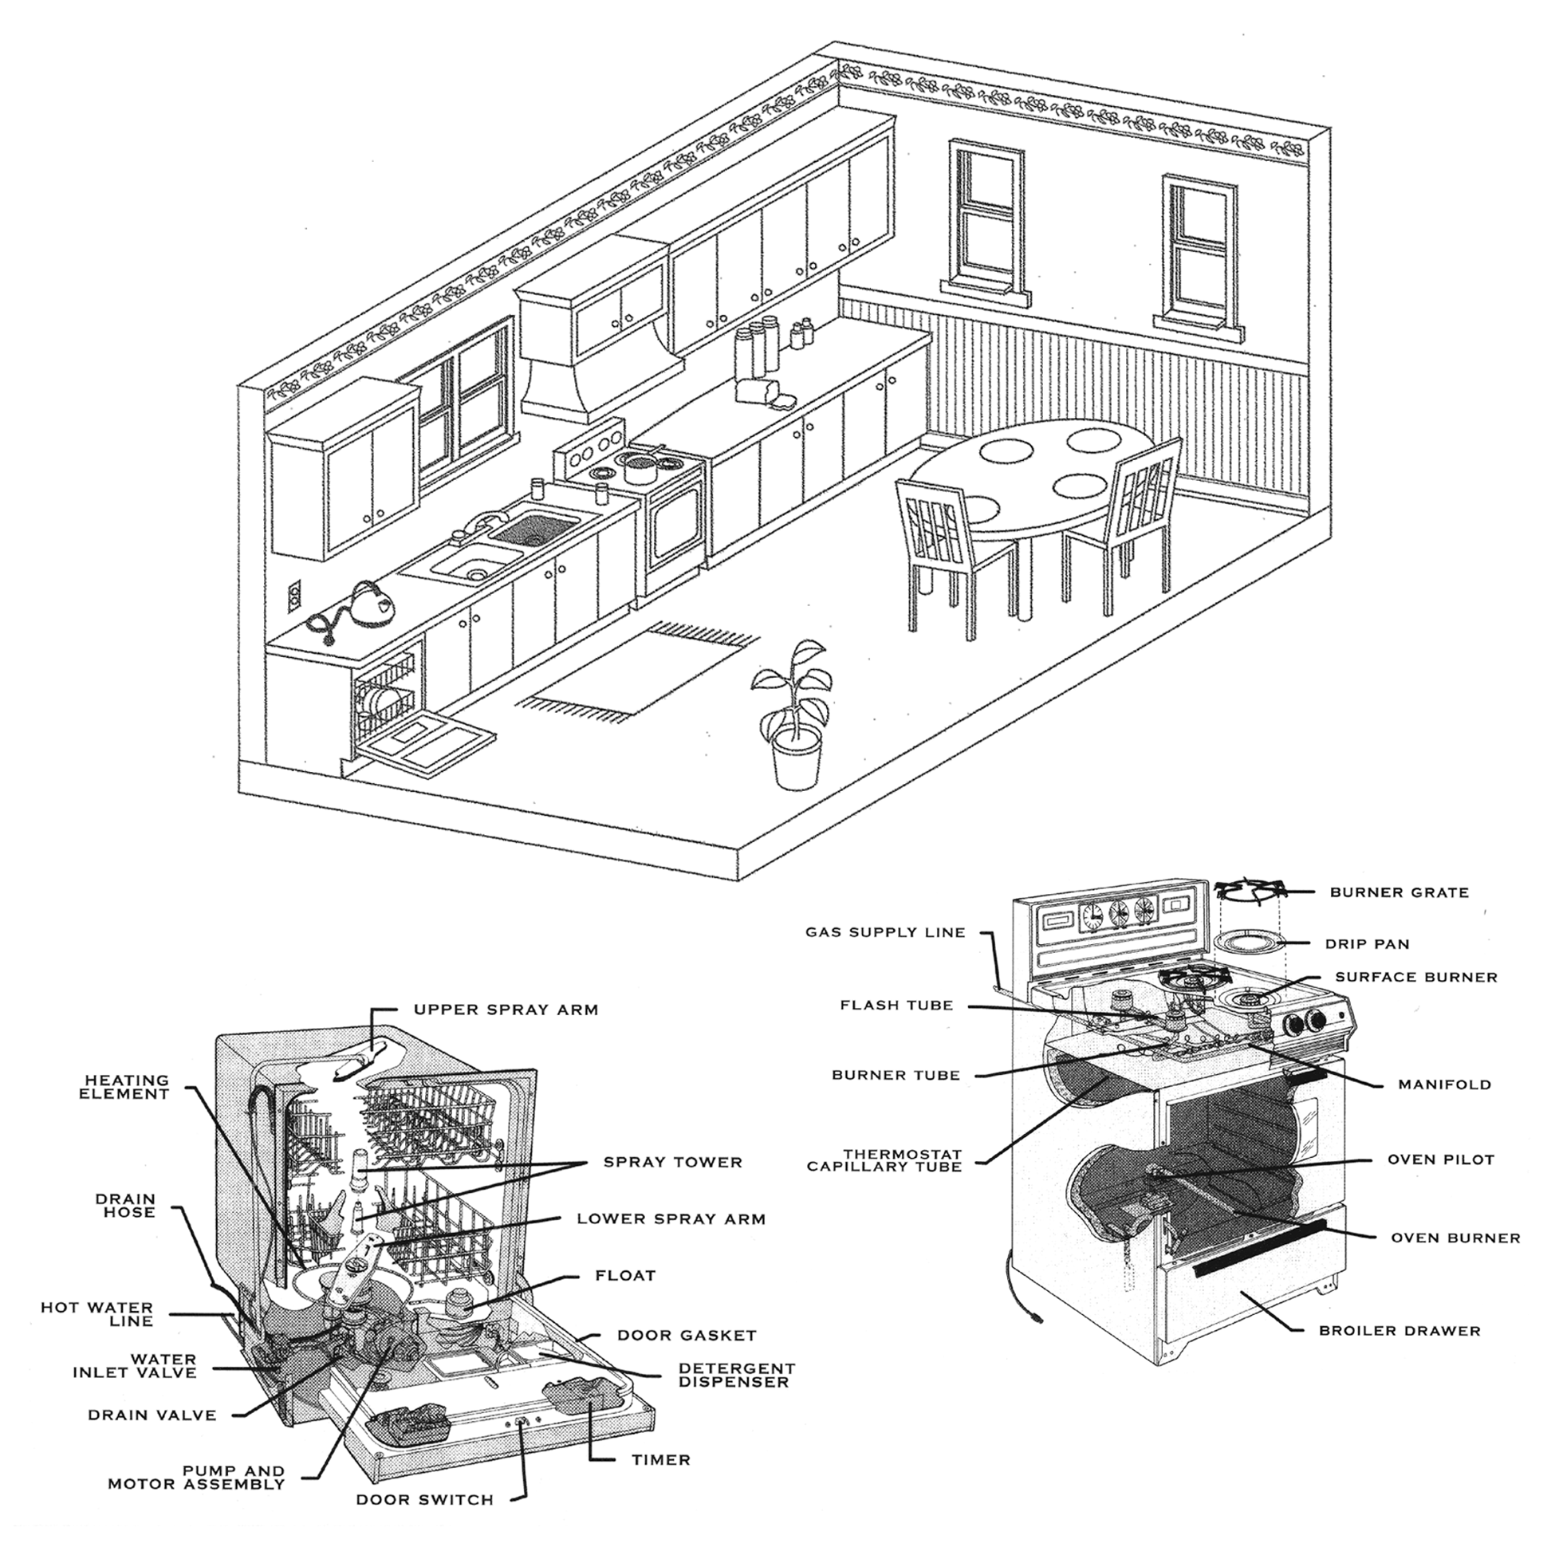
KITCHEN
Limitations/Exclusions
Except as otherwise and expressly stated in this INSPECTION REPORT, only those items, systems, structures or components that are listed in the INSPECTION REPORT have been reviewed or evaluated. In the context of KITCHEN, the items, systems, structures or components EXCLUDED from this RESIDENTIAL PROPERTY INSPECTION include, but are not limited to: self- or continuous-cleaning features of ovens; functioning or accuracy of timers, lights, clocks and cooking temperature accuracy/calibration (thermostats) of ovens, installed microwaves and/or ranges; ability or accuracy of any installed microwave oven to cook, beyond a simple test to heat water (if performed, a notation will appear in the Notes section; otherwise, this test will not be performed) ability/power of trash compactors to compact trash; refrigerators, freezers, ice-makers; appliances not permanently installed; conditions in areas of cabinets and countertops obscured from view by personal belongings, stored food, dishes and other articles; leaks and other conditions in plumbing, dishwashers, garbage disposals, and other appliances obscured from inspection; conditions of wear or defect in the interior components of any inspected appliance, garbage disposal, etc.; determination whether noise generated by appliances while operating is excessive or indicative of a defect or failure; determination whether any installed appliance operates beyond simple on-off functionality (that is, whether any advertised or expected feature beyond on-off actually operates); actual performance and/or safety of Ground Fault Circuit Interruption protection, beyond inspection using the built-in test feature. With regard to SMOKE DETECTORS covered in this inspection, the items, systems, structures or components EXCLUDED from this RESIDENTIAL PROPERTY INSPECTION include, but are not limited to: wiring methods used; estimate or opinion regarding remaining useful life of any smoke detectors and/or their batteries. Refer to the Agreement under which this RESIDENTIAL PROPERTY INSPECTION was performed for additional conditions, limitations, exceptions and exclusions.

LAUNDRY ROOM
ITEM I AREA | GOOD | FAIR | POOR | N/A | COMMENTS
Walls and Ceilings
Flooring
Dryer Vent
Water - Supply Lines |  |  |  |  | Valve Shut-Off : Yes No
Waste Lines
Laundry Sink |  |  |  |  | Valve Shut-Off : Yes No
Gas Service
Light Fixture(s)
Switches
Outlets |  |  |  |  | G.F.C.I.: Yes No
Exterior Door(s)
Interior Door(s)
Ventilation |  |  |  |  | Passive Exhaust Fan None
NOTES / COMMENTS / RECOMMENDATIONS

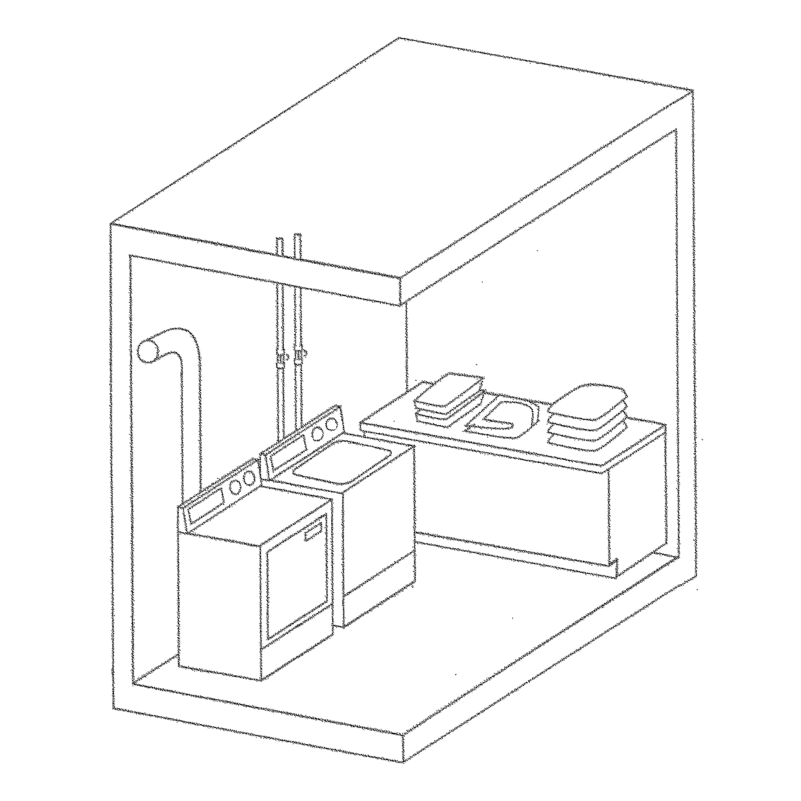
Limitations/Exclusions
Except as otherwise and expressly stated in this INSPECTION REPORT, only those items, systems, structures or components that are listed in the INSPECTION REPORT have been reviewed or evaluated. In the context of the LAUNDRY ROOM section of this report, the items, systems, structures or components EXCLUDED from this RESIDENTIAL PROPERTY INSPECTION include, but are not limited to: washing machines or clothes dryers; washing machine water supply valves or drain lines; adequacy or safety of combustion gas venting; actual performance and/or safety of Ground Fault Circuit Interruption protection, beyond inspection using the built-in test feature. Refer to the Agreement under which this RESIDENTIAL PROPERTY INSPECTION was performed for additional conditions, limitations, exceptions and exclusions.
ITEM / AREA | GOOD | FAIR | POOR | N/A | COMMENTS
BEDROOM # 1 Location:
Ceilings/Walls
Floor |  |  |  |  | Carpet Wood
Light Fixture(s)
Switches
Outlets
Fireplace
Ceiling Fan
Window(s)
Door(s)
Closet |  |  |  |  | Walk-in
Air Conditioning / Heating |  |  |  |  | Register Type/Location:
Smoke Detector |  |  |  |  | Battery Hard-Wired
BEDROOM # 2 Location:
Ceilings/Walls
Floor |  |  |  |  | Carpet Wood
Light Fixture(s)
Switches
Outlets
Fireplace
Ceiling Fan
Window(s)
Door(s)
Closet |  |  |  |  | Walk-in
Air Conditioning / Heating |  |  |  |  | Register Type/Location:
Smoke Detector |  |  |  |  | Battery Hard-Wired
BEDROOM # 3 Location:
Ceilings/Walls
Floor |  |  |  |  | Carpet Wood
Light Fixture(s)
Switches
Outlets
Fireplace
Ceiling Fan
Window(s)
Door(s)
Closet |  |  |  |  | Walk-in
Air Conditioning / Heating |  |  |  |  | Register Type/Location:
Smoke Detector |  |  |  |  | Battery Hard-Wired
NOTES / COMMENTS / RECOMMENDATIONS
ITEM / AREA | GOOD | FAIR | POOR | N/A | COMMENTS
BEDROOM # 4 Location:
Ceilings/Walls
Floor |  |  |  |  | Carpet Wood
Light Fixture(s)
Switches
Outlets
Fireplace
Ceiling Fan
Window(s)
Door(s)
Closet |  |  |  |  | Walk-in
Air Conditioning / Heating |  |  |  |  | Register Type/Location:
Smoke Detector |  |  |  |  | Battery Hard-Wired
BEDROOM # 5 Location:
Ceilings/Walls
Floor |  |  |  |  | Carpet Wood
Light Fixture(s)
Switches
Outlets
Fireplace
Ceiling Fan
Window(s)
Door(s)
Closet |  |  |  |  | Walk-in
Air Conditioning / Heating |  |  |  |  | Register Type/Location:
Smoke Detector |  |  |  |  | Battery Hard-Wired
BEDROOM # 6 Location:
Ceilings/Walls
Floor |  |  |  |  | Carpet Wood
Light Fixture(s)
Switches
Outlets
Fireplace
Ceiling Fan
Window(s)
Door(s)
Closet |  |  |  |  | Walk-in
Air Conditioning / Heating |  |  |  |  | Register Type/Location:
Smoke Detector |  |  |  |  | Battery Hard-Wired
NOTES / COMMENTS / RECOMMENDATIONS

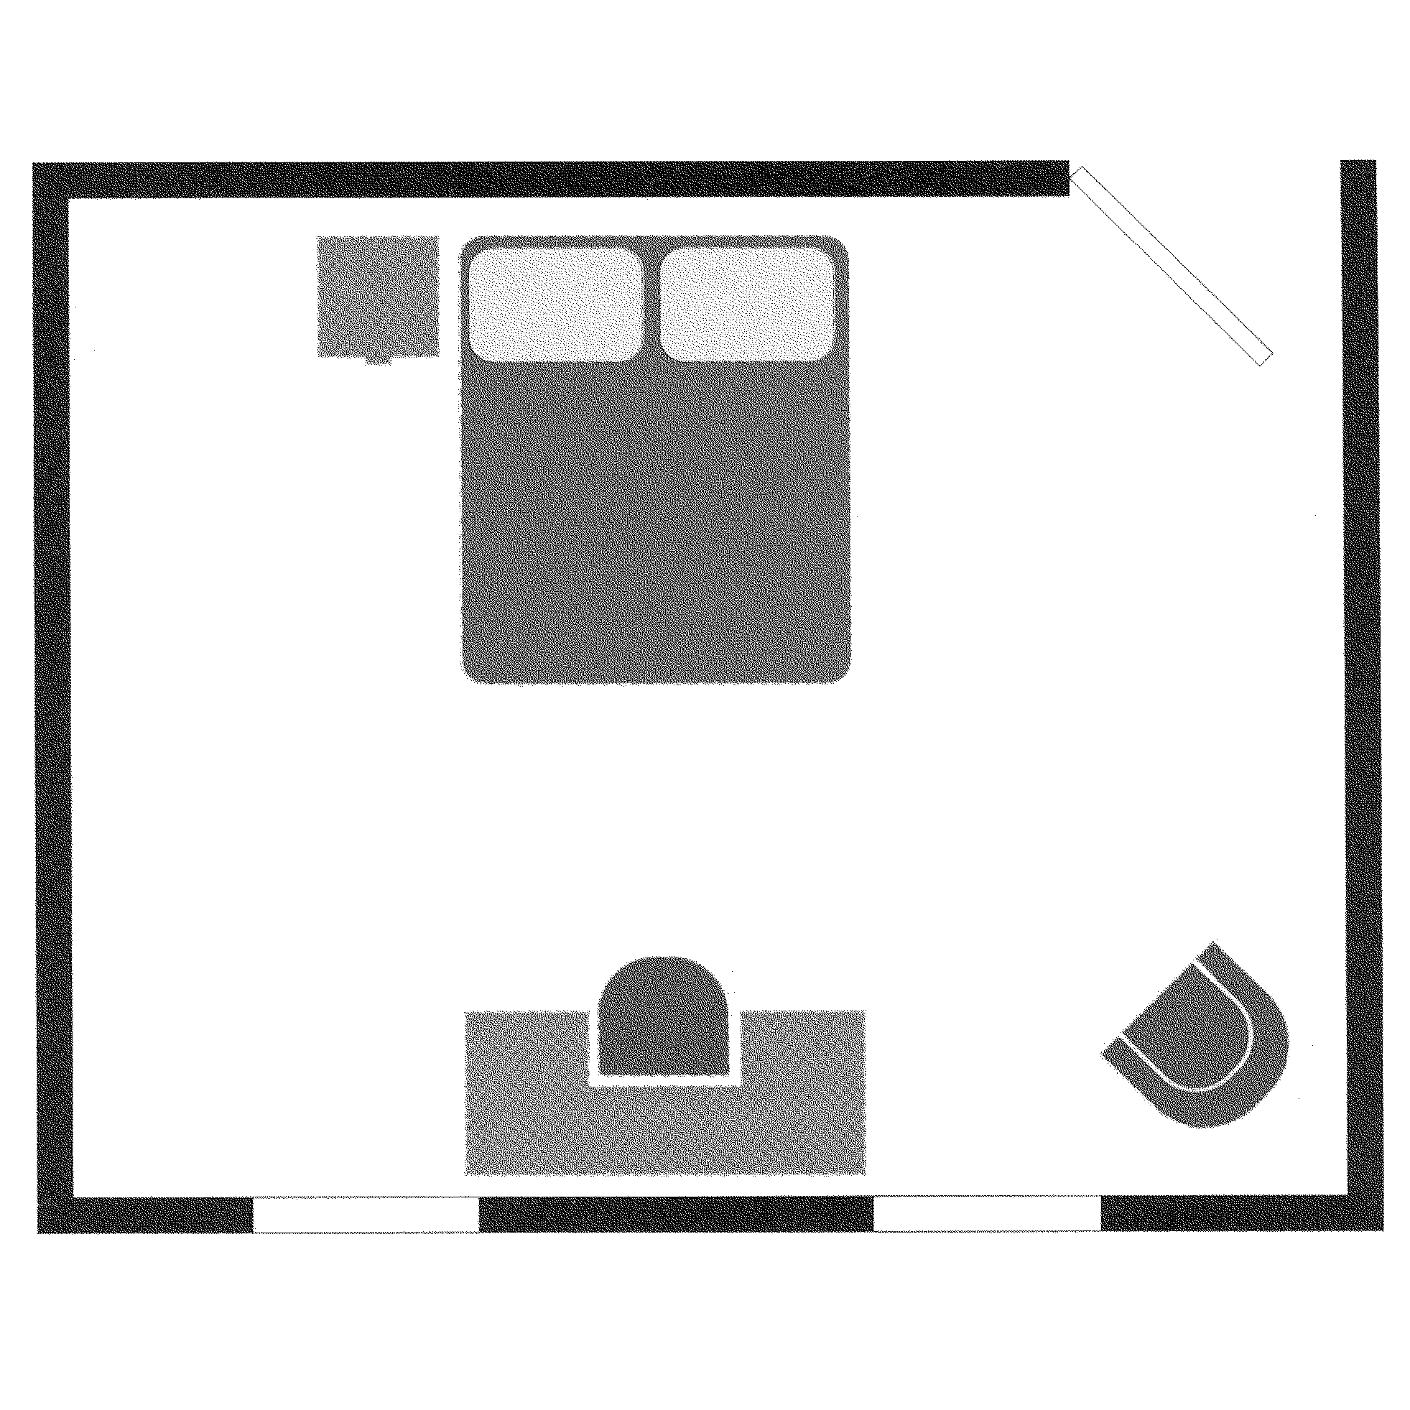
BEDROOMS
Limitations/Exclusions
With respect to FLOORS, items or conditions EXCLUDED from this RESIDENTIAL PROPERTY INSPECTION include, but are not limited to: minor or cosmetic defects or cracks; odors and hidden stains; floor condition and materials used when storage, floor coverings or other furnishings obstruct or otherwise prevent visual inspection; identification, testing or evaluation for presence of asbestos in floor tiles. With respect to WALLS or CEILINGS, items or conditions EXCLUDED from this RESIDENTIAL PROPERTY INSPECTION include, but are not limited to: wall or ceiling condition and materials used when storage, wall or ceiling coverings, moldings, or other furnishings obstruct or otherwise prevent visual inspection; small cracks indicating normal age and settling; hidden mold, rot or deterioration; identification, testing or evaluation for presence of asbestos. With respect to DOORS and WINDOWS, items or conditions EXCLUDED from this RESIDENTIAL PROPERTY INSPECTION include, but are not limited to: determination whether tempered glass (where required) has been used when no clear marking is visible; presence of or potential for leakage in multi-pane window seals. With respect to FIREPLACES, items or conditions EXCLUDED from this RESIDENTIAL PROPERTY INSPECTION include, but are not limited to: proper installation, fireproofing, condition and safety of fireplaces, chimneys, flues and inserts that cannot be determined by visual inspection; estimate or opinion regarding remaining useful life of any fans. With regard to SMOKE DETECTORS covered in this inspection, the items, systems, structures or components EXCLUDED from this RESIDENTIAL PROPERTY INSPECTION include, but are not limited to: wiring methods used; estimate or opinion regarding remaining useful life of any smoke detectors and/or their batteries.

BATHROOM # 1 Location:
ITEM / AREA |  | GOOD |  | FAIR |  | POOR |  | N/A |  | COMMENTS
Ceilings/Walls
Mirror(s)
Floor |  |  |  |  |  |  |  |  |  | Carpet Tile Vinyl Wood
Light Fixture(s): Conventional
Light Fixture(s): Radiant Heat
Switches
Outlets |  |  |  |  |  |  |  |  |  | G.F.C.I.: Yes No
Trim
Window(s)
Door(s)
Bathroom Closet / Wall Cabinets |  |  |  |  |  |  |  |  |  | Walk-in
Towel Bar(s)/Ring(s)
Toilet Paper Bar / Holder
Toilet(s)
Toilet: Grab Bars
Bidet
Sink
Sink(s): Countertop
Sink(s): Cabinet / Vanity
Sink(s): Spout
Sink(s): Faucets
Sink(s): Drain
Tub
Tub(s): Spout
Tub(s): Faucets
Tub(s): Drain
Tub(s): Spa Tub / Jets
Tub(s): Grab Bars / Seat
Shower Floor/Pan
Shower(s): Head(s)
Shower(s): Faucets
Shower(s): Drain
Shower(s): Walls
Shower(s): Door
Shower: Grab Bars / Seat
Vent / Fan
Wall Heater
Air Conditioning |  |  |  |  |  |  |  |  |  | Register Type/Location:
NOTES / COMMENTS / RECOMMENDATIONS
BATHROOM # 2 Location:
ITEM / AREA | GOOD |  | FAIR |  | POOR |  | N/A |  | COMMENTS
Ceilings/Walls
Mirror(s)
Floor |  |  |  |  |  |  |  |  | Carpet Tile Vinyl Wood
Light Fixture(s): Conventional
Light Fixture(s): Radiant Heat
Switches
Outlets |  |  |  |  |  |  |  |  | G.F.C.I.: Yes No
Trim
Window(s)
Door(s)
Bathroom Closet / Wall Cabinets |  |  |  |  |  |  |  |  | Walk-in
Towel Bar(s)/Ring(s)
Toilet Paper Bar / Holder
Toilet(s)
Toilet: Grab Bars
Bidet
Sink
Sink(s): Countertop
Sink(s): Cabinet / Vanity
Sink(s): Spout
Sink(s): Faucets
Sink(s): Drain
Tub
Tub(s): Spout
Tub(s): Faucets
Tub(s): Drain
Tub(s): Spa Tub / Jets
Tub(s): Grab Bars / Seat
Shower Floor/Pan
Shower(s): Head(s)
Shower(s): Faucets
Shower(s): Drain
Shower(s): Walls
Shower(s): Door
Shower: Grab Bars / Seat
Vent / Fan
Wall Heater
Air Conditioning |  |  |  |  |  |  |  |  | Register Type/Location:
NOTES / COMMENTS / RECOMMENDATIONS
BATHROOM # 3 Location:
ITEM / AREA | GOOD |  | FAIR |  | POOR |  | N/A |  | COMMENTS
Ceilings/Walls
Mirror(s)
Floor |  |  |  |  |  |  |  |  | Carpet Tile Vinyl Wood
Light Fixture(s): Conventional
Light Fixture(s): Radiant Heat
Switches
Outlets |  |  |  |  |  |  |  |  | G.F.C.I.: Yes No
Trim
Window(s)
Door(s)
Bathroom Closet / Wall Cabinets |  |  |  |  |  |  |  |  | Walk-in
Towel Bar(s)/Ring(s)
Toilet Paper Bar / Holder
Toilet(s)
Toilet: Grab Bars
Bidet
Sink
Sink(s): Countertop
Sink(s): Cabinet / Vanity
Sink(s): Spout
Sink(s): Faucets
Sink(s): Drain
Tub
Tub(s): Spout
Tub(s): Faucets
Tub(s): Drain
Tub(s): Spa Tub / Jets
Tub(s): Grab Bars / Seat
Shower Floor/Pan
Shower(s): Head(s)
Shower(s): Faucets
Shower(s): Drain
Shower(s): Walls
Shower(s): Door
Shower: Grab Bars / Seat
Vent / Fan
Wall Heater
Air Conditioning |  |  |  |  |  |  |  |  | Register Type/Location:
NOTES / COMMENTS / RECOMMENDATIONS
BATHROOM # 4 Location:
ITEM / AREA | GOOD |  | FAIR |  | POOR |  | N/A |  | COMMENTS
Ceilings/Walls
Mirror(s)
Floor |  |  |  |  |  |  |  |  | Carpet Tile Vinyl Wood
Light Fixture(s): Conventional
Light Fixture(s): Radiant Heat
Switches
Outlets |  |  |  |  |  |  |  |  | G.F.C.I.: Yes No
Trim
Window(s)
Door(s)
Bathroom Closet / Wall Cabinets |  |  |  |  |  |  |  |  | Walk-in
Towel Bar(s)/Ring(s)
Toilet Paper Bar / Holder
Toilet(s)
Toilet: Grab Bars
Bidet
Sink
Sink(s): Countertop
Sink(s): Cabinet / Vanity
Sink(s): Spout
Sink(s): Faucets
Sink(s): Drain
Tub
Tub(s): Spout
Tub(s): Faucets
Tub(s): Drain
Tub(s): Spa Tub / Jets
Tub(s): Grab Bars / Seat
Shower Floor/Pan
Shower(s): Head(s)
Shower(s): Faucets
Shower(s): Drain
Shower(s): Walls
Shower(s): Door
Shower: Grab Bars / Seat
Vent / Fan
Wall Heater
Air Conditioning |  |  |  |  |  |  |  |  | Register Type/Location:
NOTES / COMMENTS / RECOMMENDATIONS
BATHROOM # 5 Location:
ITEM / AREA | GOOD |  | FAIR |  | POOR |  | N/A |  | COMMENTS
Ceilings/Walls
Mirror(s)
Floor |  |  |  |  |  |  |  |  | Carpet Tile Vinyl Wood
Light Fixture(s): Conventional
Light Fixture(s): Radiant Heat
Switches
Outlets |  |  |  |  |  |  |  |  | G.F.C.I.: Yes No
Trim
Window(s)
Door(s)
Bathroom Closet / Wall Cabinets |  |  |  |  |  |  |  |  | Walk-in
Towel Bar(s)/Ring(s)
Toilet Paper Bar / Holder
Toilet(s)
Toilet: Grab Bars
Bidet
Sink
Sink(s): Countertop
Sink(s): Cabinet / Vanity
Sink(s): Spout
Sink(s): Faucets
Sink(s): Drain
Tub
Tub(s): Spout
Tub(s): Faucets
Tub(s): Drain
Tub(s): Spa Tub / Jets
Tub(s): Grab Bars / Seat
Shower Floor/Pan
Shower(s): Head(s)
Shower(s): Faucets
Shower(s): Drain
Shower(s): Walls
Shower(s): Door
Shower: Grab Bars / Seat
Vent / Fan
Wall Heater
Air Conditioning |  |  |  |  |  |  |  |  | Register Type/Location:
NOTES / COMMENTS / RECOMMENDATIONS

BATHROOM # 6 Location:
ITEM / AREA | GOOD | FAIR | POOR | N/A | COMMENTS

Ceilings/Walls
Mirror(s)
Floor |  |  |  |  | Carpet Tile Vinyl Wood
Light Fixture(s): Conventional
Light Fixture(s): Radiant Heat
Switches
Outlets |  |  |  |  | G.F.C.I.: Yes No
Trim
Window(s)
Door(s)
Bathroom Closet / Wall Cabinets |  |  |  |  | Walk-in
Towel Bar(s)/Ring(s)
Toilet Paper Bar / Holder
Toilet(s)
Toilet: Grab Bars
Bidet
Sink
Sink(s): Countertop
Sink(s): Cabinet / Vanity
Sink(s): Spout
Sink(s): Faucets
Sink(s): Drain
Tub
Tub(s): Spout
Tub(s): Faucets
Tub(s): Drain
Tub(s): Spa Tub / Jets
Tub(s): Grab Bars / Seat
Shower Floor/Pan
Shower(s): Head(s)
Shower(s): Faucets
Shower(s): Drain
Shower(s): Walls
Shower(s): Door
Shower: Grab Bars / Seat
Vent / Fan
Wall Heater
Air Conditioning |  |  |  |  | Register Type/Location:
NOTES / COMMENTS / RECOMMENDATIONS

